# 

**U18CSI7201L – CLOUD COMPUTING**

**LAB OBSERVATION**

**TABLE OF CONTENT**

|  |  |  |  |
| --- | --- | --- | --- |
| **S.No** | **Date** | **Title** | **Page No.** |
| 1 | 25.07.24 | Creating a virtual server in AWS public cloud | 3 |
| 2 | 31.07.24 | Attaching AWS EBS volume to Amazon EC2. | 16 |
| 3 | 08.08.24 | Hosting Web application in cloud | 27 |
| 4 | 28.08.24 | Attaching additional virtual servers to existing application | 36 |
| 5 | 03.10.24 | Host a static webpage | 46 |
| 6 | 01.10.24 | Create a VPC. | 55 |
| 7 | 18.09.24 | Creating My SQL instances. | 66 |
| 8 | 18.09.24 | Create and carryout Read and Write operations on Dynamo DB. | 75 |

**1. Creating a virtual server in AWS public cloud**

**Aim :**

To create a virtual server (EC2 instance) in AWS public cloud.

**Procedure:**

**Step 1:** Sign in to AWS Management Console

* **Open AWS Management Console:** Go to [AWS ManagemenConsole](<https://aws.amazon.com/console/>).
* **Sign in:** Use your AWS account credentials to sign in.

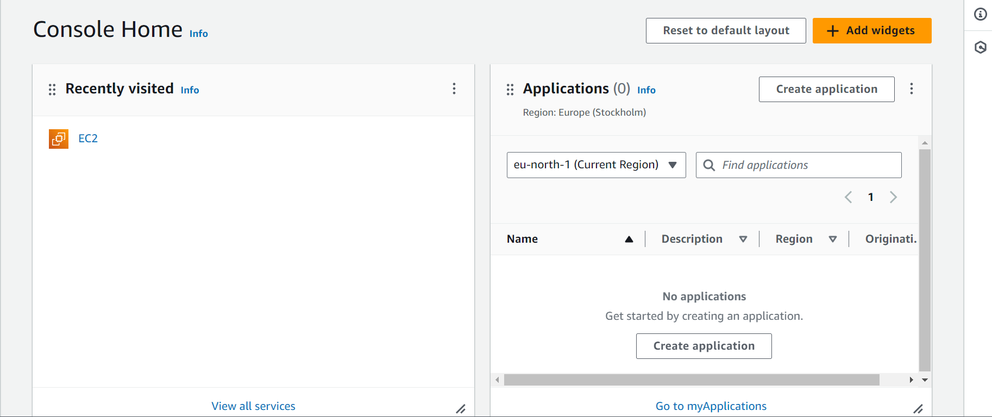

**Step 2:** Launch EC2 Dashboard

* **Navigate to EC2:** In the AWS Management Console, type "EC2" in the search bar and select EC2 to go to the EC2 Dashboard.

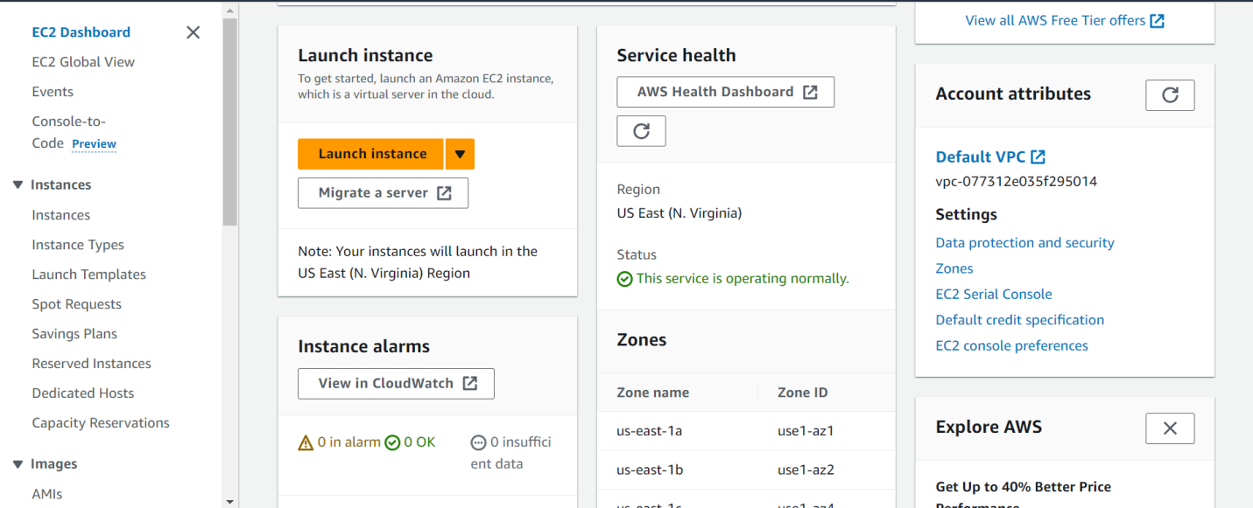

**Step 3:** Launch Instance

* **Launch Instance:** Click on the Launch Instance button to start the process of creating an instance.
* **Select AMI:** Choose an Amazon Machine Image (AMI). You can select a free tier eligible AMI, such as Amazon Linux 2 AMI.

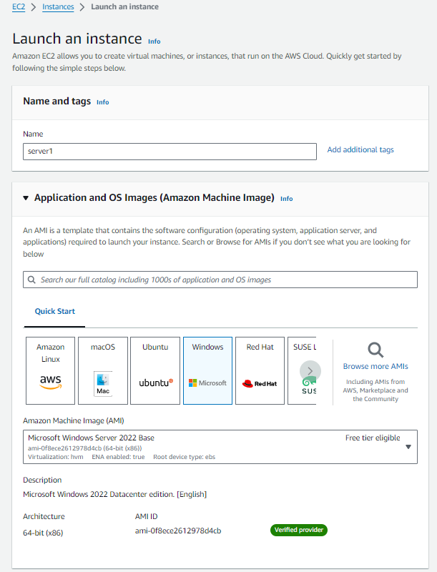

**Step 4:** Choose Instance Type

* Select Instance Type: Choose an instance type based on your requirements. For the free tier, select `t2.micro`.

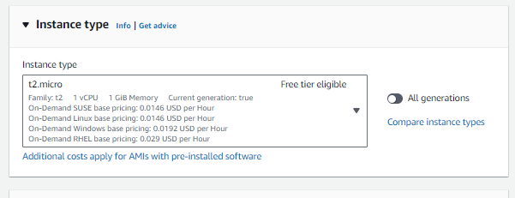

* Create a new key-pair or use the existing one.

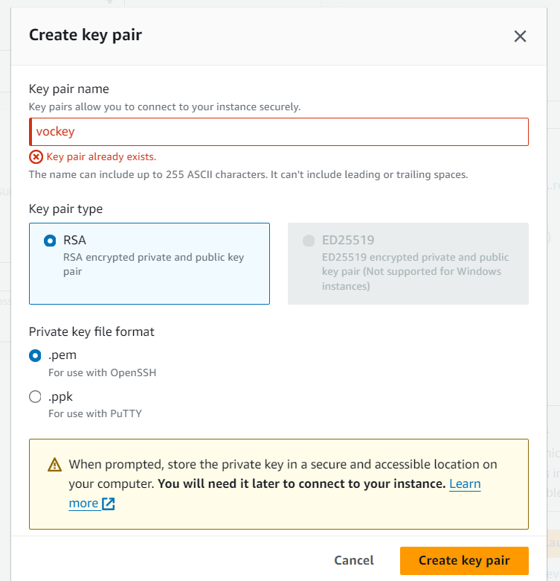

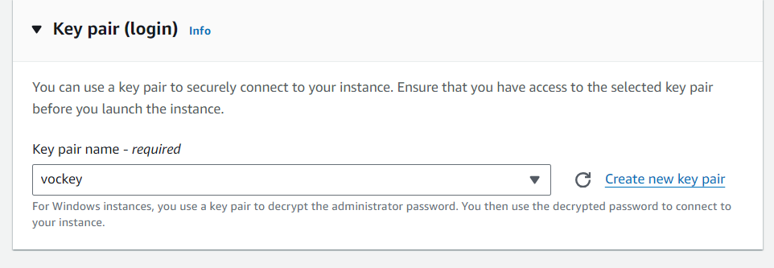

**Step 6:** Add Storage

* Add Storage: Specify the storage volume size. For the free tier, you can use the default value.

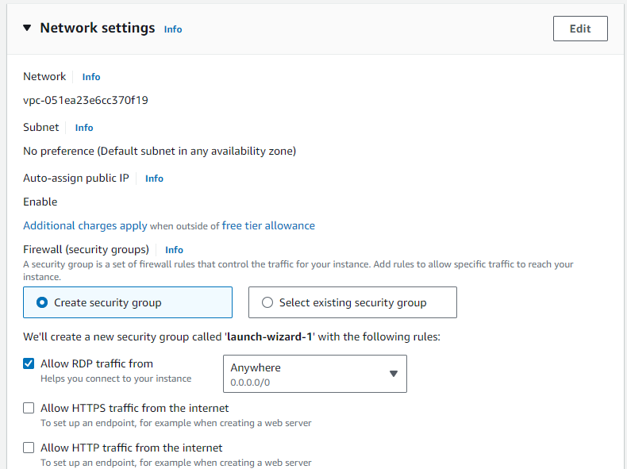

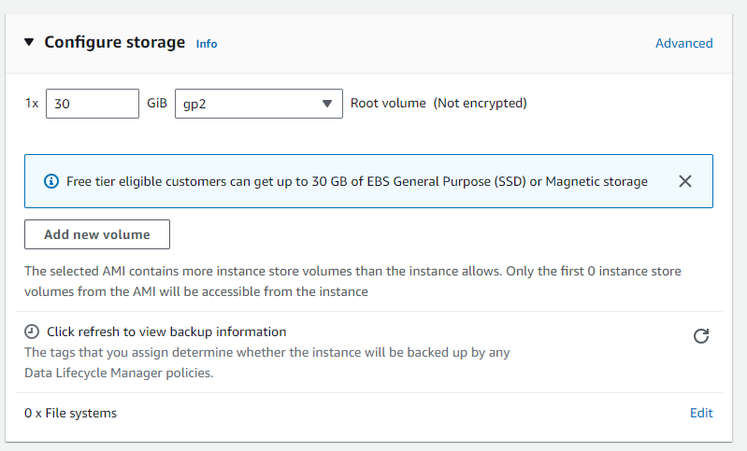

**Step 7:** Add Tags

* Add Tags: Add tags to help identify your instance. This step is optional.

**Step 8:** Configure Security Group

* Configure Security Group: Set up a security group to allow SSH access. You can create a new security group or use an existing one.

**Step 9:** Review and Launch

* Review: Review your settings and click on the Launch button.
* Select Key Pair: Select an existing key pair or create a new key pair for SSH access to your instance. Download the key pair and save it securely.

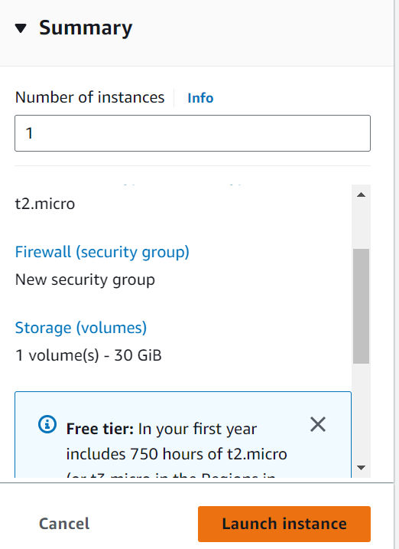

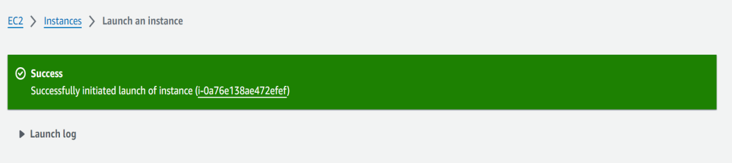

**Step 10:** View Instances

* Go back to the EC2 dashboard and click on Instances to view your running instances.

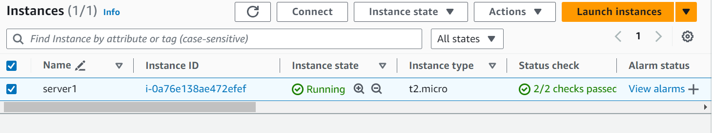

**Step 11:** Connect to EC2 instance

* Once your instance is launched go to EC2 dashboard. Select your instance and click connect to get the instructions for accessing it via SSH.

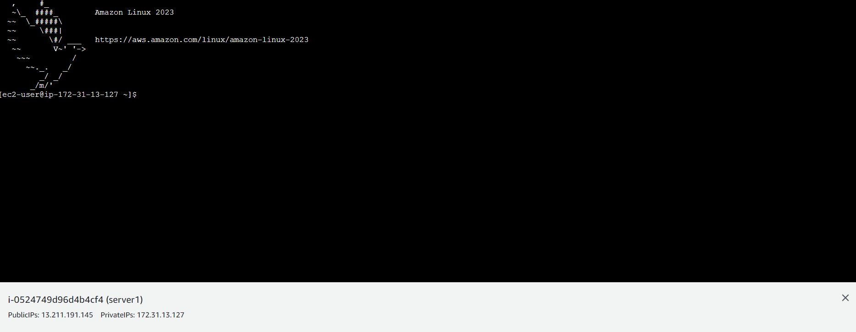

**Step 12:** Terminate the instance.

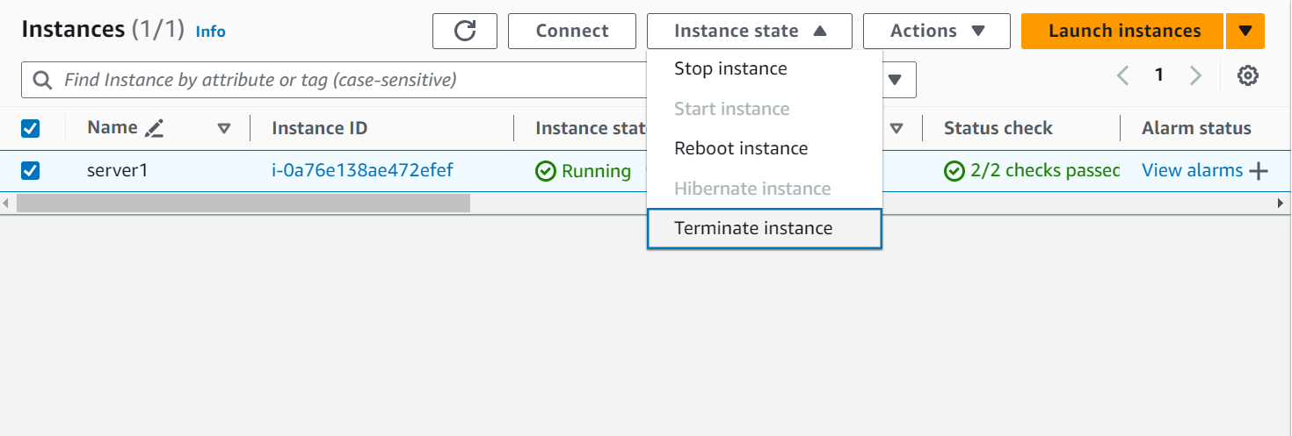

**Result:**

You have successfully created a virtual server (EC2 instance) in AWS. You are now connected to your virtual server in AWS.  
  
**II) WINDOWS SERVER**

**Creating a virtual server (EC2 instance) in AWS involves several steps. Here’s a guide with screenshots to help you through the process:**

**Aim :**

To create a Windows server in AWS public cloud.

**Procedure:**

**Step 1:** Sign in to AWS Management Console

* **Open AWS Management Console:** Go to [AWS ManagemenConsole](<https://aws.amazon.com/console/>).
* **Sign in:** Use your AWS account credentials to sign in.



**Step 2:** Launch EC2 Dashboard

* **Navigate to EC2:** In the AWS Management Console, type "EC2" in the search bar and select EC2 to go to the EC2 Dashboard.



**Step 3:** Launch Instance

* **Launch Instance:** Click on the Launch Instance button to start the process of creating an instance.
* **Select AMI:** Choose an Amazon Machine Image (AMI). You can select a free tier eligible AMI, such as Amazon Linux 2 AMI.



**Step 4:** Choose Instance Type

* Select Instance Type: Choose an instance type based on your requirements. For the free tier, select `t2.micro`.



* Create a new key-pair or use the existing one.





**Step 6:** Add Storage

* Add Storage: Specify the storage volume size. For the free tier, you can use the default value.





**Step 7:** Add Tags

* Add Tags: Add tags to help identify your instance. This step is optional.

**Step 8:** Configure Security Group

* Configure Security Group: Set up a security group to allow SSH access. You can create a new security group or use an existing one.

**Step 9:** Review and Launch

* Review: Review your settings and click on the Launch button.
* Select Key Pair: Select an existing key pair or create a new key pair for SSH access to your instance. Download the key pair and save it securely.





**Step 10:** View Instances

* Go back to the EC2 dashboard and click on Instances to view your running instances.



**Step 11:** Connect

* In the Connect to instance dialog, select the RDP client tab.
* Click on **Download Remote Desktop File**. This action downloads a .rdp file to your local computer.
* On the "Connect to Instance" page, choose "Get Windows Password."
* Upload your key pair file (.pem) and click "Decrypt Password" to retrieve the Administrator password.

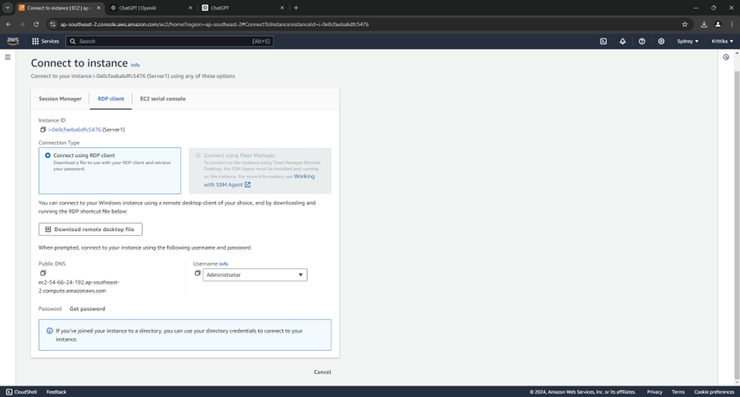

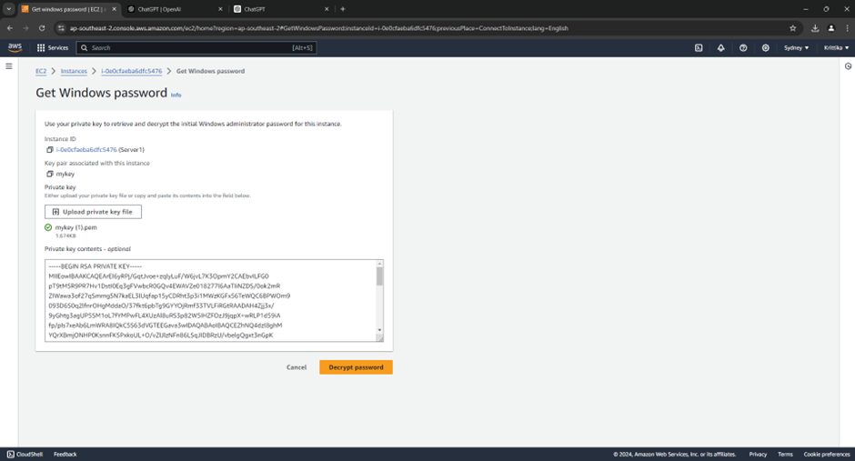

**Step12:**

* Verify the connection
* You should now be connected to your Windows Server instance via Remote Desktop.
* We can perform any task and configure the server has context menu.

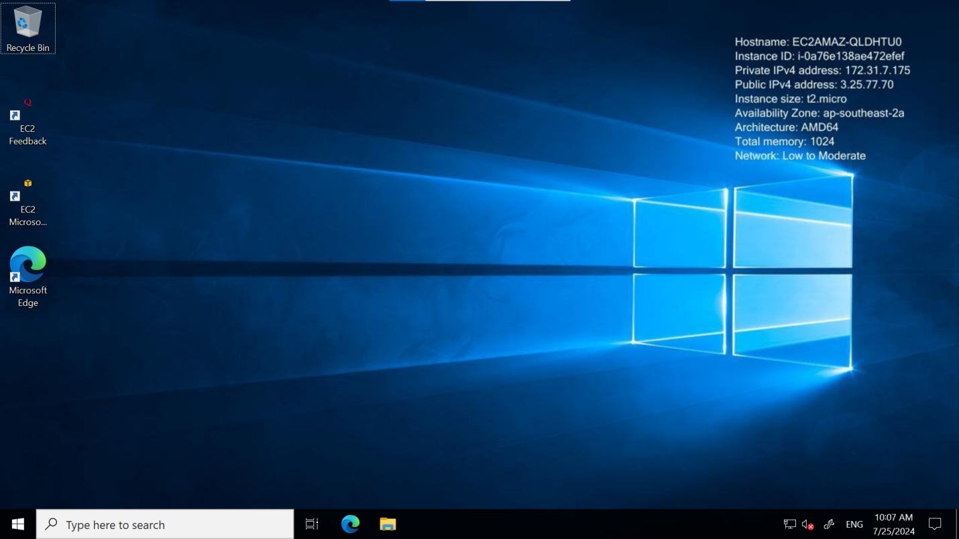

**Step 12:** Terminate the instance.



**Result:**

You have successfully created a running Windows server in AWS.

**2.Attaching AWS EBS volume to Amazon EC2.**

**AIM:**

To attach AWS EBS volume to Amazon EC2.

**STEPS:**

**Step 1: Launch an EC2 Instance**

1. Log in to AWS Management Console:

* Go to [AWS Console](https://aws.amazon.com/console/) and sign in with your AWS account.

1. Navigate to EC2 Dashboard
2. Click "Launch Instance"
3. Configure Instance Settings:

* Choose an Amazon Machine Image (AMI): Select the operating system and version you want to run, such as Amazon Linux, Ubuntu, or Windows Server.
* Choose an Instance Type: Select the hardware configuration, such as t2.micro for free-tier eligible users.
* Configure Instance Details: Choose the number of instances, network settings, and other options.
* Add Storage: Configure the root volume and any additional EBS volumes.
* Add Tags: Optionally, add tags to your instance for identification.
* Configure Security Group: Set up a security group to define firewall rules, like allowing SSH (for Linux) or RDP (for Windows) access.

1. Review and Launch:

* Review your instance configuration. If everything looks good, click Launch.
* You will be prompted to select or create a key pair. This key pair is used for accessing the instance.

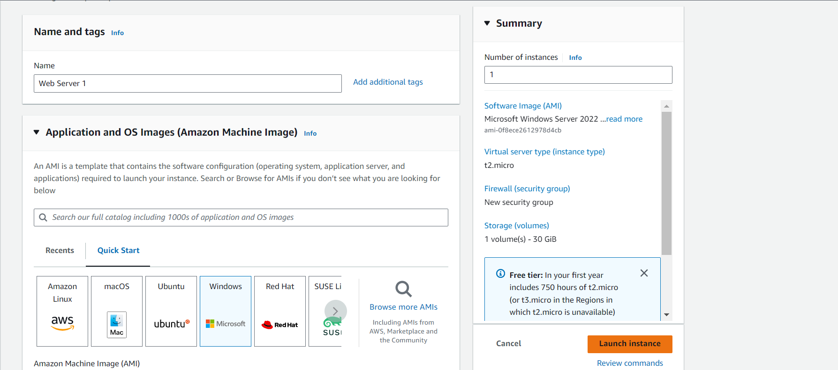

1. Launch the Instance:

* After selecting the key pair, click Launch Instances.
* Your EC2 instance will start launching. You can view its status in the EC2 Dashboard.

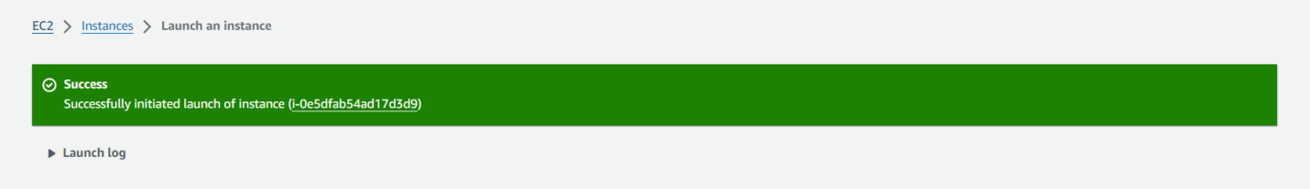

1. Connect to Your Windows EC2 Instance:

* Open RDP Client
* On your local computer, open the Remote Desktop Protocol (RDP) client. This is typically called "Remote Desktop Connection" on Windows.
* Enter Connection Details
* Enter the public DNS or IP address of your Windows EC2 instance. This information is available in the AWS Management Console under the instance details.

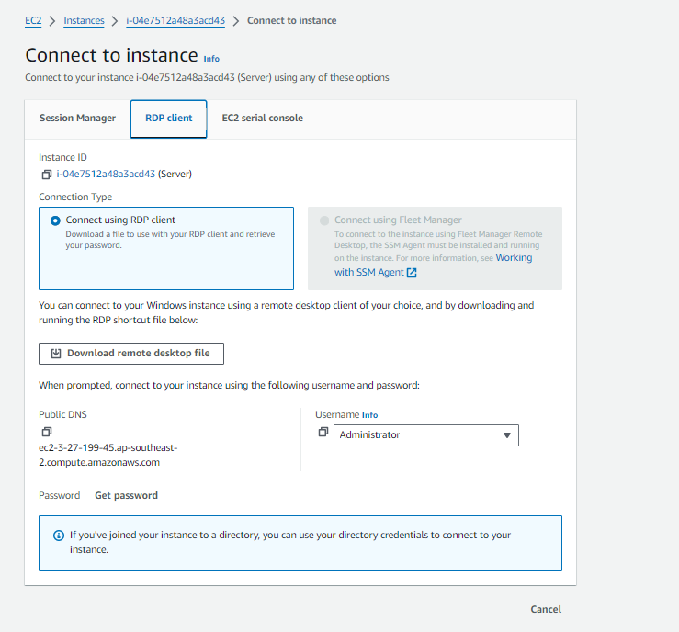

* Use the username (usually Administrator for Windows instances) and the password you set up when you launched the instance.

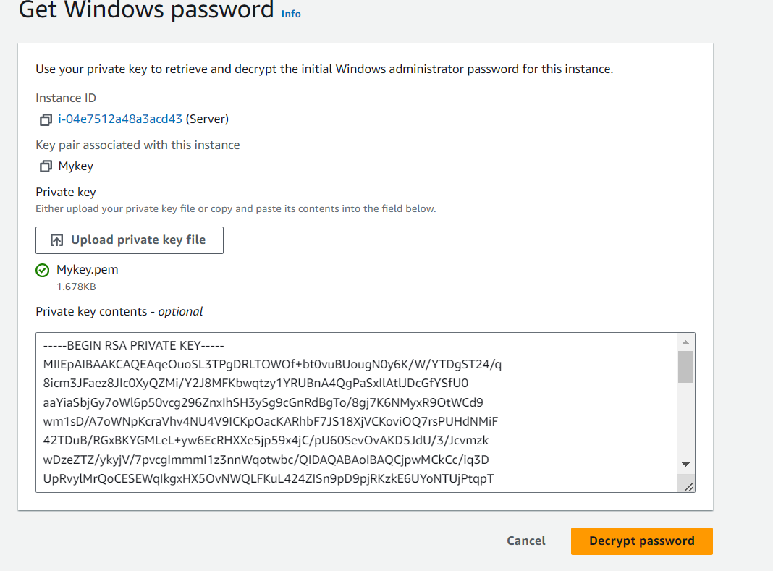

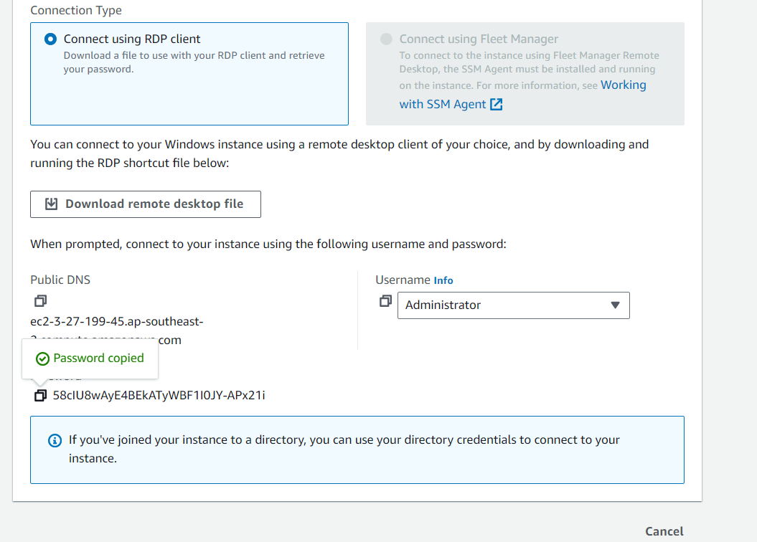

* Click "Connect" to log in to the Windows server.

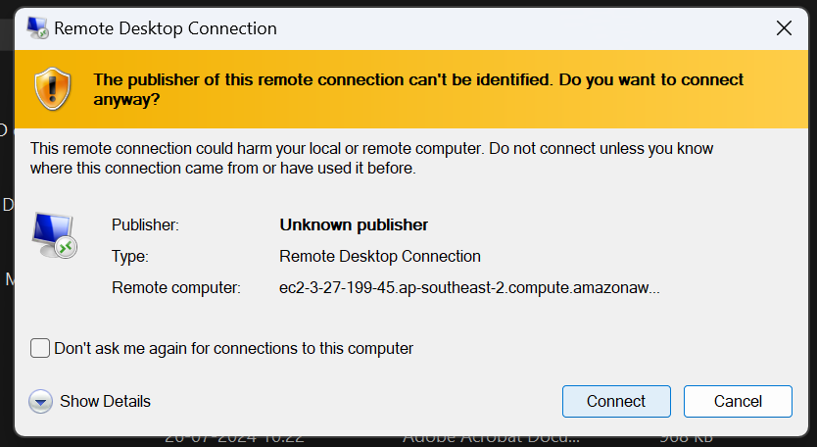

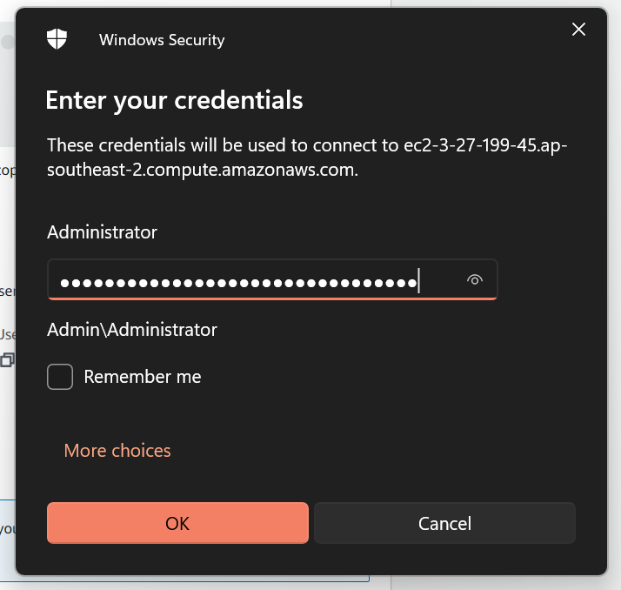

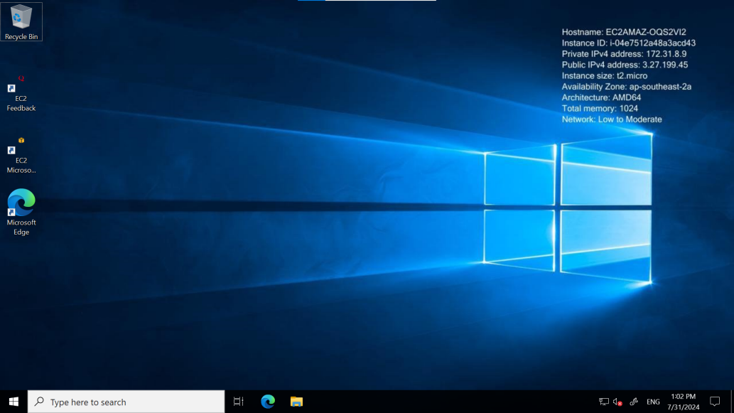

1. **Create Volume:**

* In the left-hand menu, under **Elastic Block Store**, click on **Volumes**.
* Click on the **Create Volume** button.
* Choose the volume type (e.g., General Purpose SSD, Provisioned IOPS SSD, etc.), size, and availability zone (make sure it matches the availability zone of your EC2 instance).
* Click **Create Volume**.

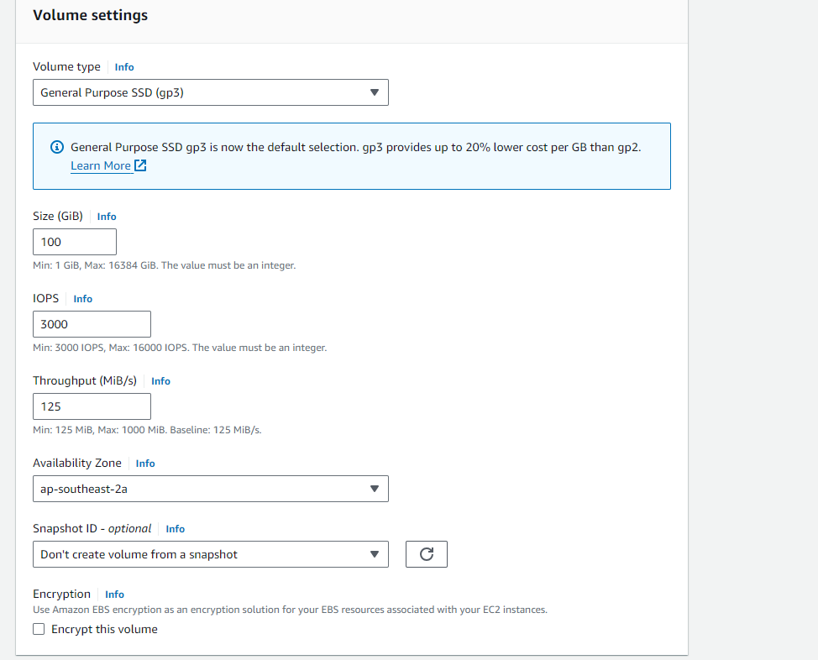

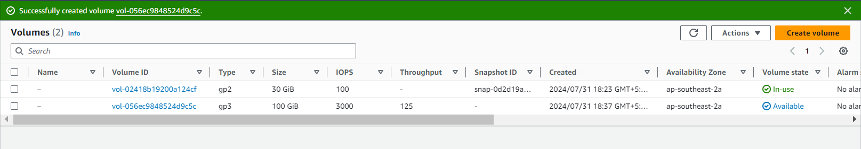

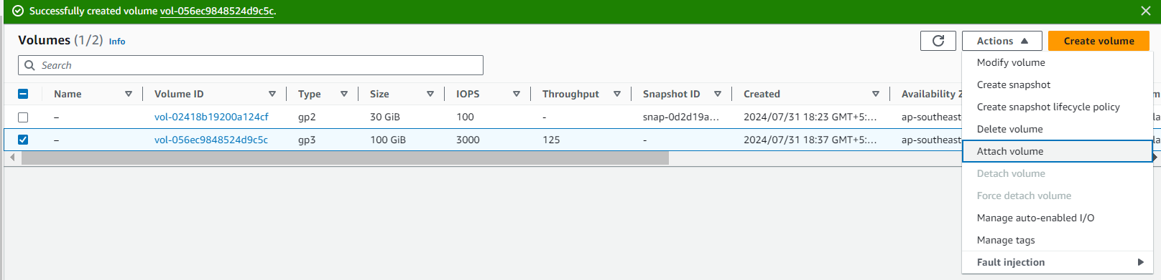

9. **Attach the EBS Volume to an EC2 Instance:**

* **Select the Volume:**
  + After creating the volume, go to the **Volumes** section in the EC2 Dashboard.
  + Select the volume you created.
* **Attach Volume:**
  + Click on **Actions** and select **Attach Volume**.
  + In the dialog box, select the instance you want to attach the volume to from the dropdown menu.
  + Specify the device name (Windows will typically use something like /dev/sdf or similar).
  + Click **Attach**.

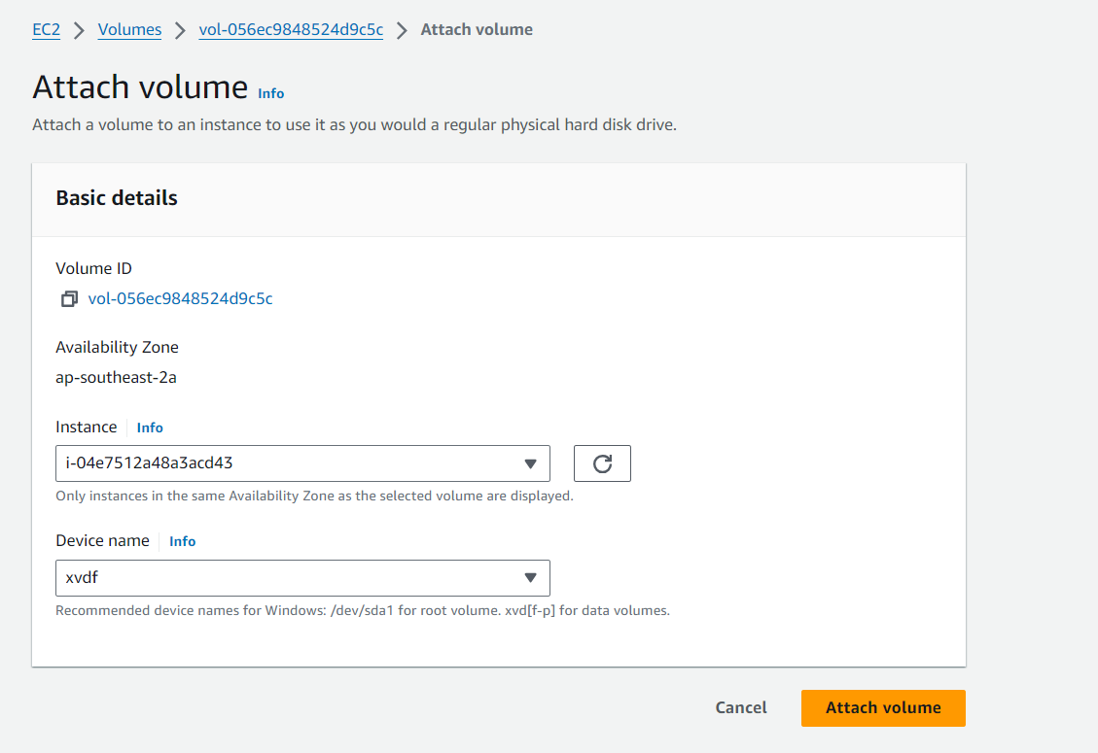

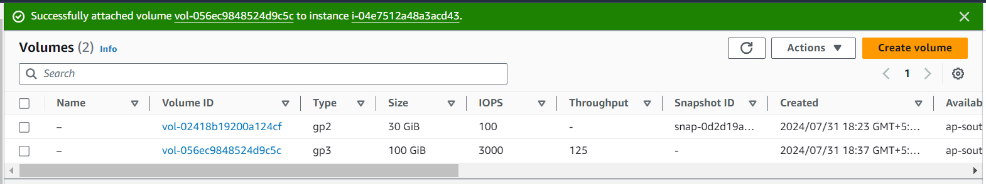

9. **Initialize and Format the New Volume in Windows:**

* **Open Disk Management:**
  + Once logged into the Windows instance, right-click on the **Start Menu** and select **Disk Management**.
  + Alternatively, you can open it by typing **diskmgmt.msc** in the Run dialog (Win + R).
* **Initialize Disk:**
  + You should see the new EBS volume as an unallocated disk in Disk Management.
  + A prompt might automatically ask you to initialize the disk. If not, right-click on the new disk and select **Initialize Disk**.
  + Choose the partition style (MBR or GPT).
* **Create a New Volume:**
  + Right-click on the unallocated space and select **New Simple Volume**.
  + Follow the wizard to create a new volume. Assign a drive letter, and format the volume (usually with NTFS).
* **Complete the Wizard:**
  + Finish the wizard, and the new EBS volume should now be available as a drive in your Windows instance.

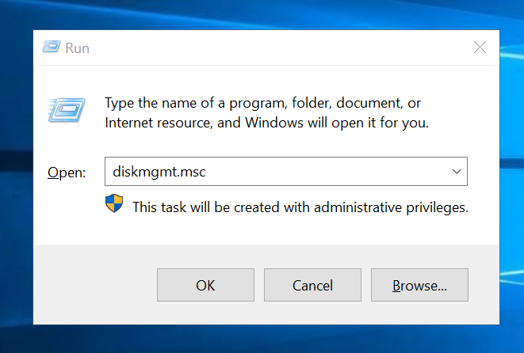

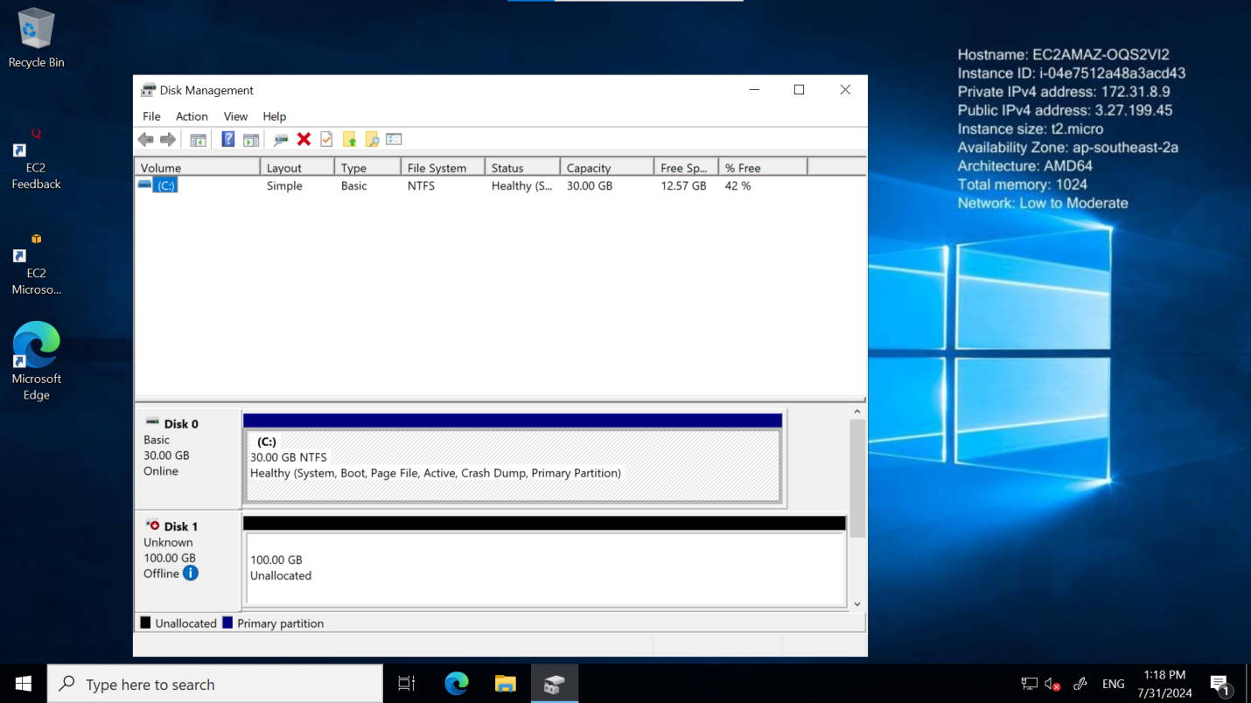

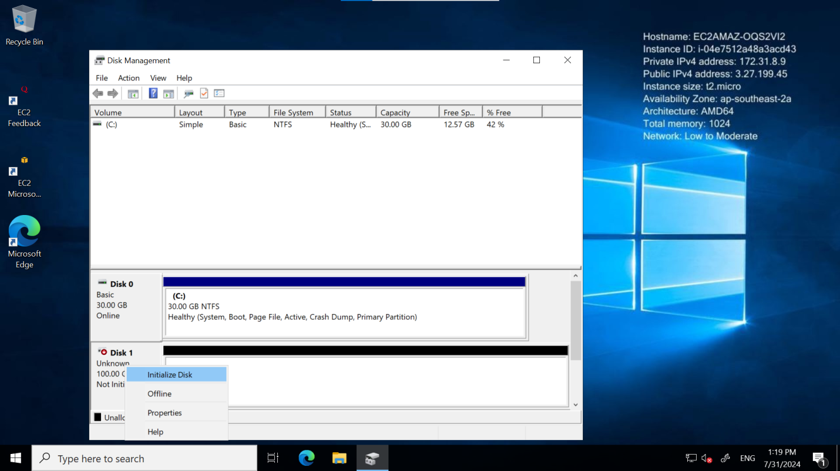

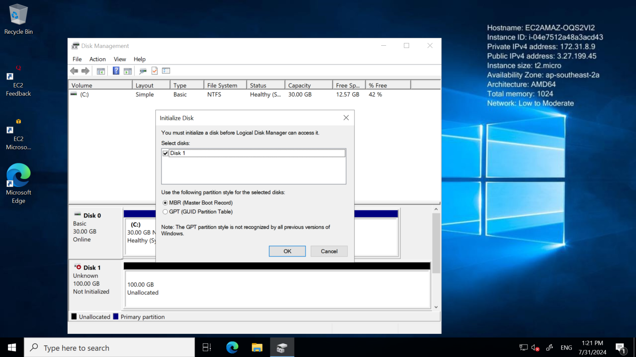

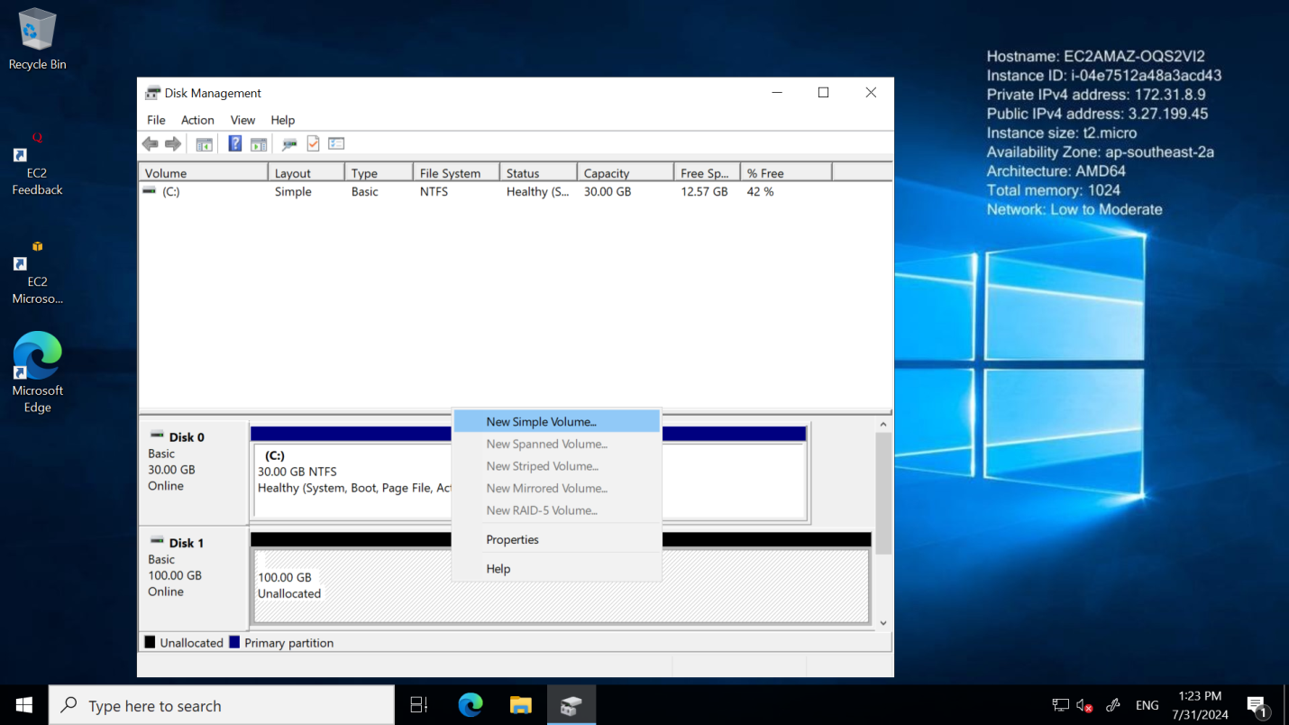

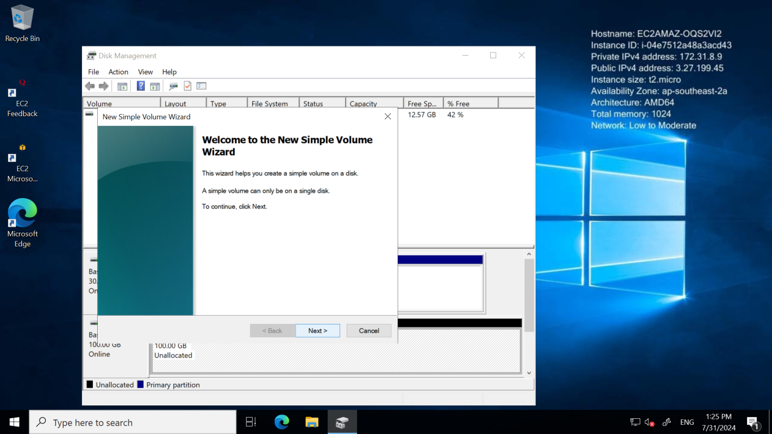

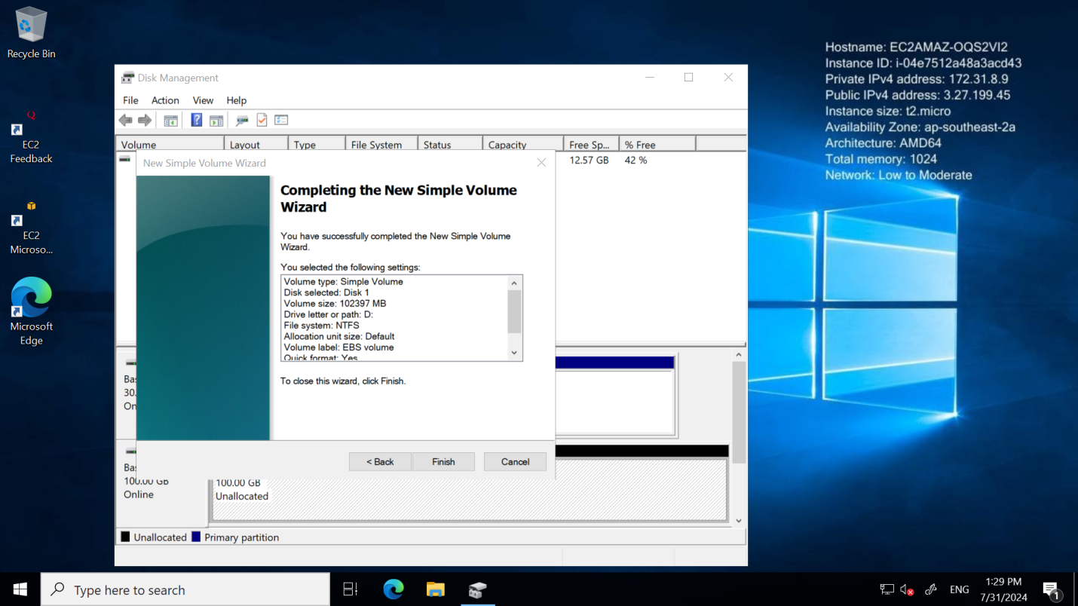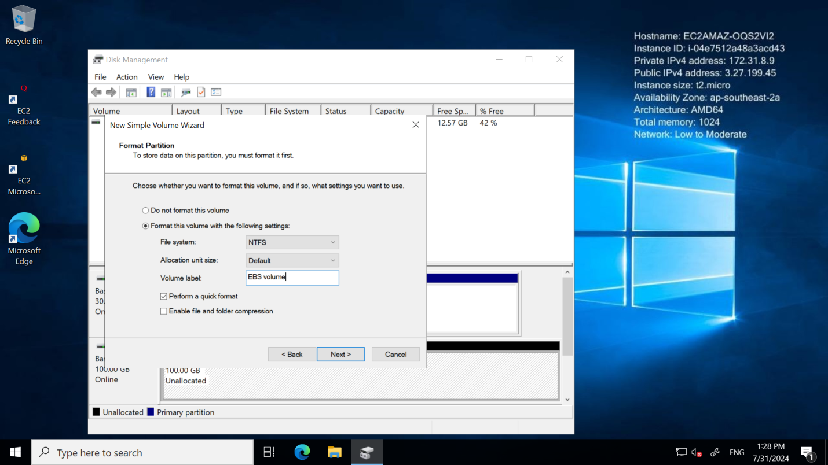

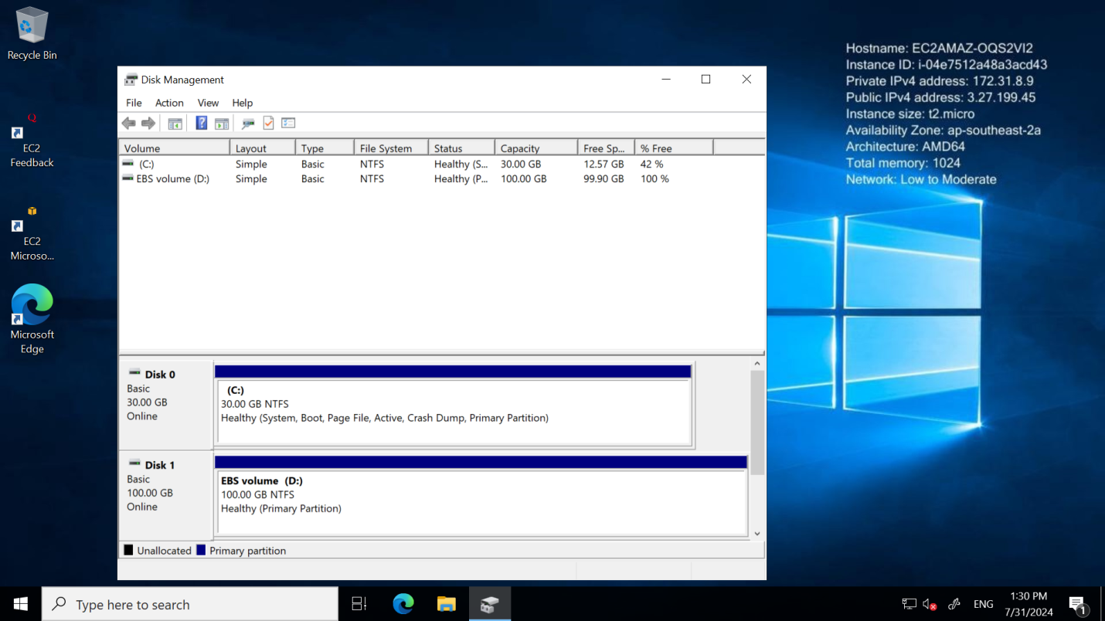

10.**Open File Explorer:**

* + Verify that the new drive is accessible and has the correct size and format.

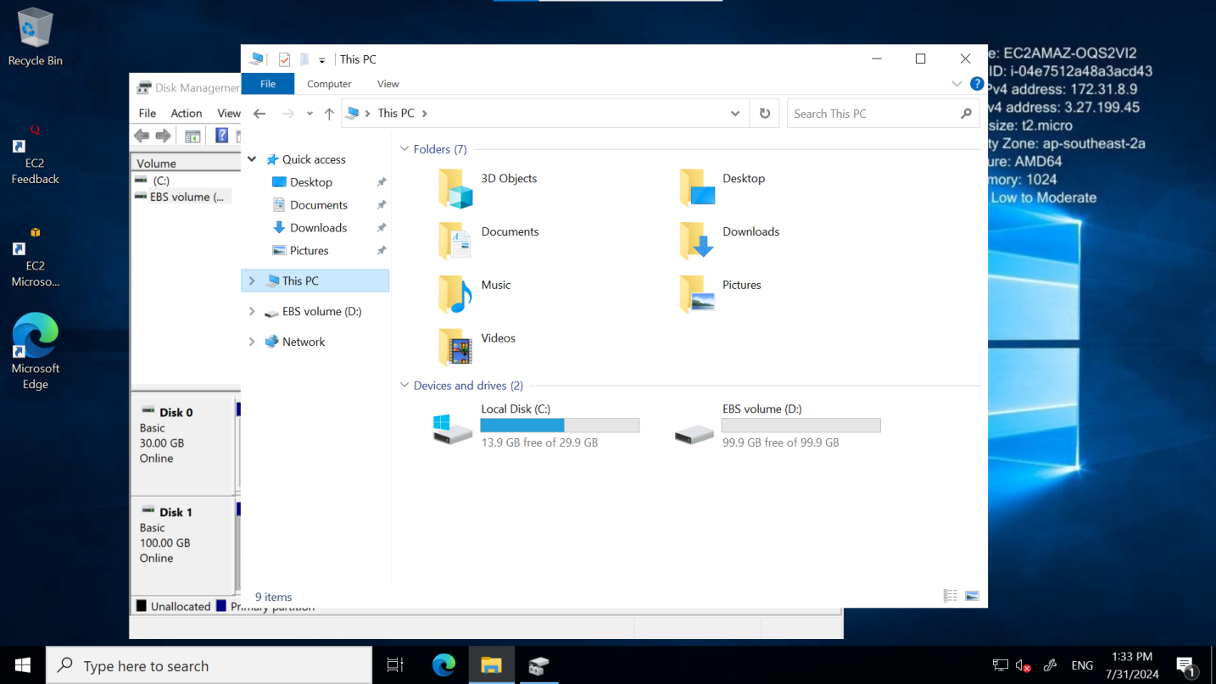

**Result:**

Successfully attached an EBS volume to the Amazon EC2 instance, initialized the disk in Windows, and formatted it as NTFS. The new volume is now available and ready for use in File Explorer.

**3. Hosting a Web Application in the Cloud**

**Aim:**

To host a web application in the cloud.

**STEPS:**

Step 1: Launch an EC2 Instance

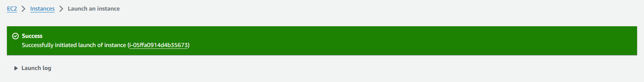

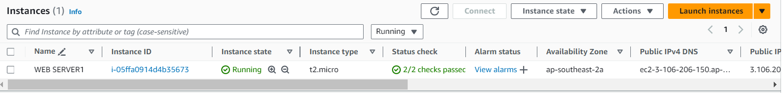

### Step 2: Connect to Your Windows EC2 Instance

1. **Open RDP Client:**

* On your local computer, open the Remote Desktop Protocol (RDP) client. This is typically called "Remote Desktop Connection" on Windows.

1. **Enter Connection Details:**

* Enter the public DNS or IP address of your Windows EC2 instance. This information is available in the AWS Management Console under the instance details.

1. **Log In:**

* Use the username (usually Administrator for Windows instances) and the password you set up when you launched the instance.
* Click "Connect" to log in to the Windows server.

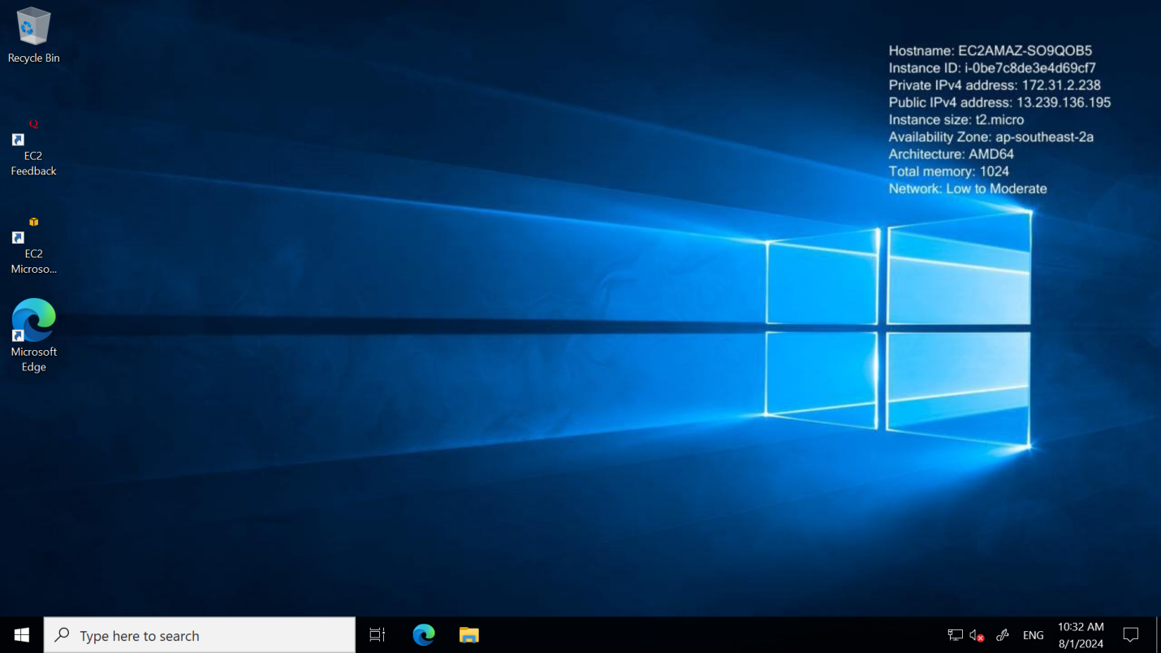

### Step 3: Set Up IIS (Internet Information Services)

1. **Install IIS:**
   * Open the Server Manager.
   * Navigate to Add Roles and Features.
     + Click "Add roles and features".
     + In the wizard, select "Role-based or feature-based installation".
     + Choose your instance (local server) from the server pool.
     + In the "Server Roles" section, check "Web Server (IIS)".
     + Add any required features and proceed through the wizard.
     + Install IIS and any desired features (e.g., management tools).
2. **Verify IIS Installation:**
   * After installation, open a browser on the server and navigate to http://localhost. You should see the default IIS welcome page.

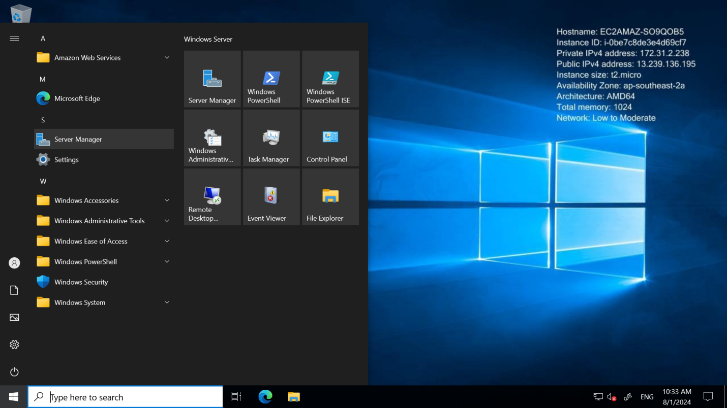

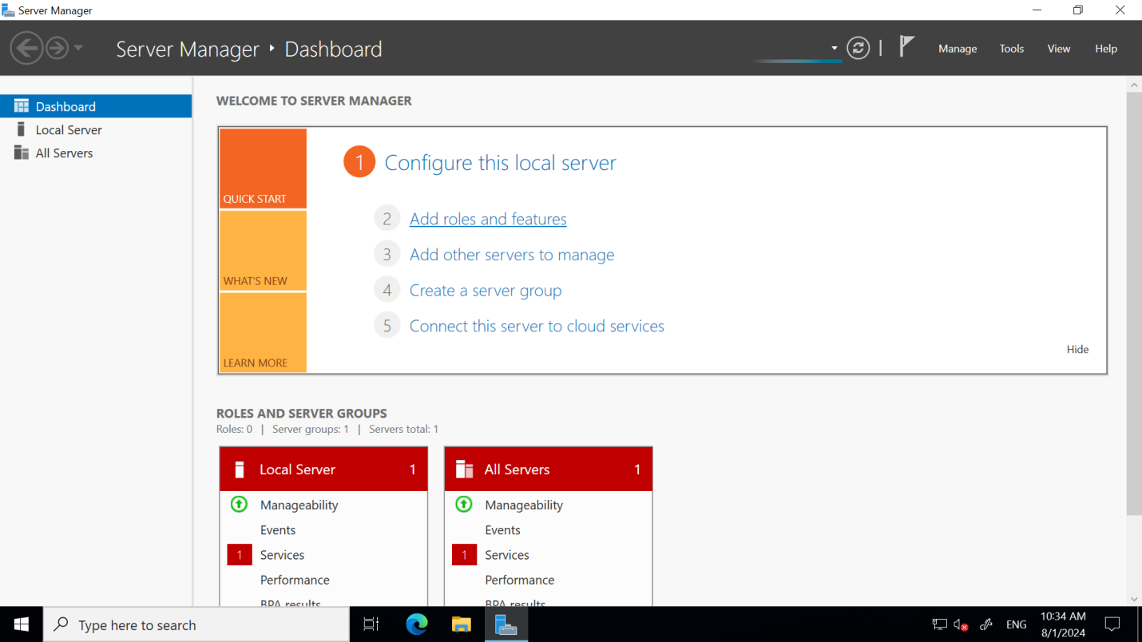

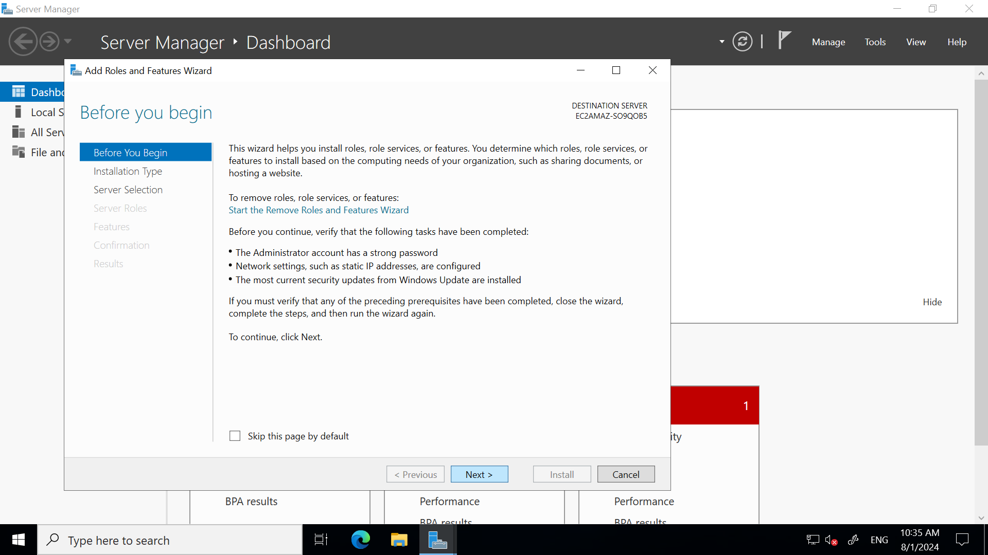

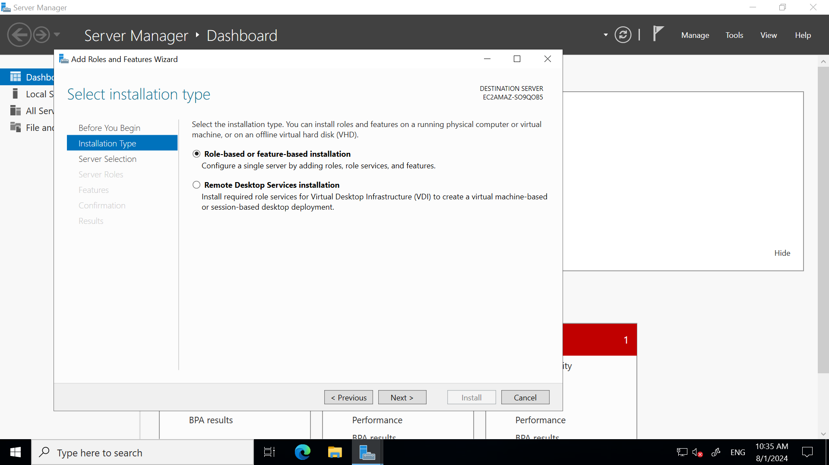

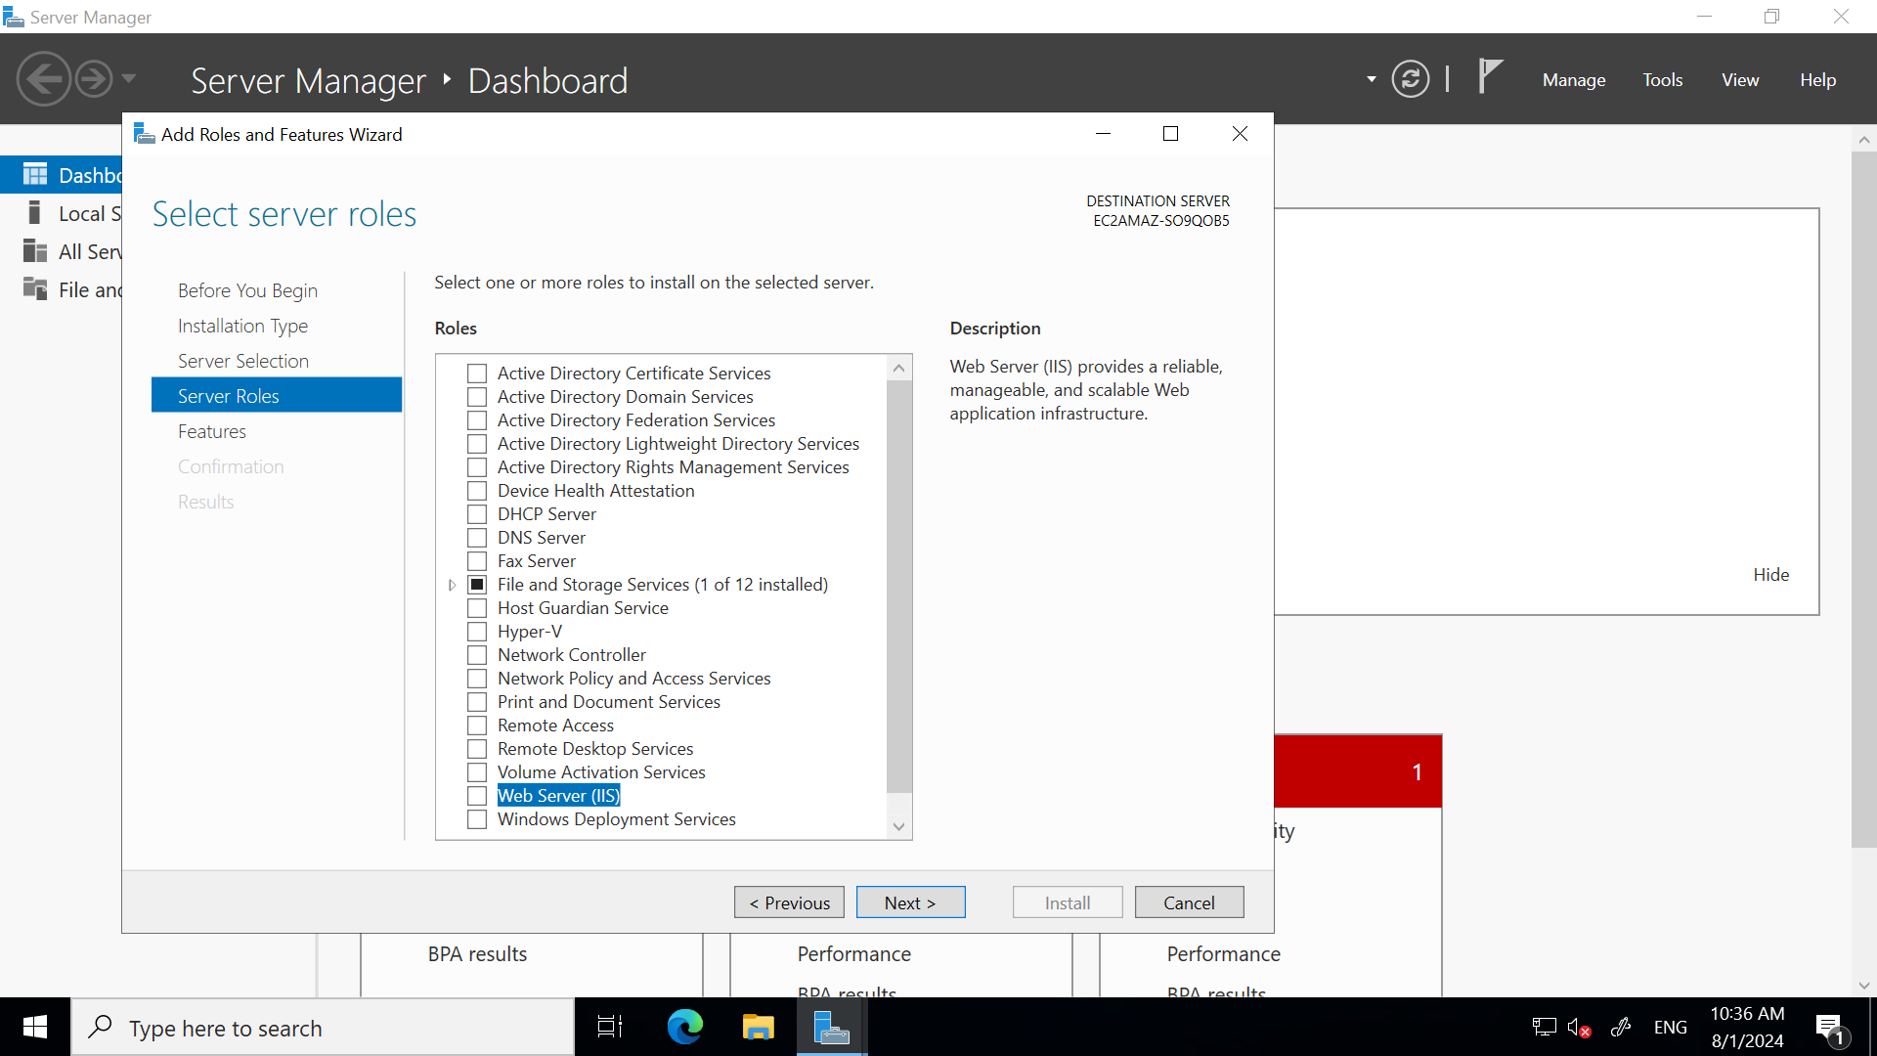

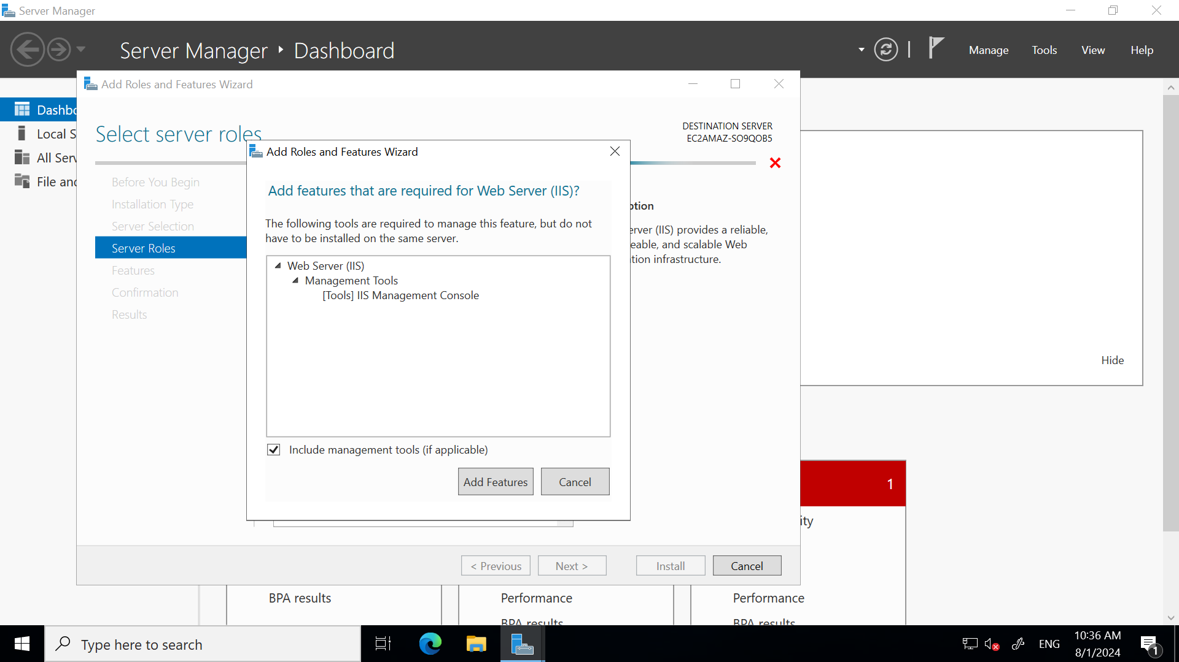

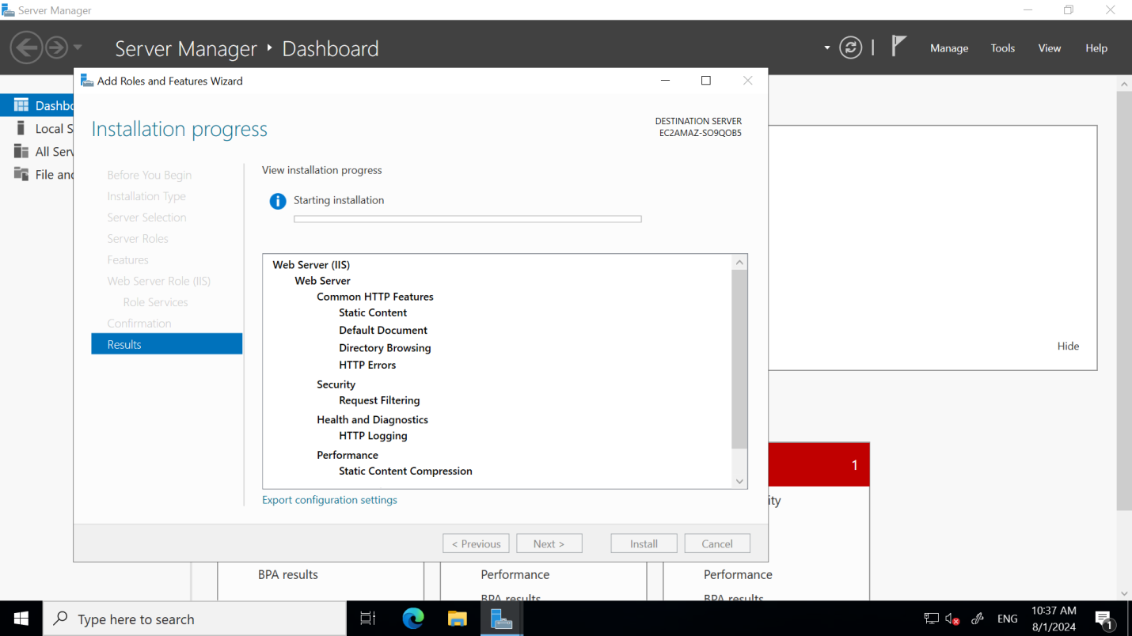

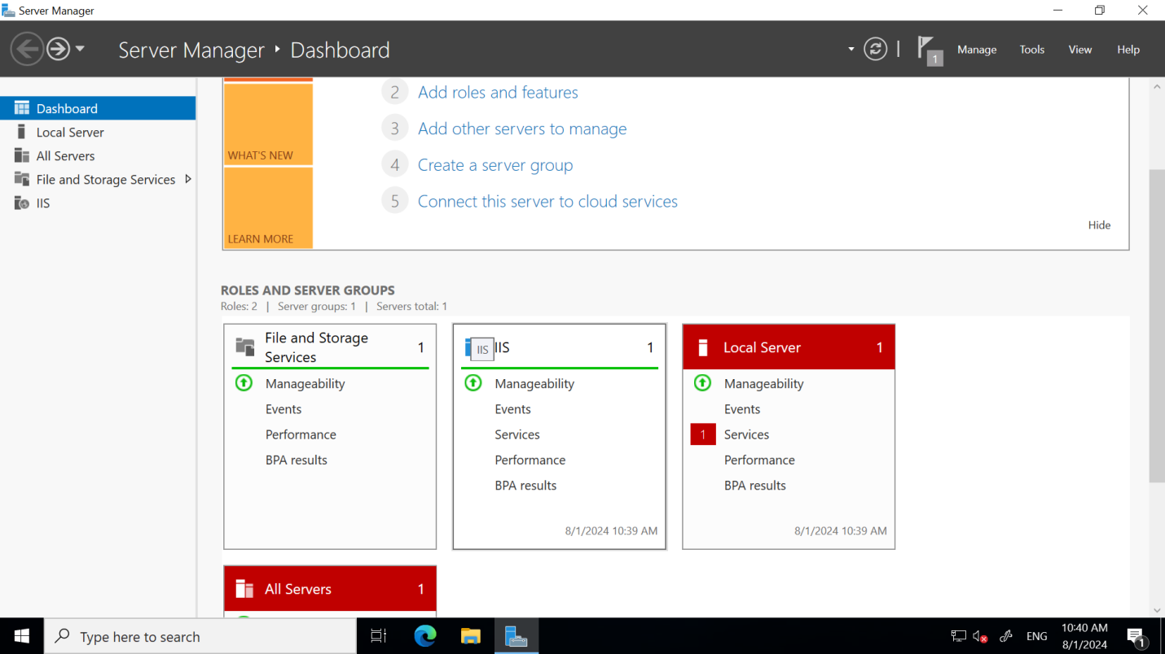

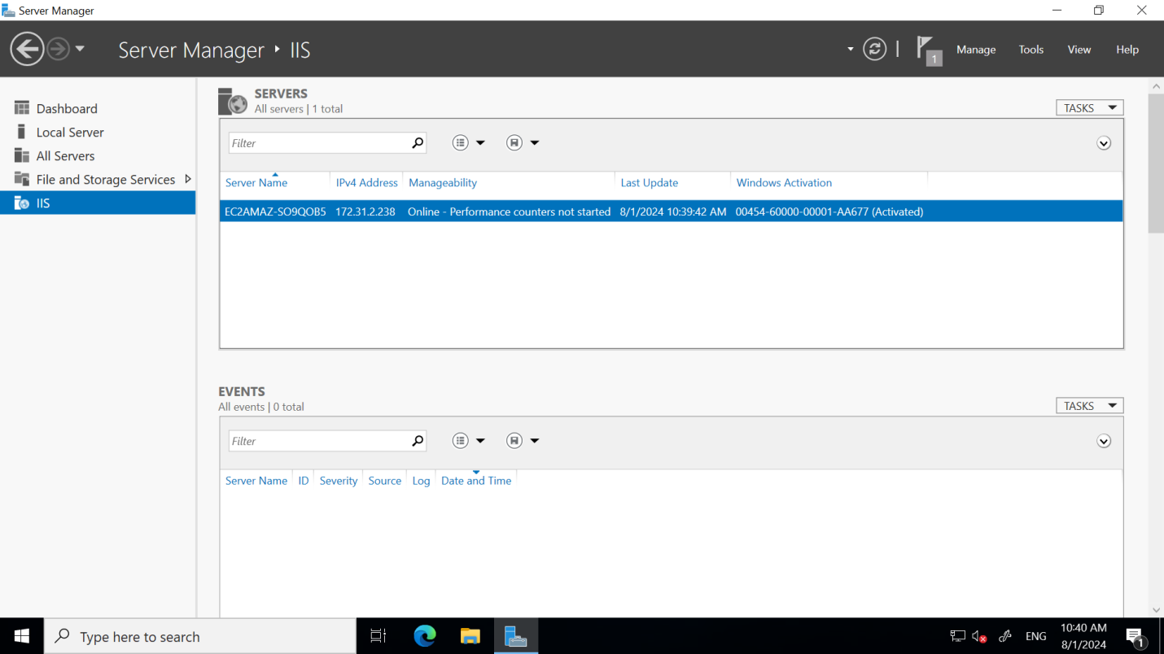

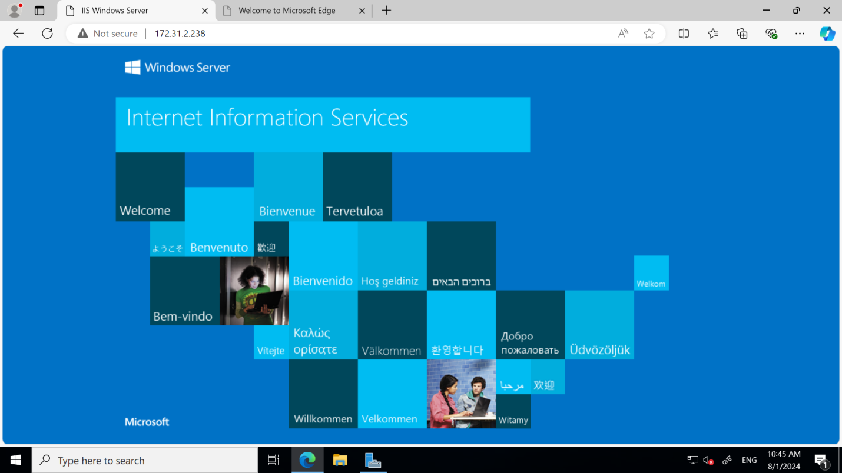

### Step 4: Deploy Your Web Page

1. **Place your web files:**
   * By default, IIS serves files from C:\inetpub\wwwroot.
   * Upload your HTML, CSS, JavaScript, and other web files to this directory.
2. **Configure IIS (if needed):**
   * Open the IIS Manager from the Start menu.
   * Explore the settings to manage your website (e.g., bindings, authentication).

### Step 5: Test Your Website

1. **Access your website:**
   * Open a web browser and enter your instance's public IP address.

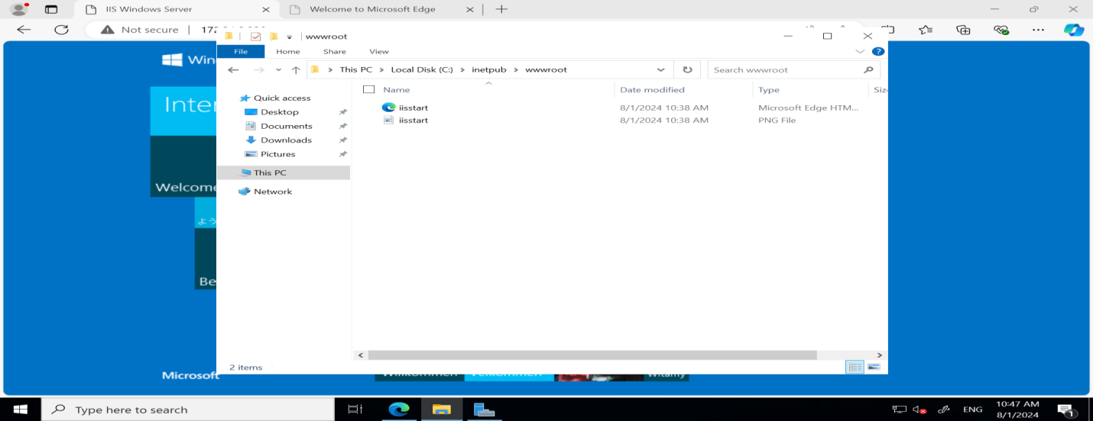

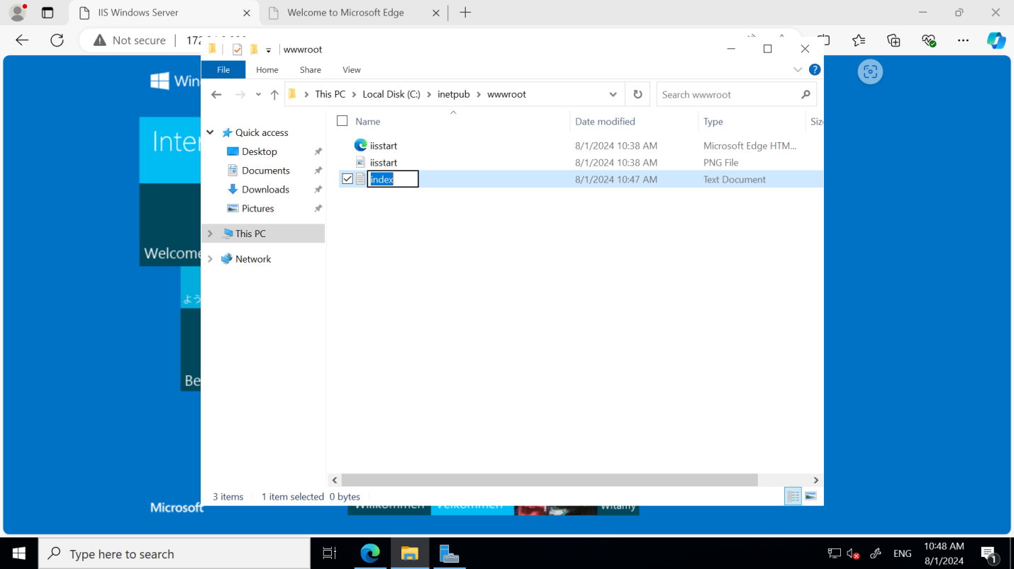



**RESULT:**

The web page is successfully hosted in the cloud and is accessible via the server's public IP address, confirming the deployment was successful.

**4. Attaching additional virtual servers to exisiting application**

**AIM:**

Attaching additional virtual servers to exisiting application.

**STEPS:**

**Step 1: Create an Instance or Select an Existing Instance**

1. **Access the Instance Management Service:**
   * Navigate to the instance management service of your cloud provider (e.g., EC2 in AWS, Compute Engine in Google Cloud, or Virtual Machines in Azure).
2. **Option 1: Select an Existing Instance**
   * **Locate Your Instance:** Browse the list of instances in your account.
   * **Filter by VPC:** Apply a filter to show only the instances that are already associated with the specific VPC you are working with.
   * **Select the Instance:** Click on the instance you want to use. Ensure it meets the requirements for your application.
3. **Option 2: Create a New Instance**
   * **Launch a New Instance:** Click on the "Launch Instance" or "Create" button to start the process of creating a new instance.
   * **Choose Instance Type:** Select the type of instance based on your computing needs (e.g., general-purpose, memory-optimized).
   * **Configure VPC Settings:**
     + **Select VPC:** Choose the VPC where this instance should be launched.
     + **Select Subnet:** Choose the appropriate subnet within the VPC.
     + **Assign IP Address:** Optionally, decide whether the instance should have a public IP address.
   * **Review and Launch:** After configuring the instance settings, review your selections and click "Launch" to create the instance.

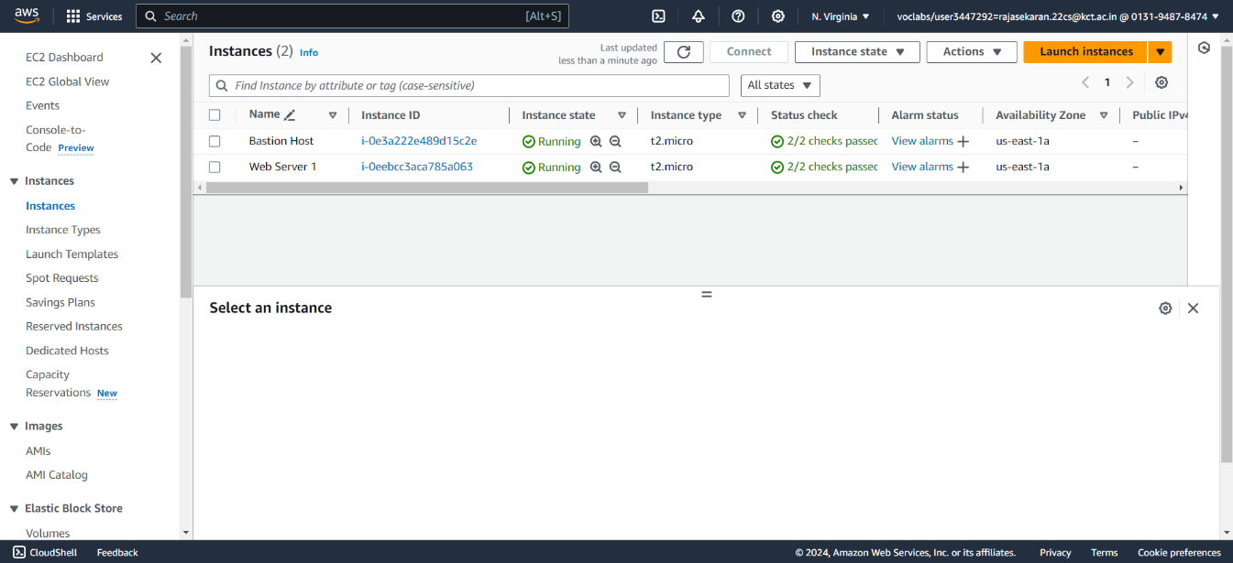

**Step 2: Create an Image from an Instance**

1. **Access Instance Management:** Navigate to your cloud provider’s instance management service.
2. **Select the Instance:** Locate and select the instance you want to create an image from.
3. **Open Actions Menu:** Click on the "Actions" button, then go to "Image and templates."
4. **Create Image:** Select "Create image."
5. **Configure Image:**
   * Enter a name and description.
   * Choose whether to disable reboot (optional).
   * Adjust volume settings if needed.
6. **Create:** Click "Create Image" to start the process.
7. **Monitor:** Track progress in the "Images" section until the image is ready.

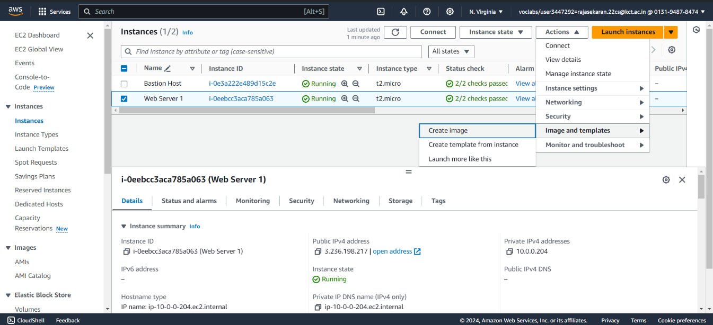

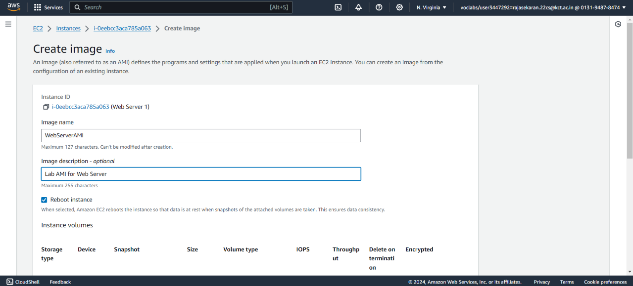

**Step 3: Create a Target Group**

1. **Navigate to the Target Groups Section:**
   * In your cloud provider's console, go to the section that manages load balancing services (e.g., EC2 for AWS, or similar in other platforms).
   * Look for the "Target Groups" option in the load balancing or networking menu.
2. **Open the Target Group Page:**
   * Click on "Target Groups" to view the existing target groups associated with your load balancer.
3. **Create a New Target Group:**
   * On the Target Groups page, click the "Create target group" button.
   * This will open the target group creation wizard, where you can configure the settings for your new target group.
4. **Configure the Target Group:**
   * **Target Type:** Choose whether the target group will direct traffic to instances, IP addresses, or a Lambda function.
   * **VPC:** Select the VPC where the targets reside.
   * **Protocol and Port:** Specify the protocol (e.g., HTTP, HTTPS) and port on which the load balancer will forward traffic to targets.
   * **Health Checks:** Configure health check settings to monitor the health of targets, including the protocol, path, and interval.
5. **Create and Review:**
   * After configuring all the necessary settings, click "Create" to finalize the target group.
   * Review the target group settings and confirm its creation.

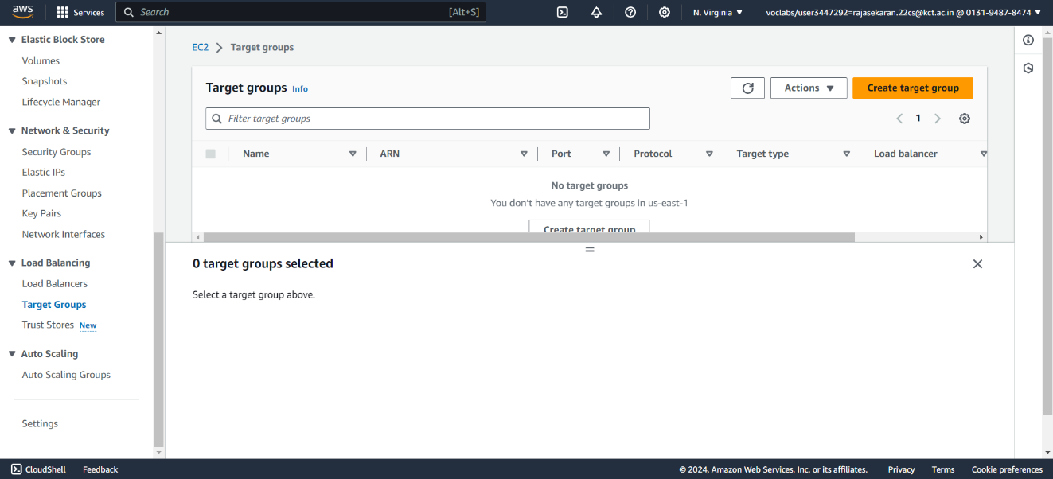

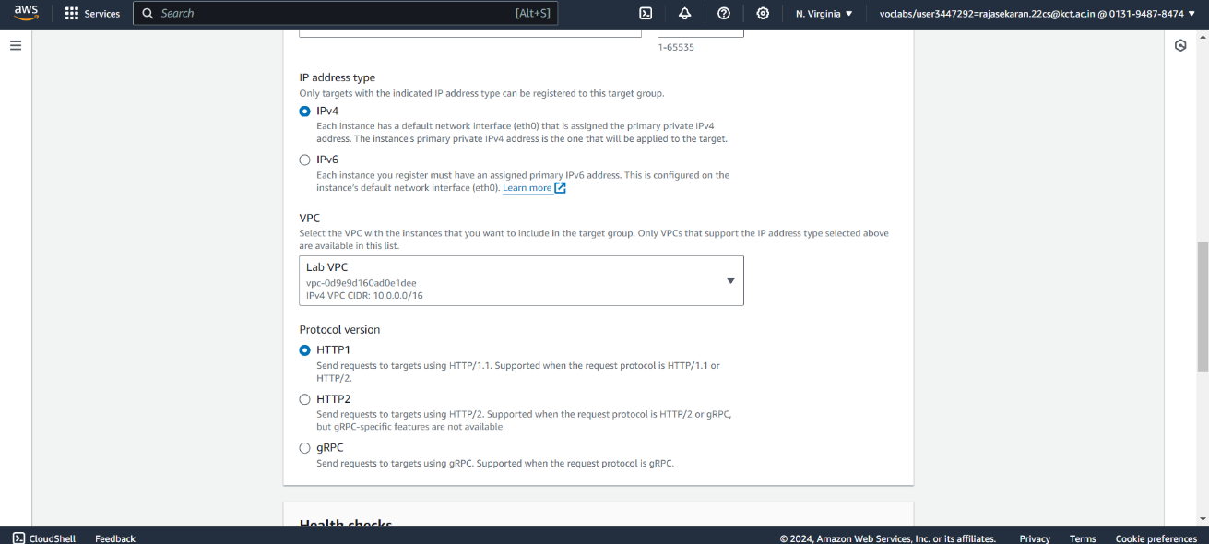

**Step 4: Create a Load Balancer**

1. **Navigate to Load Balancers:** Go to the Load Balancers section in your cloud provider's console.
2. **Create New Load Balancer:** Click on "Create load balancer."
3. **Select Load Balancer Type:** Choose the desired load balancer type (e.g., Application, Network, or Classic).
4. **Configure Settings:** Enter the name, select the VPC, set up listeners, and configure security groups.
5. **Review and Create:** Review your configurations and click "Create Load Balancer.

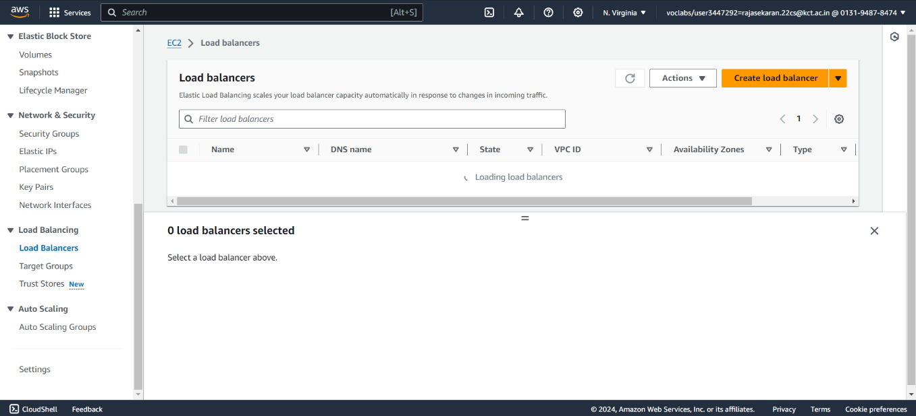

**Step 5: Create an Application Load Balancer**

1. **Go to Load Balancers Section:**
   * Navigate to the Load Balancers section in your cloud provider's console.
2. **Select Application Load Balancer:**
   * Click on "Create load balancer" and choose the "Application Load Balancer" option.
3. **Click on Create:**
   * Under the Application Load Balancer section, click the "Create" button to start the setup process.
4. **Configure Load Balancer:**
   * Enter the required details such as name, VPC, subnets, and listener settings.
5. **Review and Finalize:**
   * Review your settings and click "Create" to deploy the Application Load Balancer.

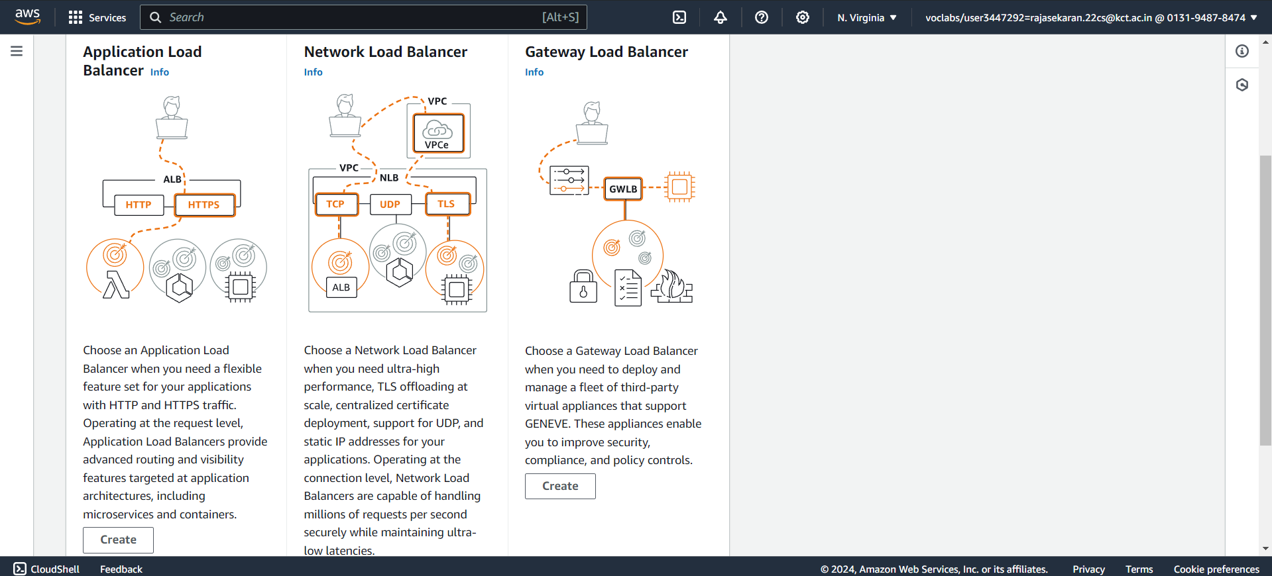

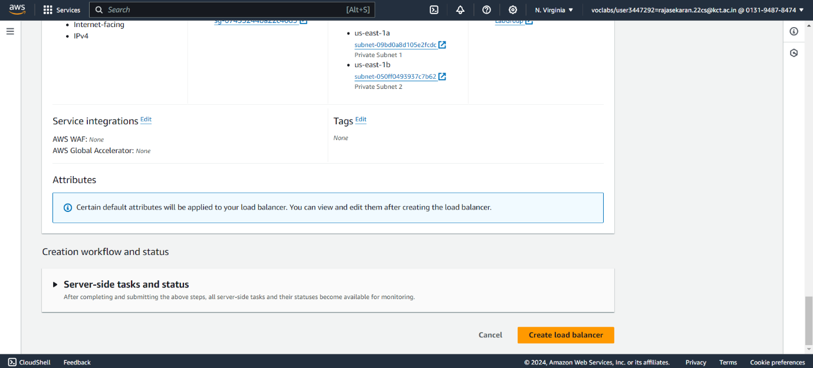

**Step 6:Create a Launch Template and an Auto Scaling Group**

1. **Navigate to Launch Templates:** Access the "Launch Templates" section in your cloud provider’s console.
2. **Create Launch Template:** Click "Create launch template."
3. **Configure Launch Template:** Set the template name, choose an AMI, select instance type, configure key pair and network settings.
4. **Review and Save:** Review the details and click "Create launch template."
5. **Navigate to Auto Scaling Groups:** Go to the "Auto Scaling Groups" section in the console.
6. **Create Auto Scaling Group:** Click "Create Auto Scaling group" and select the launch template created earlier.
7. **Configure Auto Scaling:** Set the VPC, subnets, capacity settings, scaling policies, review configurations, and click "Create Auto Scaling group.

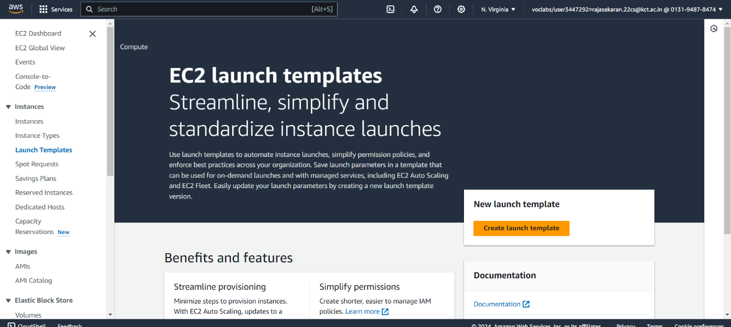

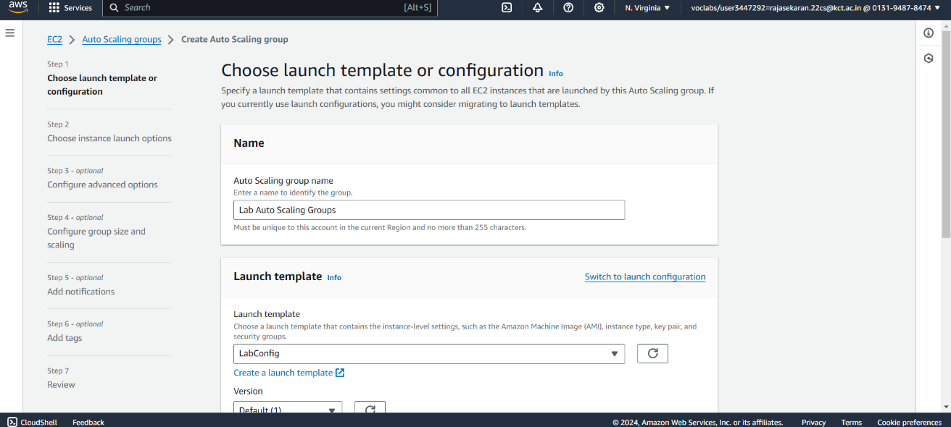

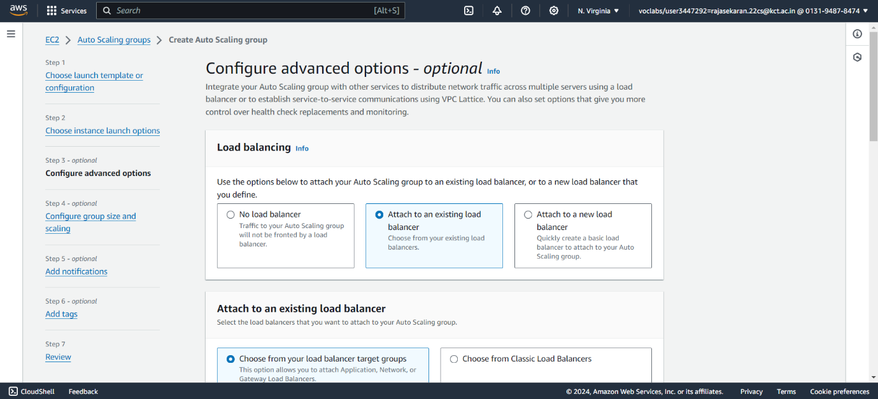

**Step 7:Verify that your Load Balancer is working**

1. **Check Load Balancer Status:**
   * Go to the Load Balancers section in your cloud provider’s console.
   * Ensure the status of your load balancer is “Active” or “Running.”
2. **Verify Health Checks:**
   * Check the health status of your registered targets (e.g., EC2 instances) under the "Target Groups" section.
   * Ensure that the health checks are passing and the targets are marked as healthy.
3. **Test Access to the Application:**
   * Use the DNS name or public IP address of the load balancer to access your application.
   * Open a web browser or use a tool like curl to ensure you can reach the application through the load balancer.
4. **Review Load Balancer Logs:**
   * Check the access logs (if enabled) for the load balancer to ensure it is routing traffic correctly.
   * Look for logs in the specified storage (e.g., Amazon S3 for AWS).
5. **Monitor Metrics:**
   * Review monitoring metrics and dashboards to check for metrics like request count, latency, and error rates.
   * Ensure these metrics indicate normal operation without high error rates or latency.
6. **Test Failover and Scaling:**
   * Simulate a failure of a target instance to ensure the load balancer properly routes traffic to healthy instances.
   * Verify that the auto-scaling group adjusts the number of instances based on the load.
7. **Check Security Group Rules:**
   * Ensure that the security groups attached to the load balancer and target instances allow the necessary traffic.

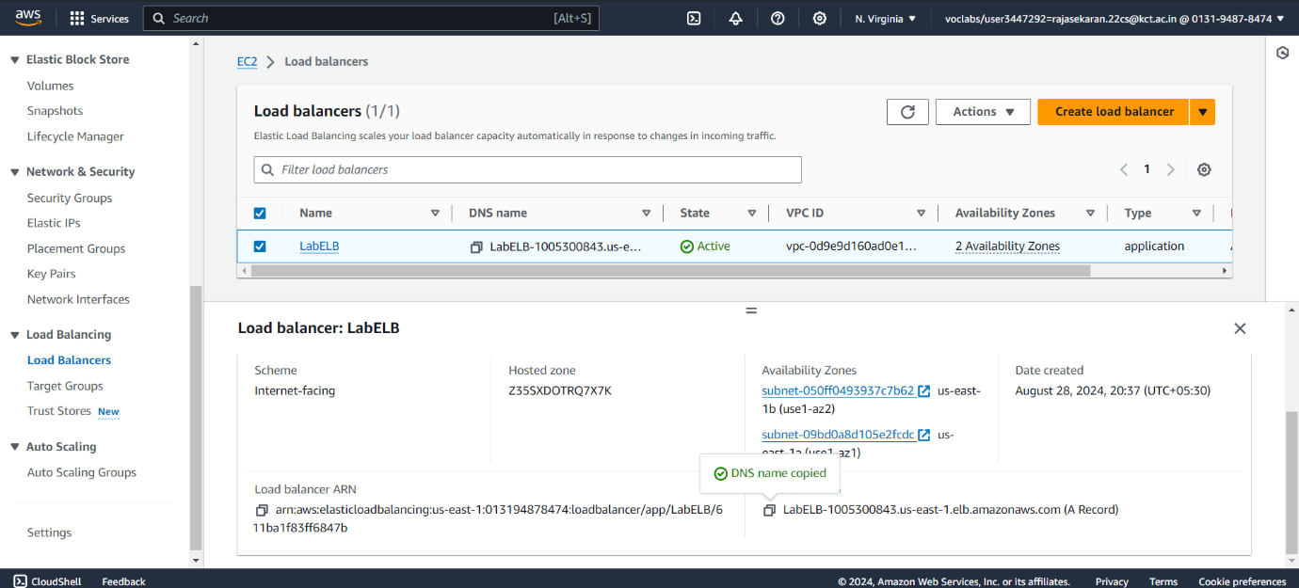

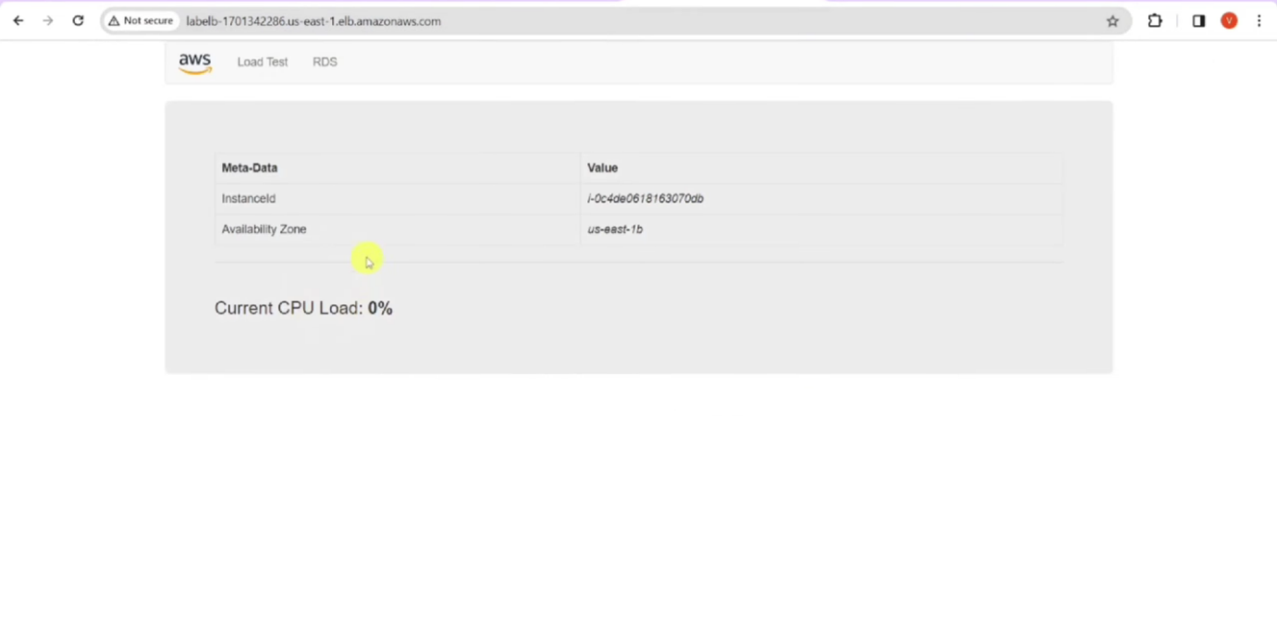

**RESULT:**

The experiment to implement load balancing has successfully demonstrated that the load balancer is active, correctly routes traffic, maintains healthy targets, and performs as expected under failover and scaling conditions.

## 5. CREATING STATIC WEBSITE

**AIM:**

To host a static website in Amazon S3.

**STEPS:**

# Step 1: Create a bucket

1. Sign in to the AWS Management Console and open the Amazon S3 console at <https://console.aws.amazon.com/s3/>.
2. Choose **Create bucket**.

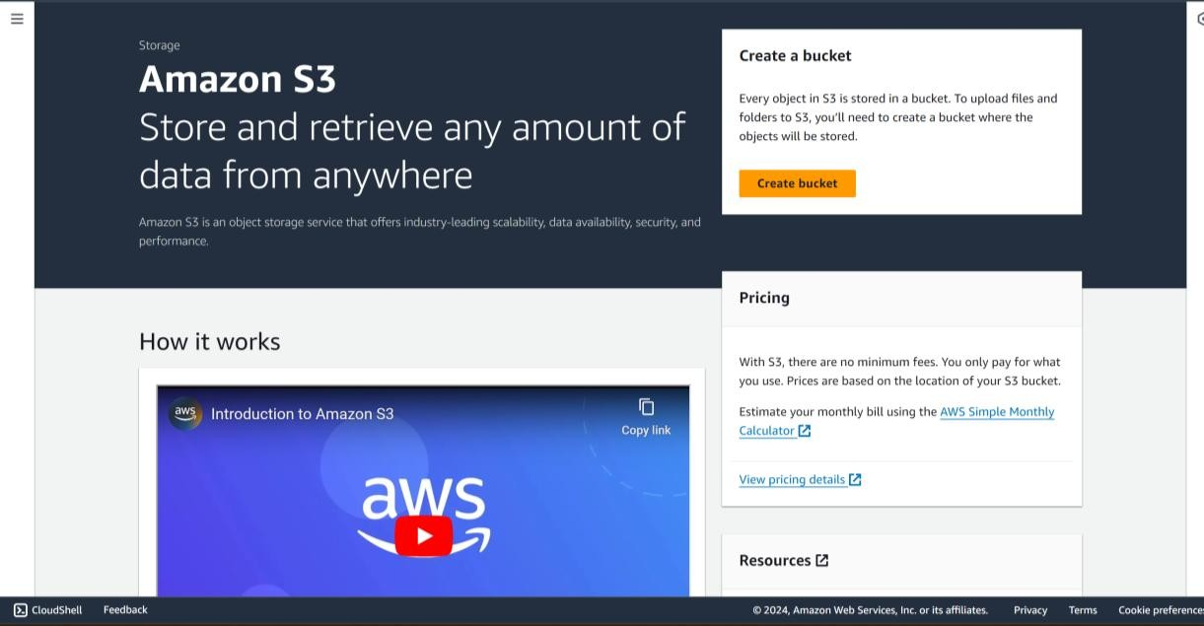

1. Enter the **Bucket name** (for example, **example.com**).

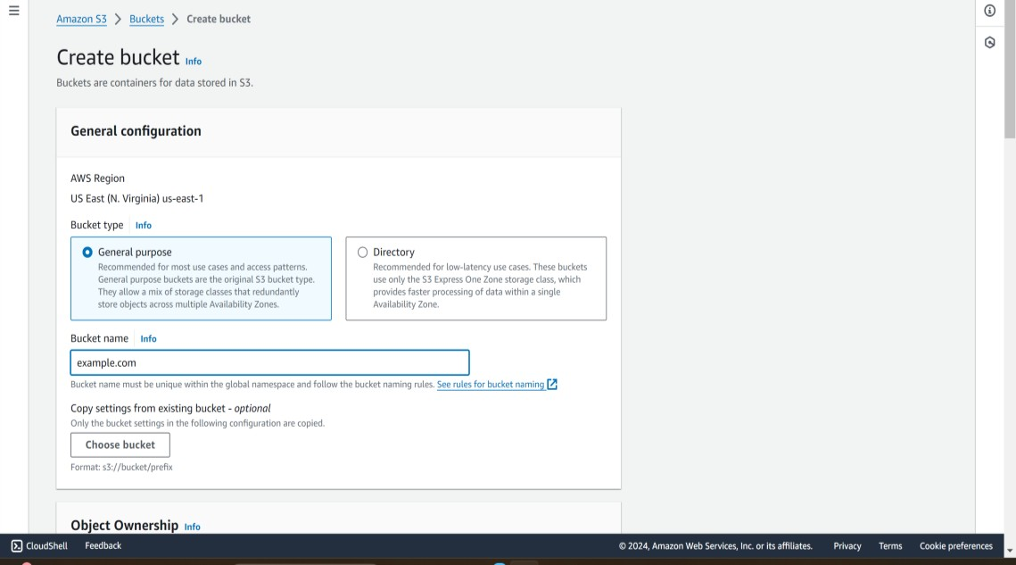

1. Choose the Region where you want to create the bucket.
2. To accept the default settings and create the bucket, choose **Create**.

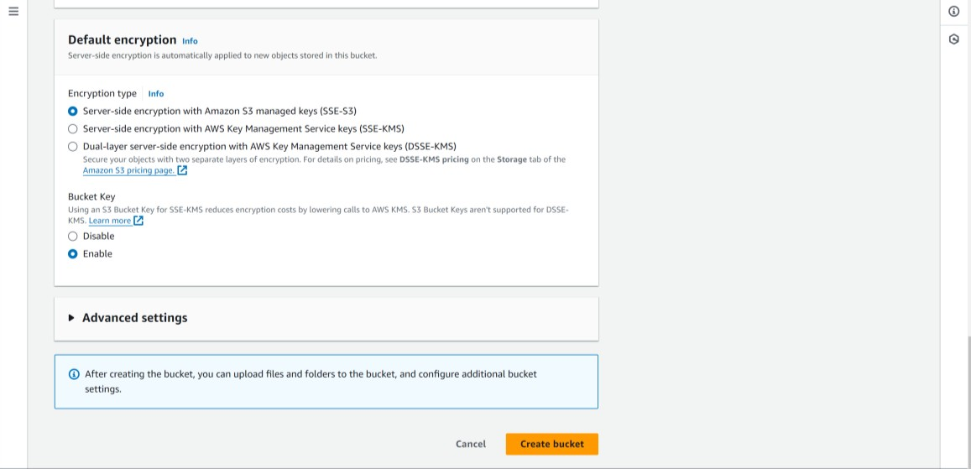

## Step 2: Enable static website hosting

1. Sign in to the AWS Management Console and open the Amazon S3 console at <https://console.aws.amazon.com/s3/>.
2. In the Buckets list, choose the name of the bucket that you want to enable static website hosting for.
3. 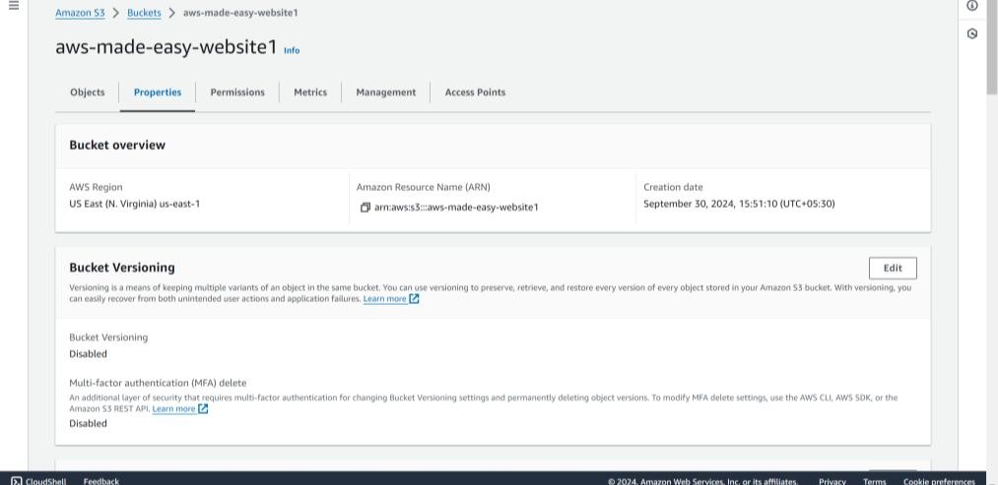Choose Properties
4. Under Static website hosting, choose Ed

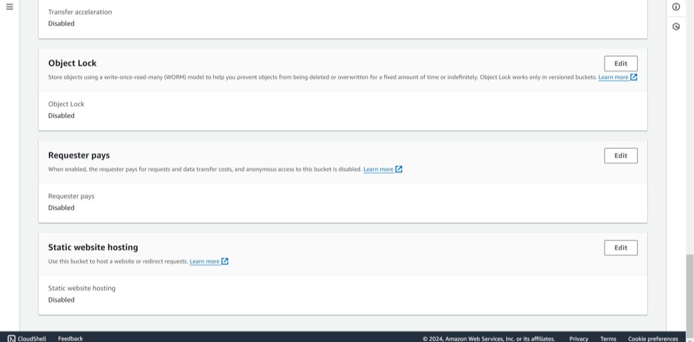

1. Choose Use this bucket to host a website.
2. Under Static website hosting, choose Enable.
3. In Index document, enter the file name of the index document, typically index.html.

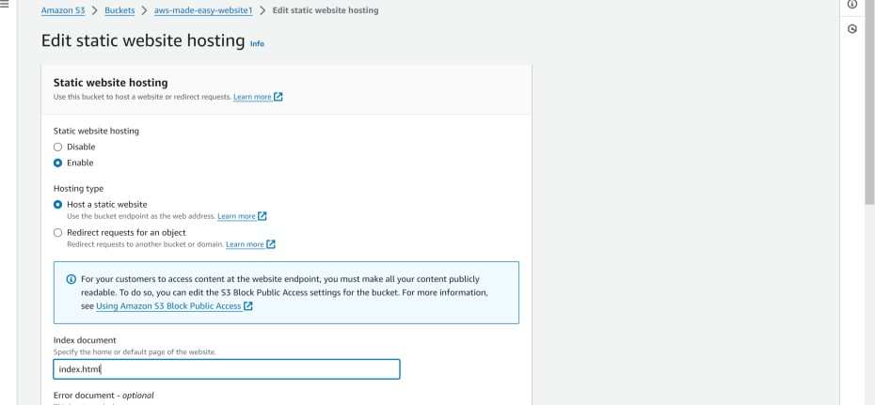

1. To provide your own custom error document for 4XX class errors, in Error document, enter the custom error document file name.
2. Choose Save changes.

Amazon S3 enables static website hosting for your bucket. At the bottom of the page, under Static website hosting, you see the website endpoint for your bucket.

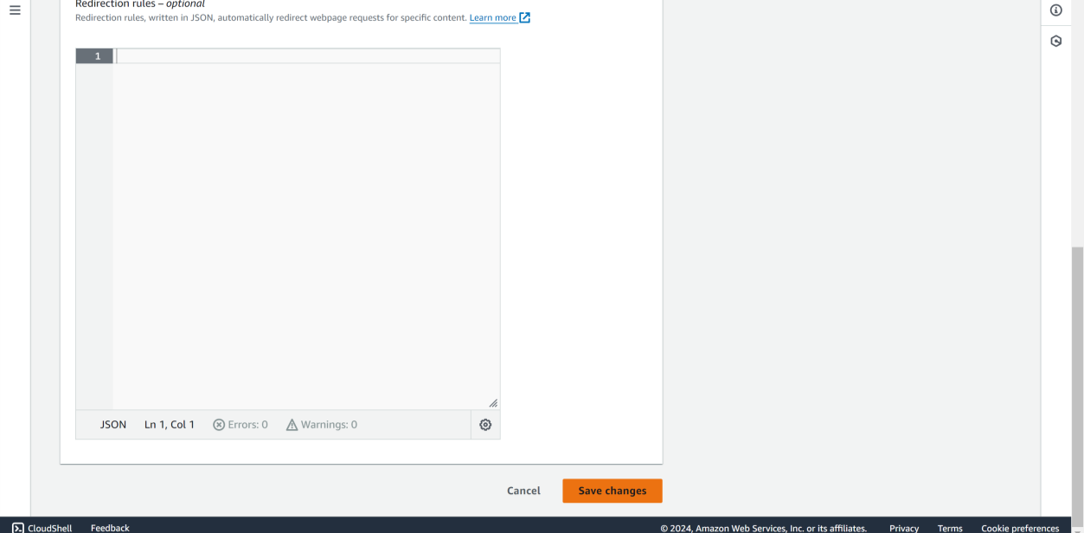

1. Under Static website hosting, note the Endpoint.

The Endpoint is the Amazon S3 website endpoint for your bucket. After you finish configuring your bucket as a static website, you can use this endpoint to test your website.

# Step 3: Edit Block Public Access settings

1. Open the Amazon S3 consoleat <https://console.aws.amazon.com/s3/>.
2. Choose the name of the bucket that you have configured as a static website.
3. Choose Permissions.
4. Under Block public access (bucket settings), choose Edit.
5. Clear Block *all* public access, and choose Save changes.

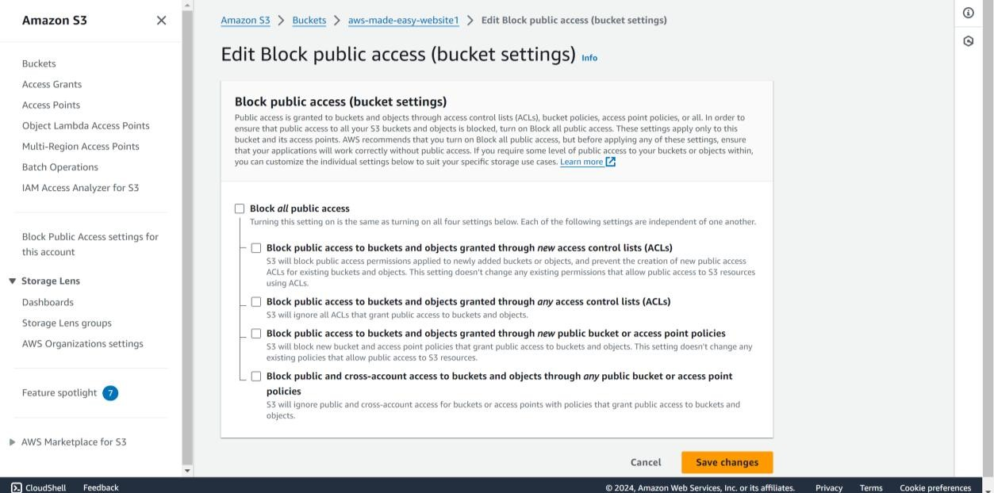

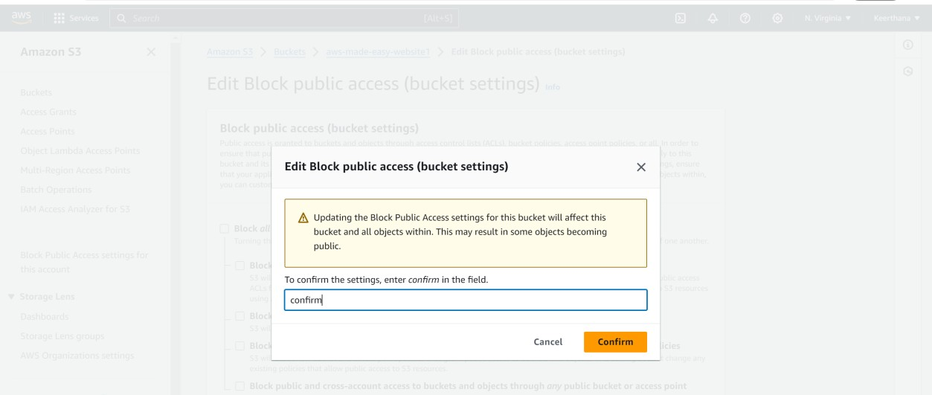

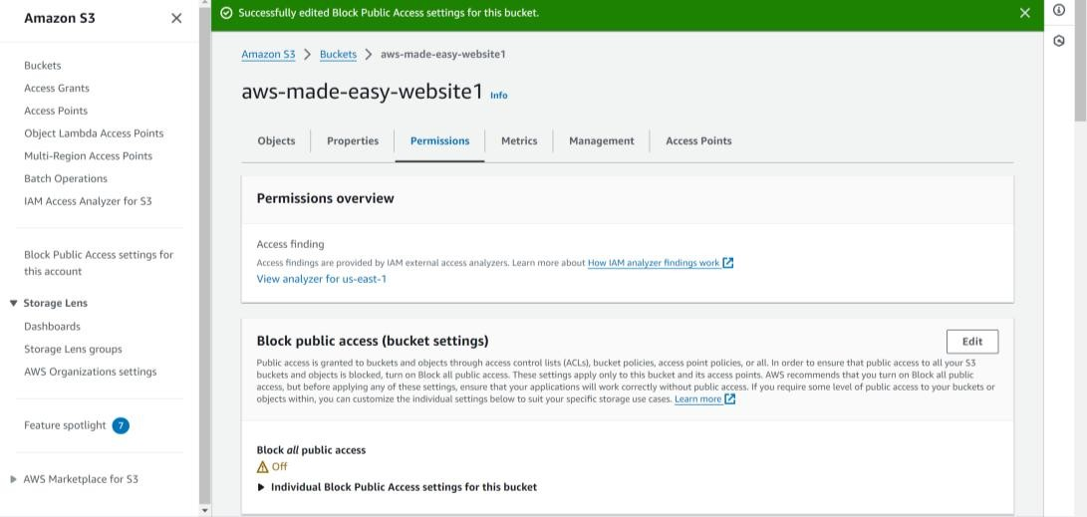

# Step 4: Add a bucket policy that makes your bucket content publicly available

1. Under Buckets, choose the name of your bucket.
2. Choose Permissions.
3. Under Bucket Policy, choose Edit.
4. To grant public read access for your website, copy the following bucket policy, and paste it in the Bucket policy editor.

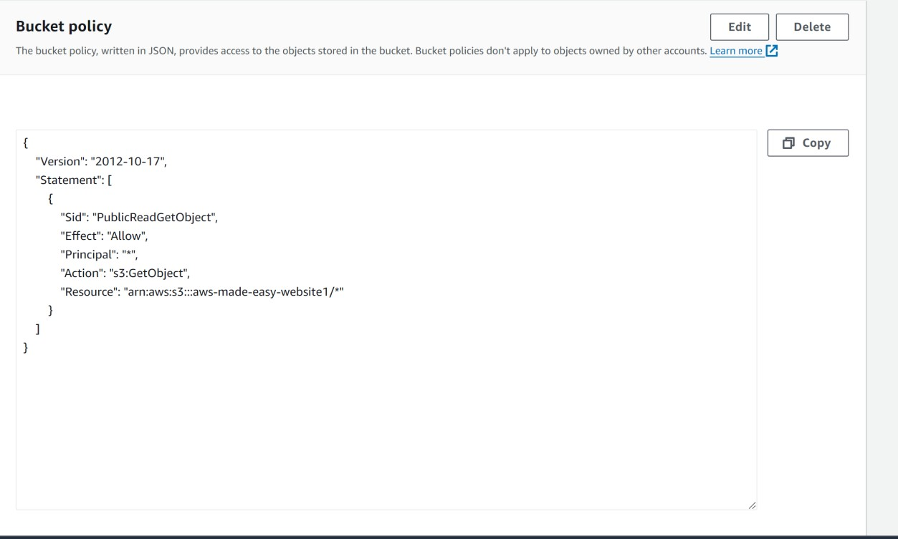

1. Update the Resource to your bucket name.

In the preceding example bucket policy, *Bucket-Name* is a placeholder for the bucket name. To use this bucket policy with your own bucket, you must update this name to match your bucket name.

1. Choose Save changes.

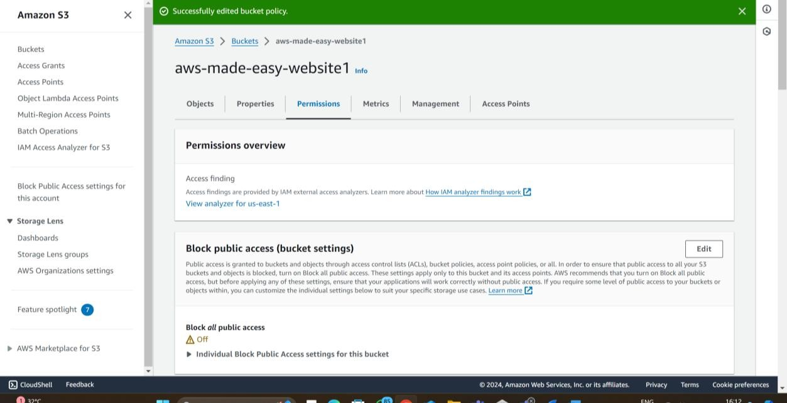

## STEP 5: CONFIGURE AN INDEX DOCUMENT:

1. Create an index.html file.
2. Sign in to the AWS Management Console and open the Amazon S3 console at <https://console.aws.amazon.com/s3/>.
3. In the **Buckets** list, choose the name of the bucket that you want to use to host a static website.
4. Enable static website hosting for your bucket, and enter the exact name of your index document (for example, index.html). For more information, see [Enabling](https://docs.aws.amazon.com/AmazonS3/latest/userguide/EnableWebsiteHosting.html) [website hosting](https://docs.aws.amazon.com/AmazonS3/latest/userguide/EnableWebsiteHosting.html).

After enabling static website hosting, proceed to step 6.

1. To upload the index document to your bucket, do one of the following:
   * Drag and drop the index file into the console bucket listing.
   * Choose **Upload**, and follow the prompts to choose and upload the index file.

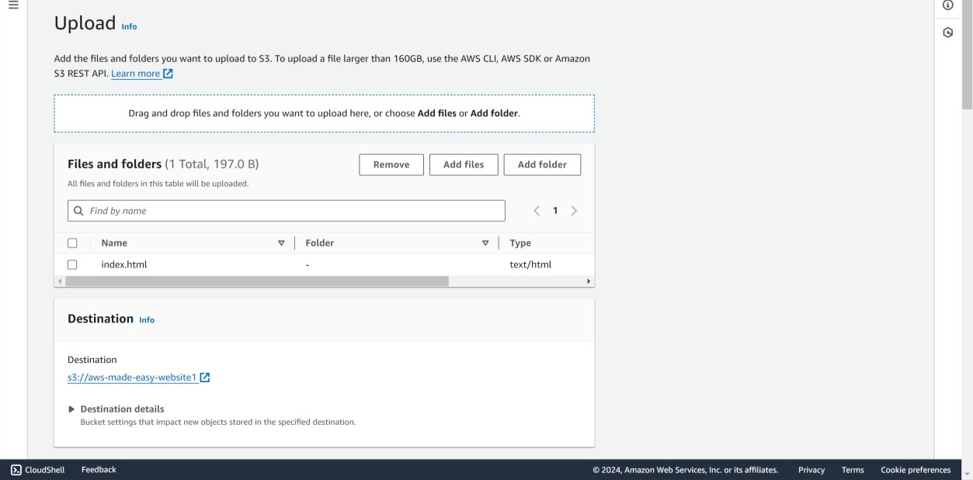

# Step 6: Configure an error document

1. Create an error document, for example 404.html.
2. Save the error document file locally.
3. In the **Buckets** list, choose the name of the bucket that you want to use to host a static website.
4. Enable static website hosting for your bucket, and enter the exact name of your error document (for example, 404.html). After enabling static website hosting, proceed to step 6.
5. To upload the error document to your bucket, do one of the following:
   * Drag and drop the error document file into the console bucket listing.
   * Choose **Upload**, and follow the prompts to choose and upload the index file.

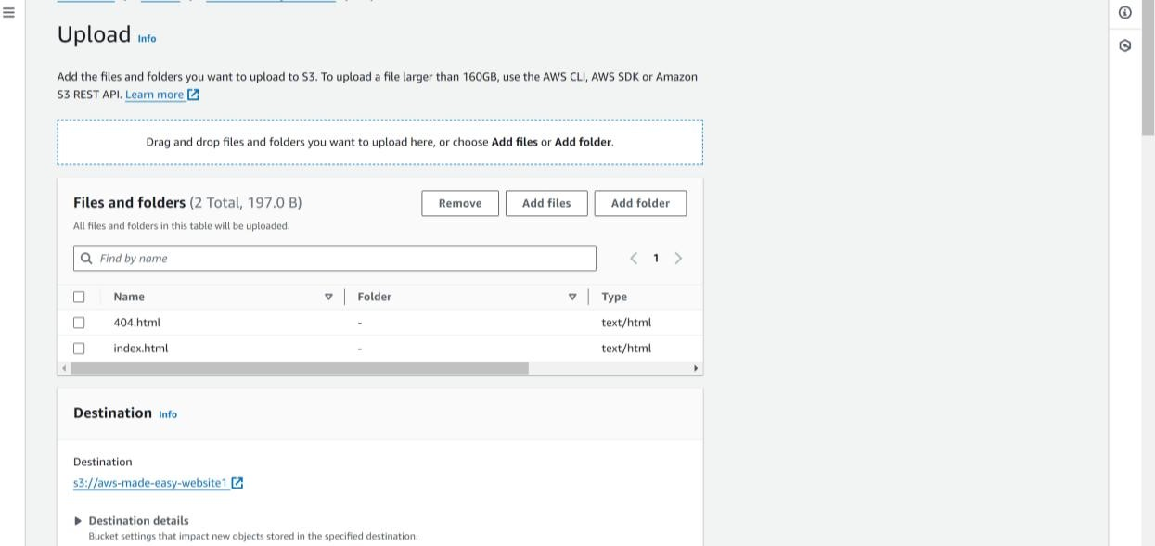

## Step 7: Test your website endpoint

1. Under **Buckets**, choose the name of your bucket.

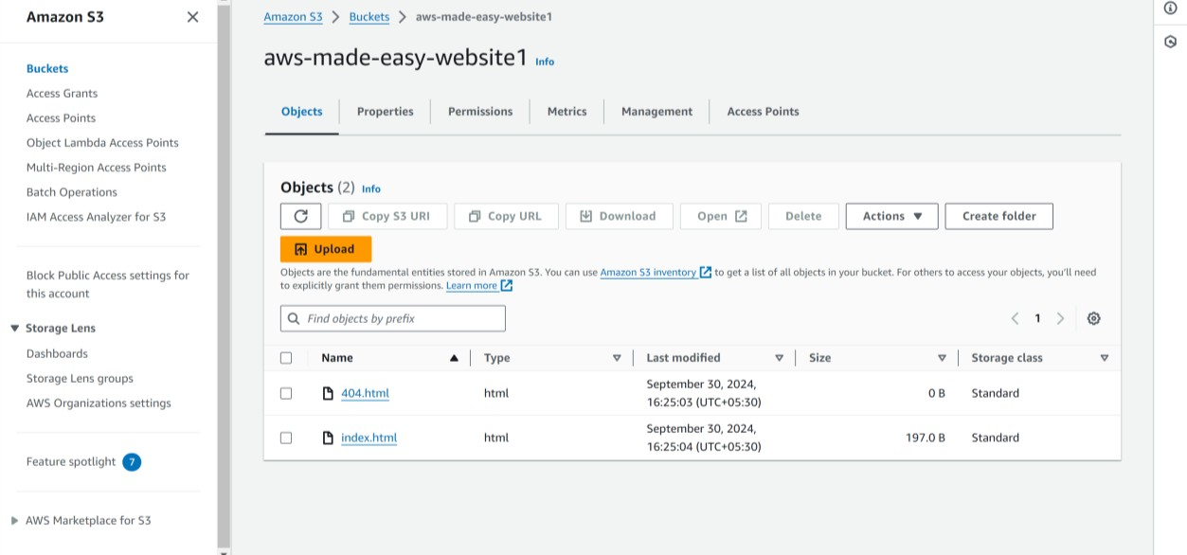

1. Choose **Properties**.
2. At the bottom of the page, under **Static website hosting**, choose your **Bucket website endpoint**.

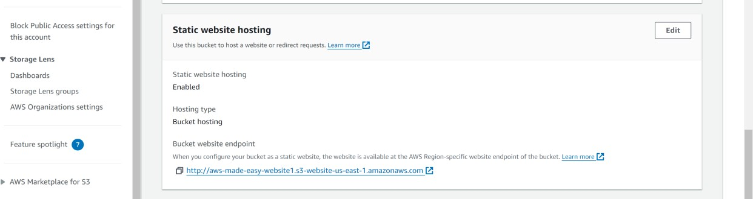

Your index document opens in a separate browser window.



## RESULT:

Thus the experiment to host a static website has been performed successfully.

6.VPC CREATION

AIM:

To create a VPC in AWS academy.

PROCEDURE

Step 1: Sign in to the AWS Management Console

* Open your web browser and go to the [AWS Management Console](https://aws.amazon.com/console/).

Step 2: Navigate to the VPC Dashboard

* In the AWS Management Console, locate and click on "VPC" under the "Networking & Content Delivery" section.

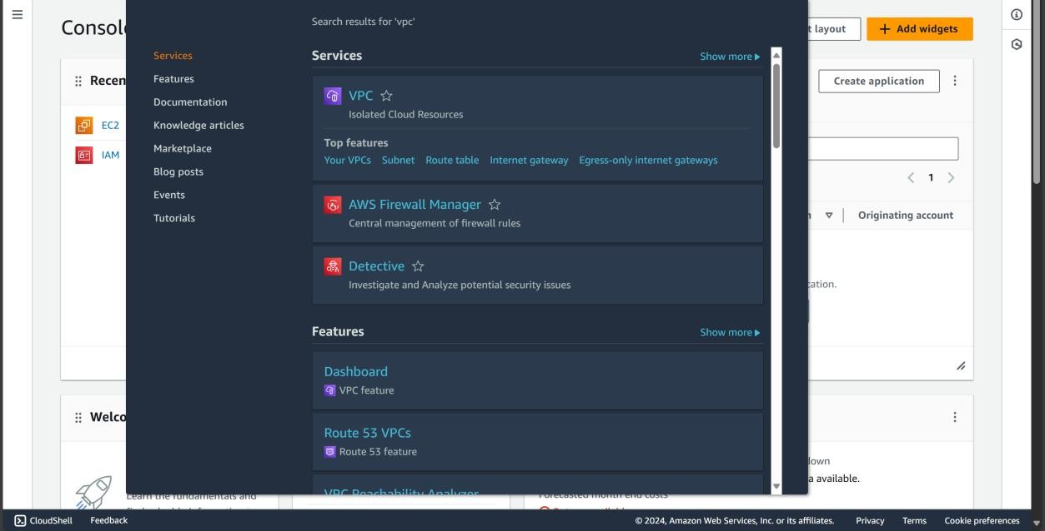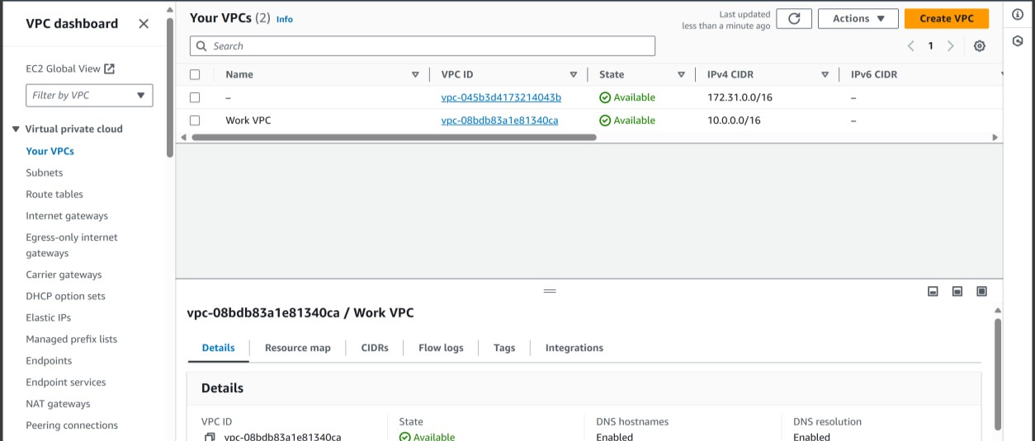

Step 3: Create a New VPC

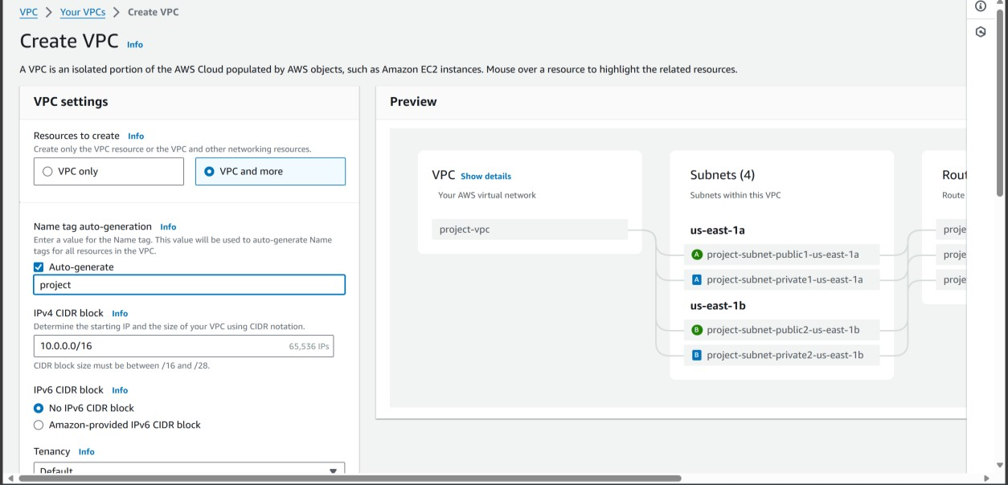

Step 4: Configure the VPC

* **Name tag:** Enter a name for your VPC(project)

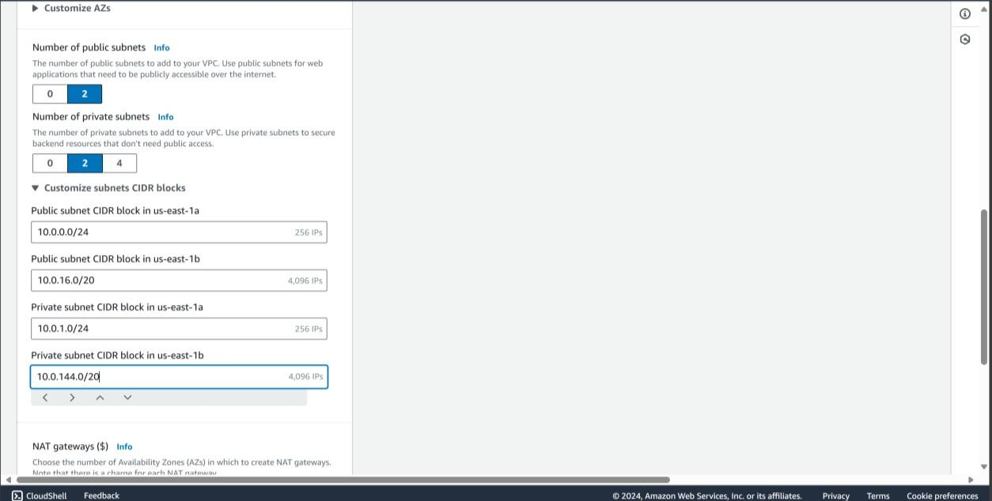

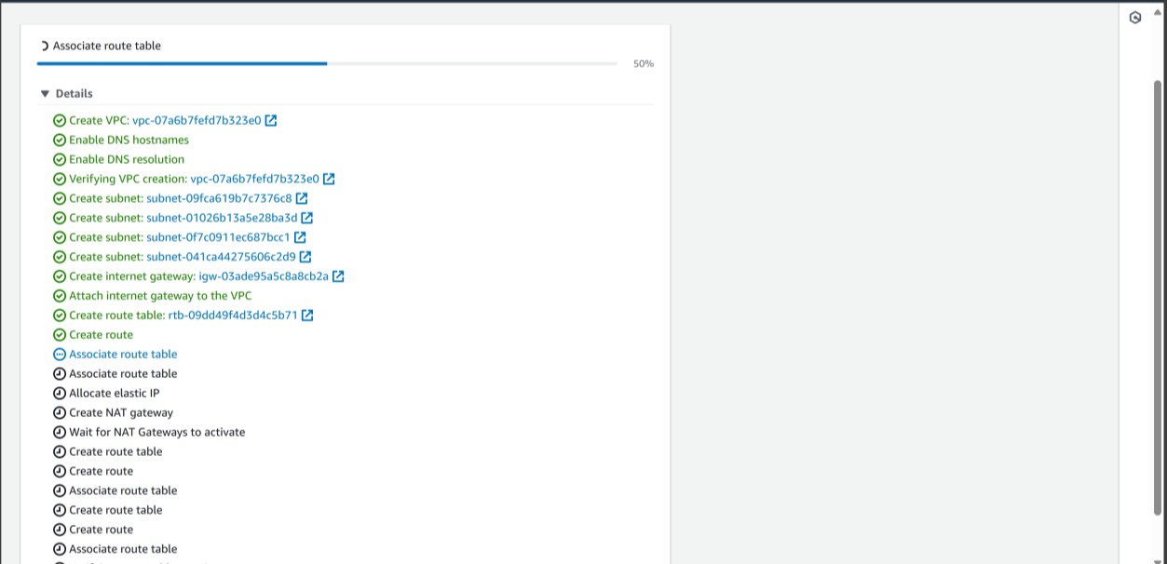

Step 6: Create Subnets

1. **Click on "Subnets"** in the left-hand menu.
2. Click on the "Create Subnet" button.

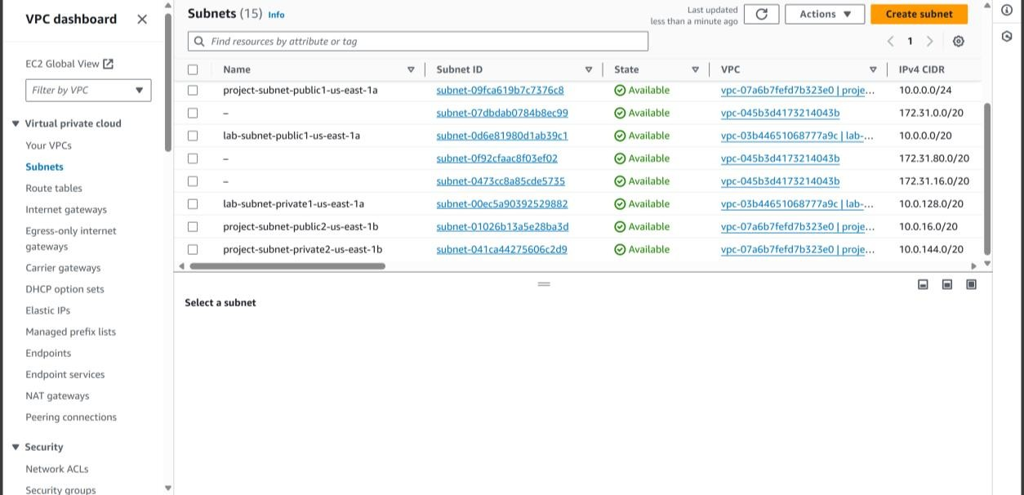

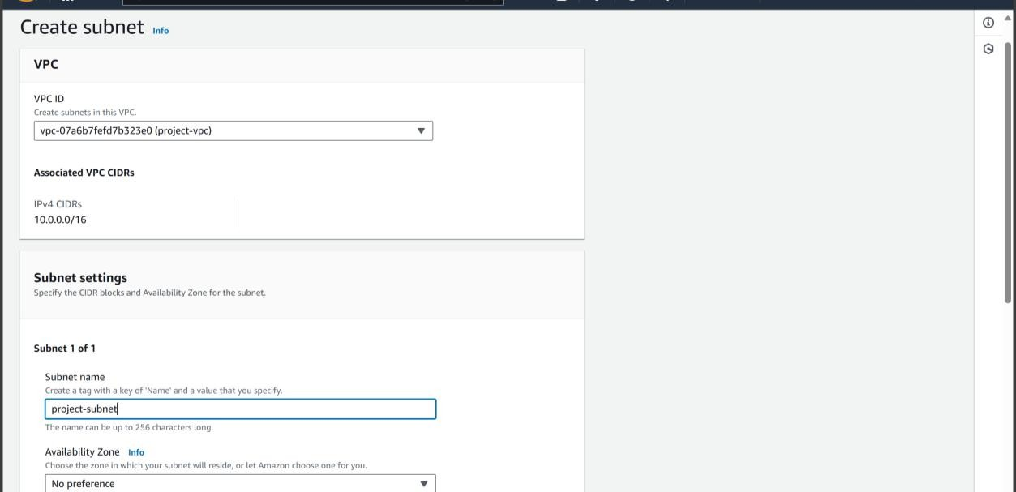

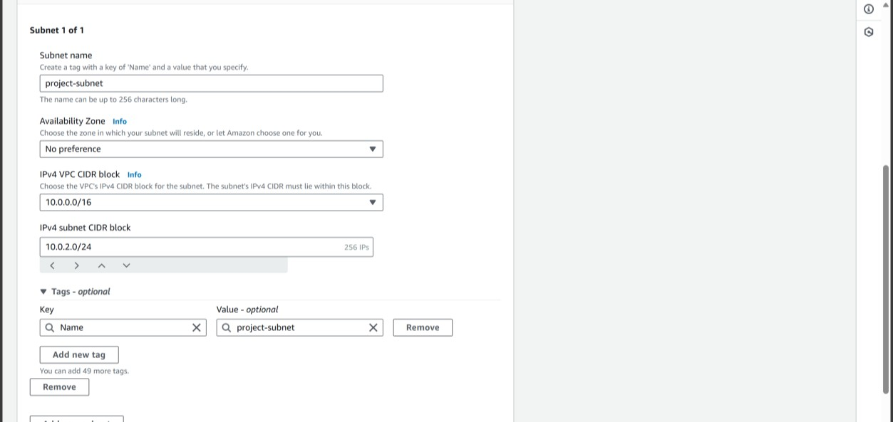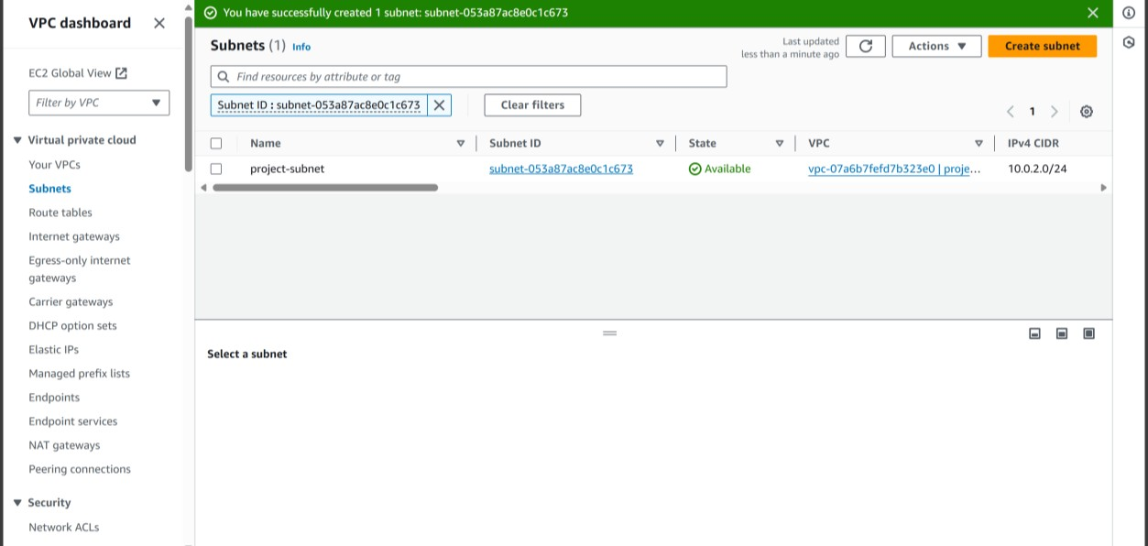

Step 7: Update Route Tables

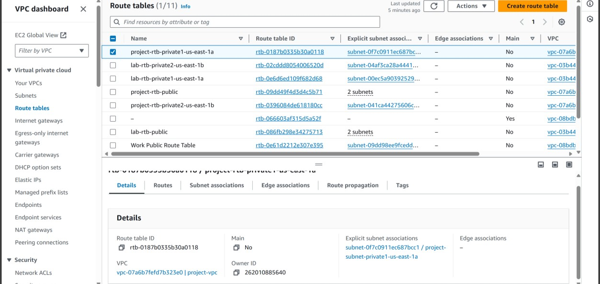

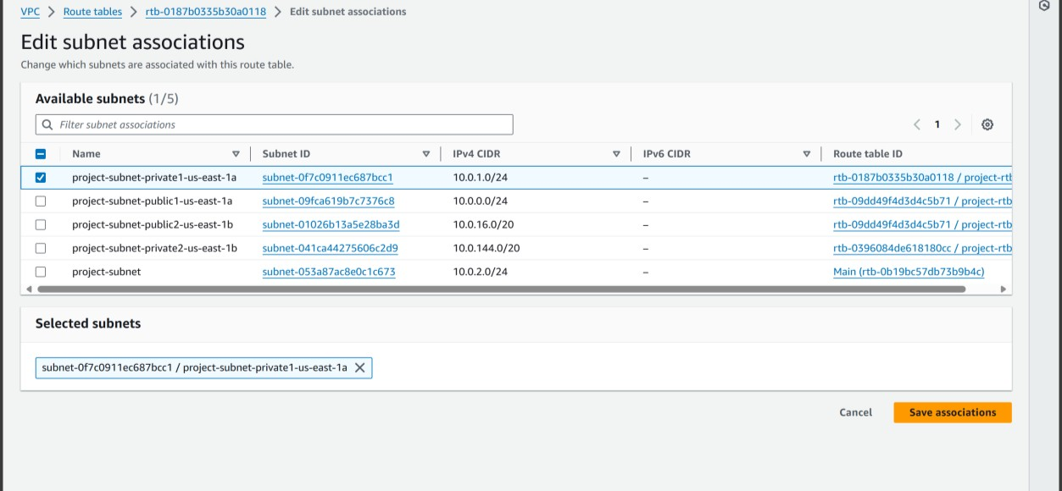

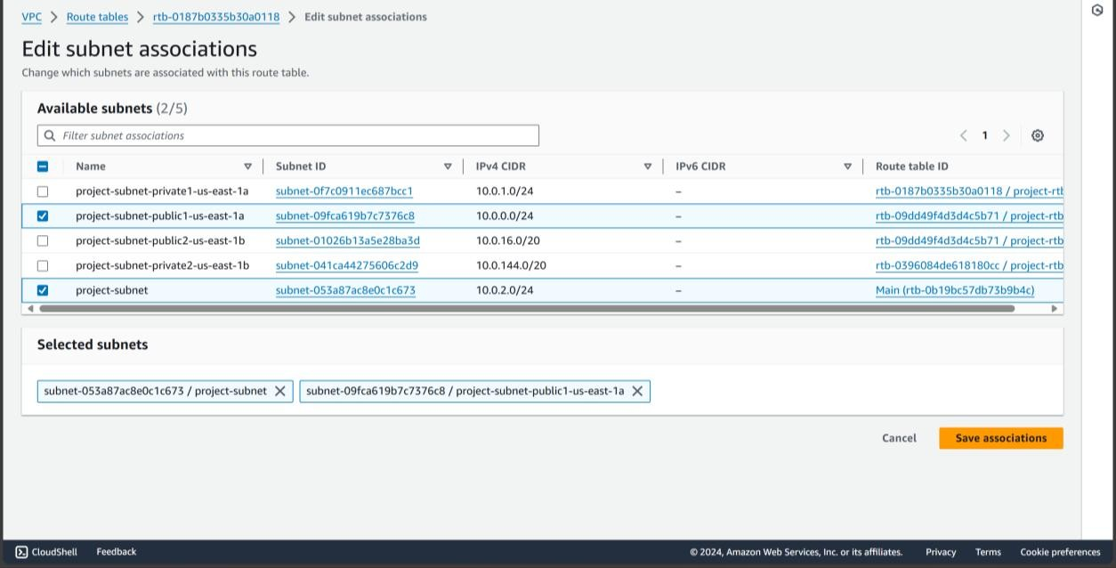

Step 8: Set Up Network ACLs and Security Groups

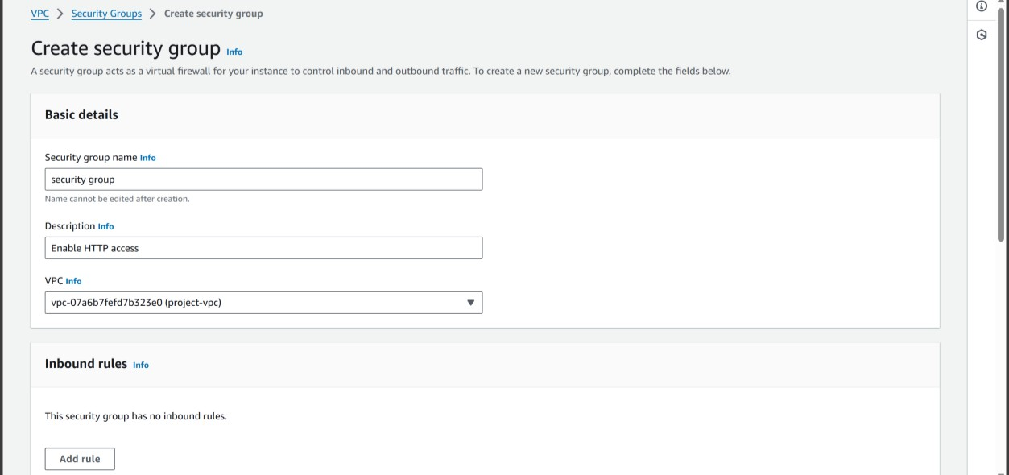

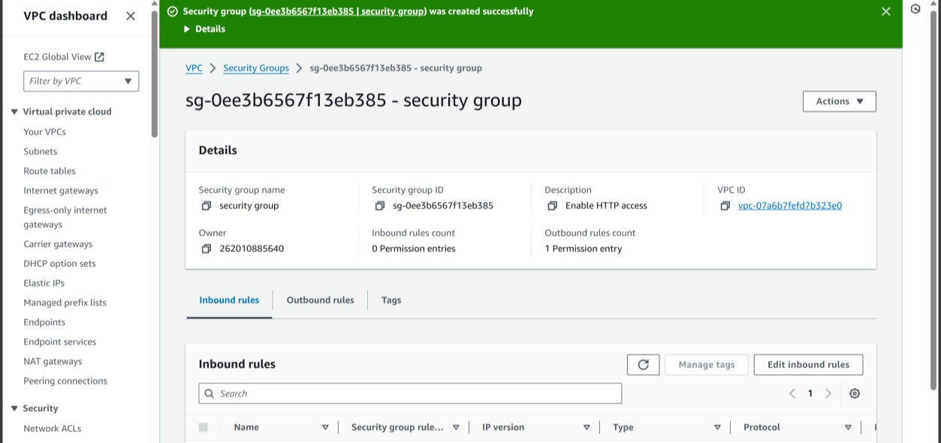

Step 9: Navigate to EC2 for web server creation

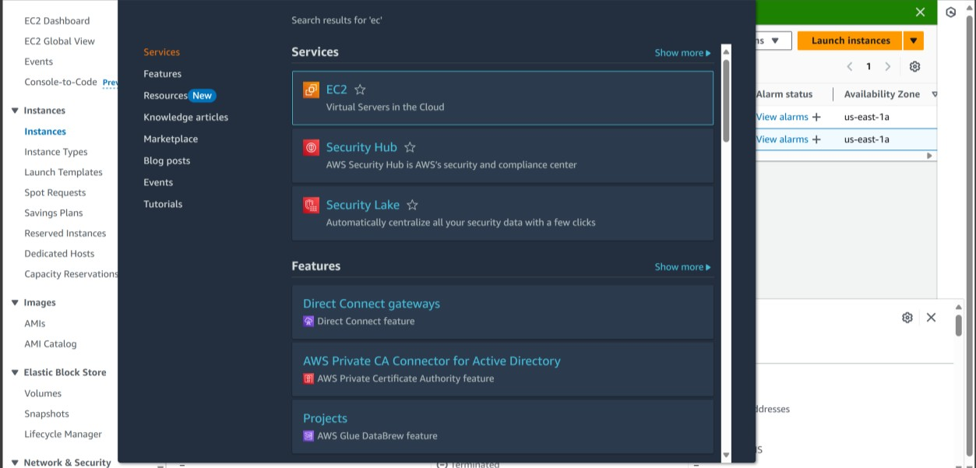

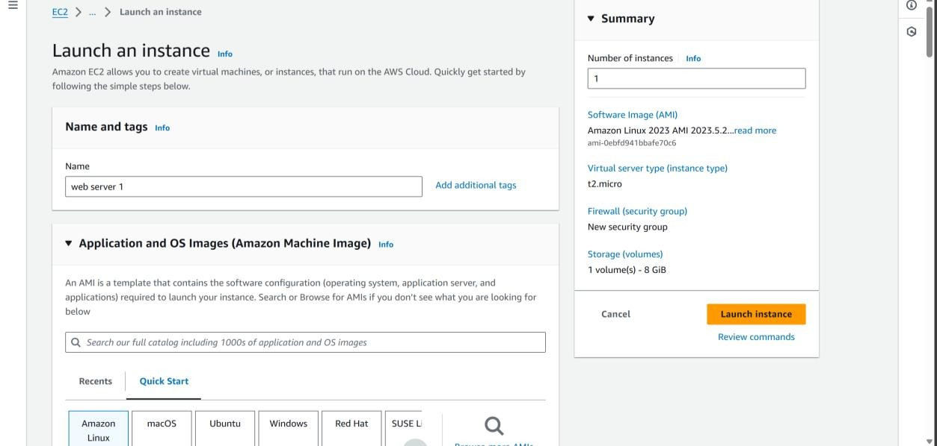

Step 10: Launch instance

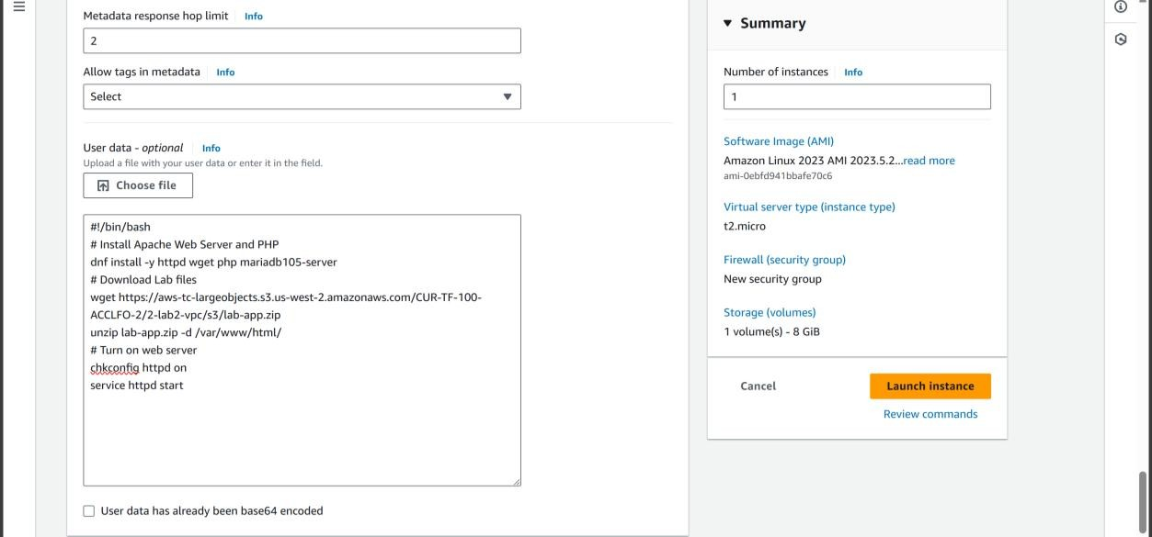

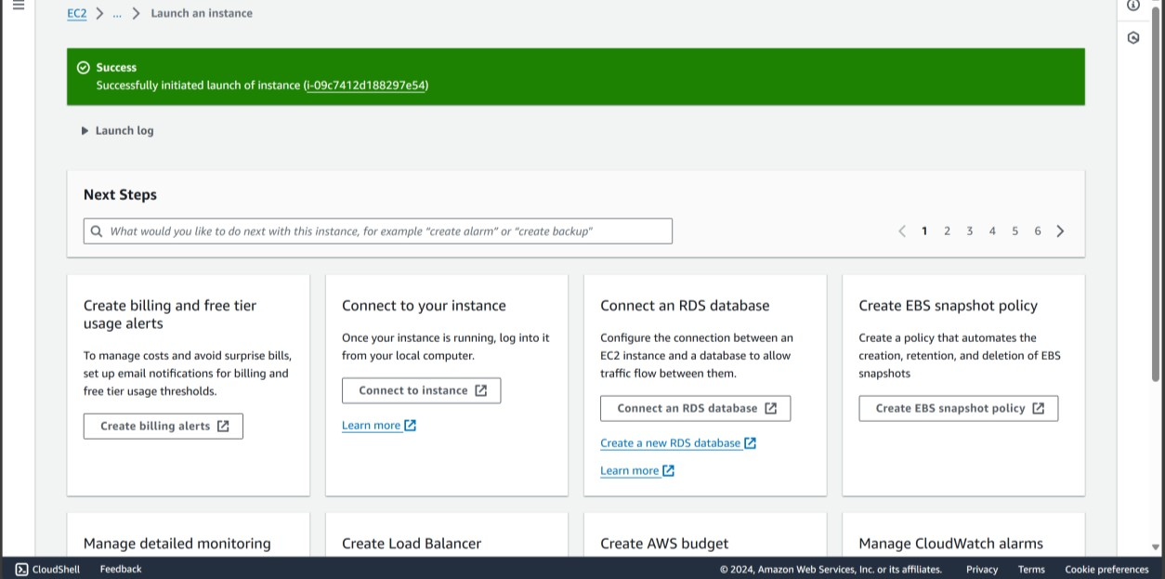

Step 11: Terminate the instance

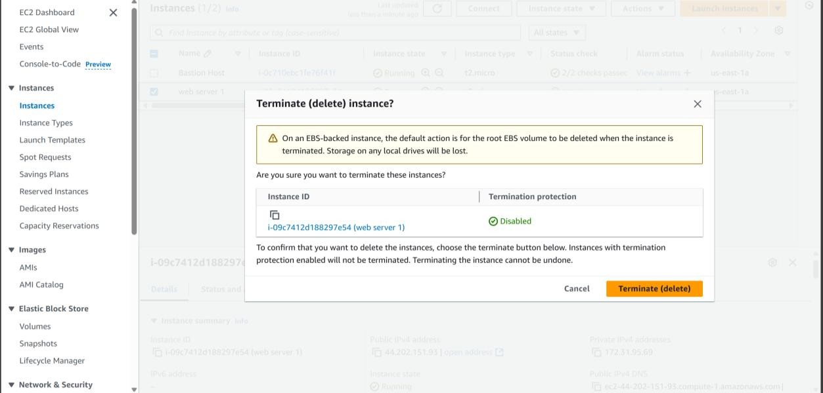

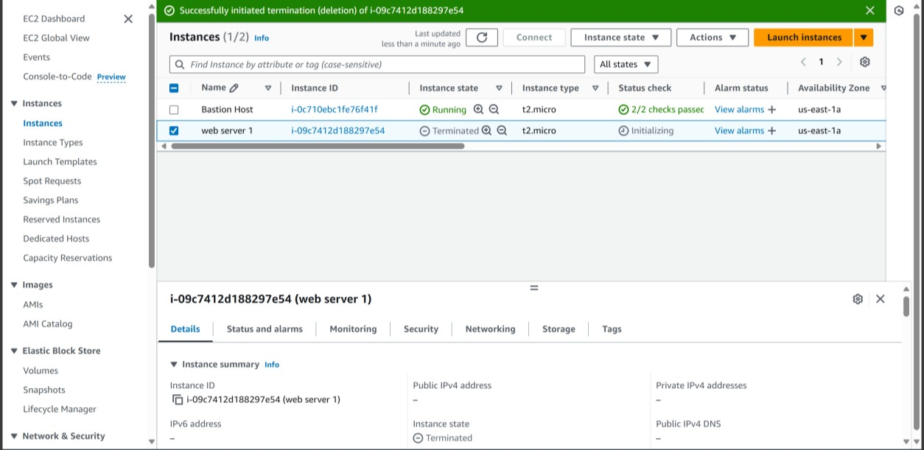

**RESULT:**

A VPC in AWS academy is created.

**7.MYSQL DATABASE**

**AIM:**

To create a MYSQL Database using Amazon EC2

**Step 1:Create an Amazon EC2 instance that you will use to connect to your database.**

**To create an EC2 instance**

1. Sign in to the AWS Management Console and open the Amazon EC2 console at <https://console.aws.amazon.com/ec2/>.
2. In the upper-right corner of the AWS Management Console, choose the AWS Region in which you want to create the EC2 instance.
3. Choose **EC2 Dashboard**, and then choose **Launch instance**, as shown in the following image.

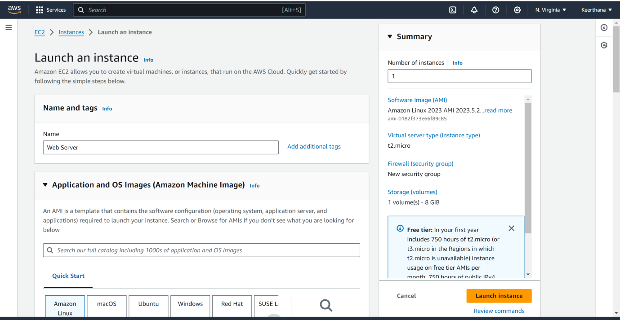

The **Launch an instance** page opens.

1. Choose the following settings on the **Launch an instance** page.
   1. Under **Name and tags**, for **Name**, enter **Web Server**.
   2. Under **Application and OS Images (Amazon Machine Image)**, choose **Amazon Linux**, and then choose the **Amazon Linux 2023 AMI**. Keep the defaultselections for the other choices.

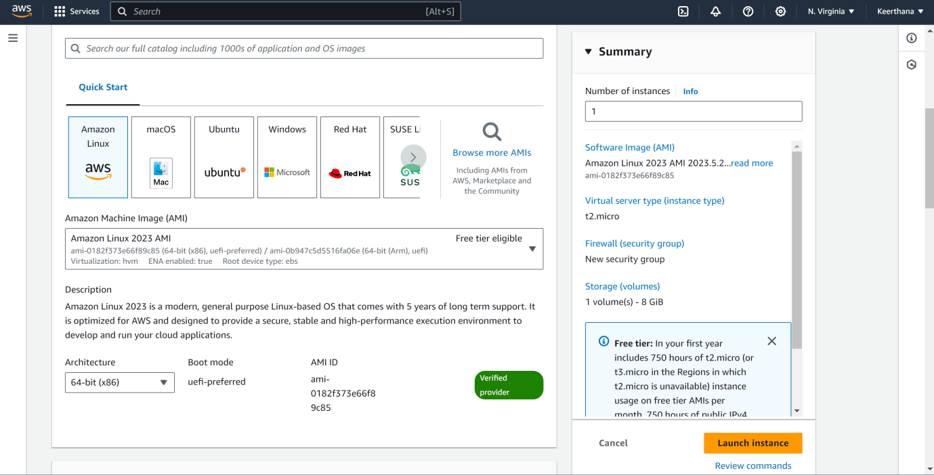

* 1. Under **Instance type**, choose **t2.micro**.
  2. Under **Key pair (login)**, choose a **Key pair name** to use an existing key pair. To create a new key pair for the Amazon EC2 instance, choose **Create new key pair** and then use the **Create key pair** window to create it.
  3. For **Allow SSH traffic** in **Network settings**, choose the source of SSH connections to the EC2 instance.
  4. Leave the default values for the remaining sections.
  5. Review a summary of your EC2 instance configuration in the **Summary** panel, and when you're ready, choose **Launch instance**

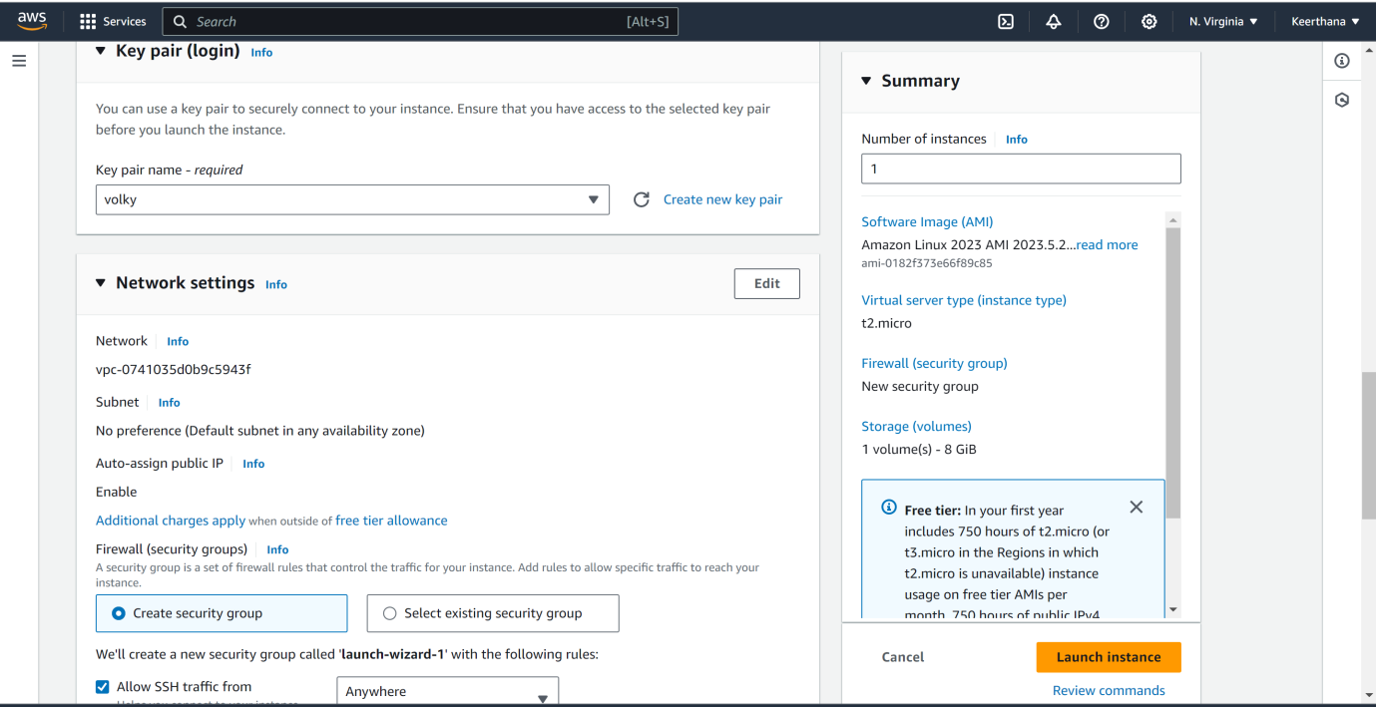

1. On the **Launch Status** page, note the identifier for your new EC2 instance, for example: i-1234567890abcdef

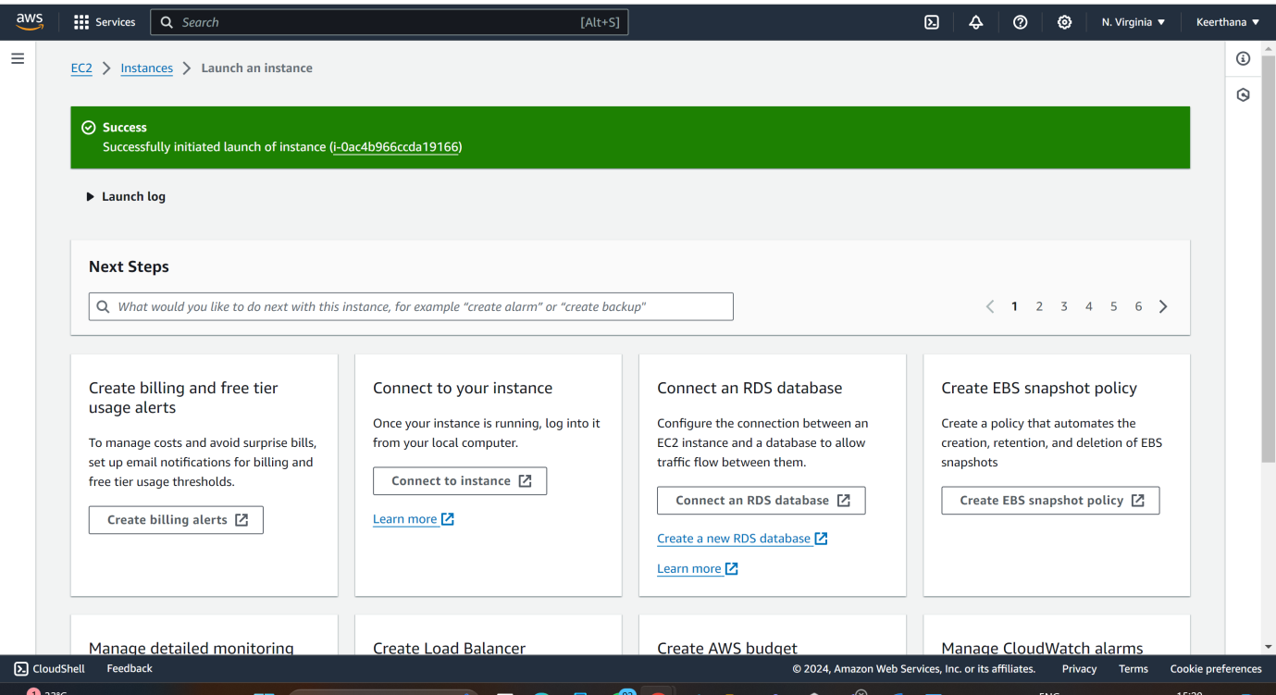

1. Choose the EC2 instance identifier to open the list of EC2 instances, and then select your EC2 instance.
2. In the **Details** tab, note the following values, which you need when you connect using SSH:

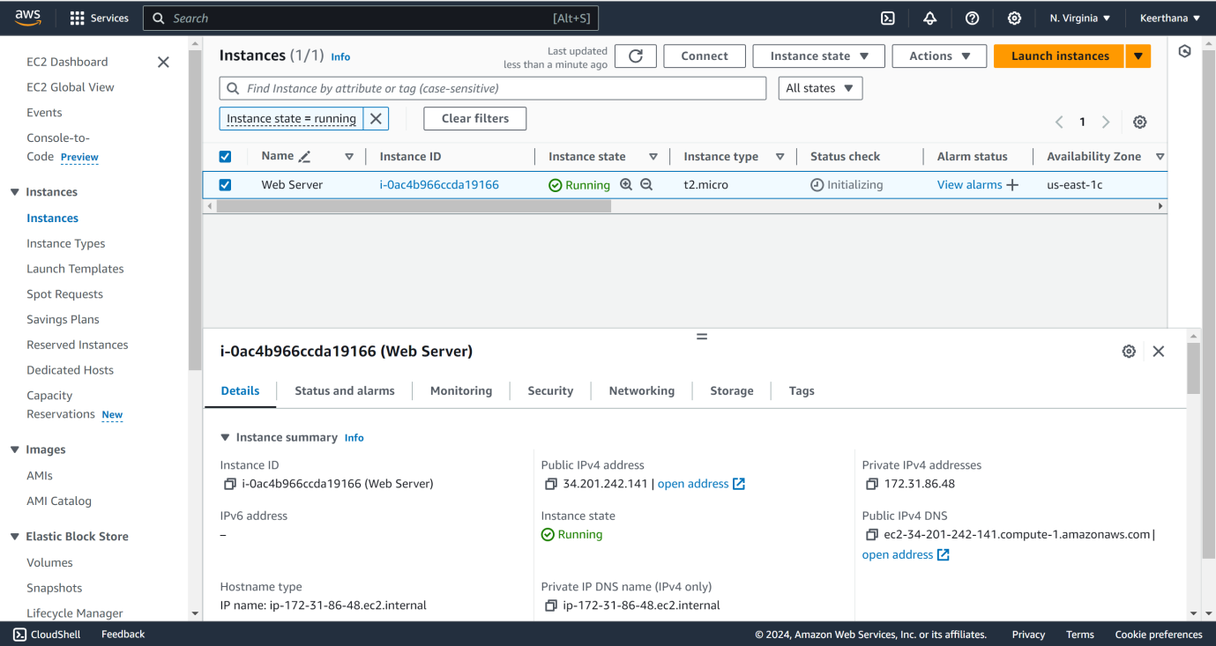  
  
 a. In **Instance summary**, note the value for **Public IPv4 DNS**.

b. In **Instance details**, note the value for **Key pair name**.

1. Wait until the **Instance state** for your EC2 instance has a status of **Running** before continuing.

**Step 2: Create a MySQL DB instance**

**To create a MySQL DB instance with Easy create**

1. Sign in to the AWS Management Console and open the Amazon RDS console at <https://console.aws.amazon.com/rds/>.
2. In the upper-right corner of the Amazon RDS console, choose the AWS Region you used for the EC2 instance previously.
3. In the navigation pane, choose **Databases**.
4. Choose **Create database** and make sure that **Easy create** is chosen.
5. In **Configuration**, choose **MySQL**.
6. For **DB instance size**, choose **Free tier**.
7. For **DB instance identifier**, enter **database-test1**.
8. For **Master username**, enter a name for the master user, or keep the default name.  
     
   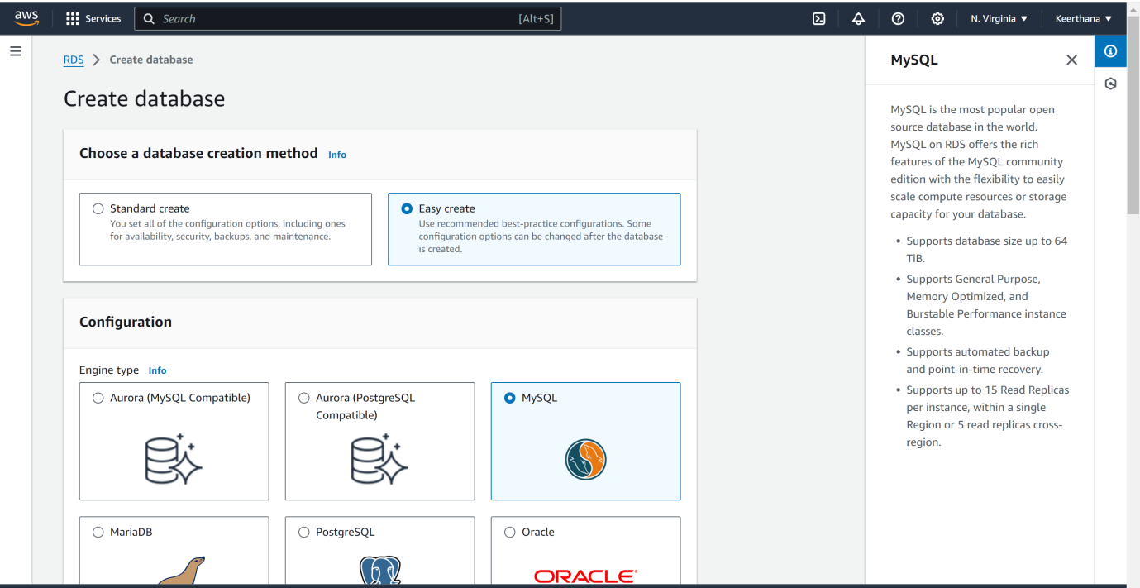  
     
   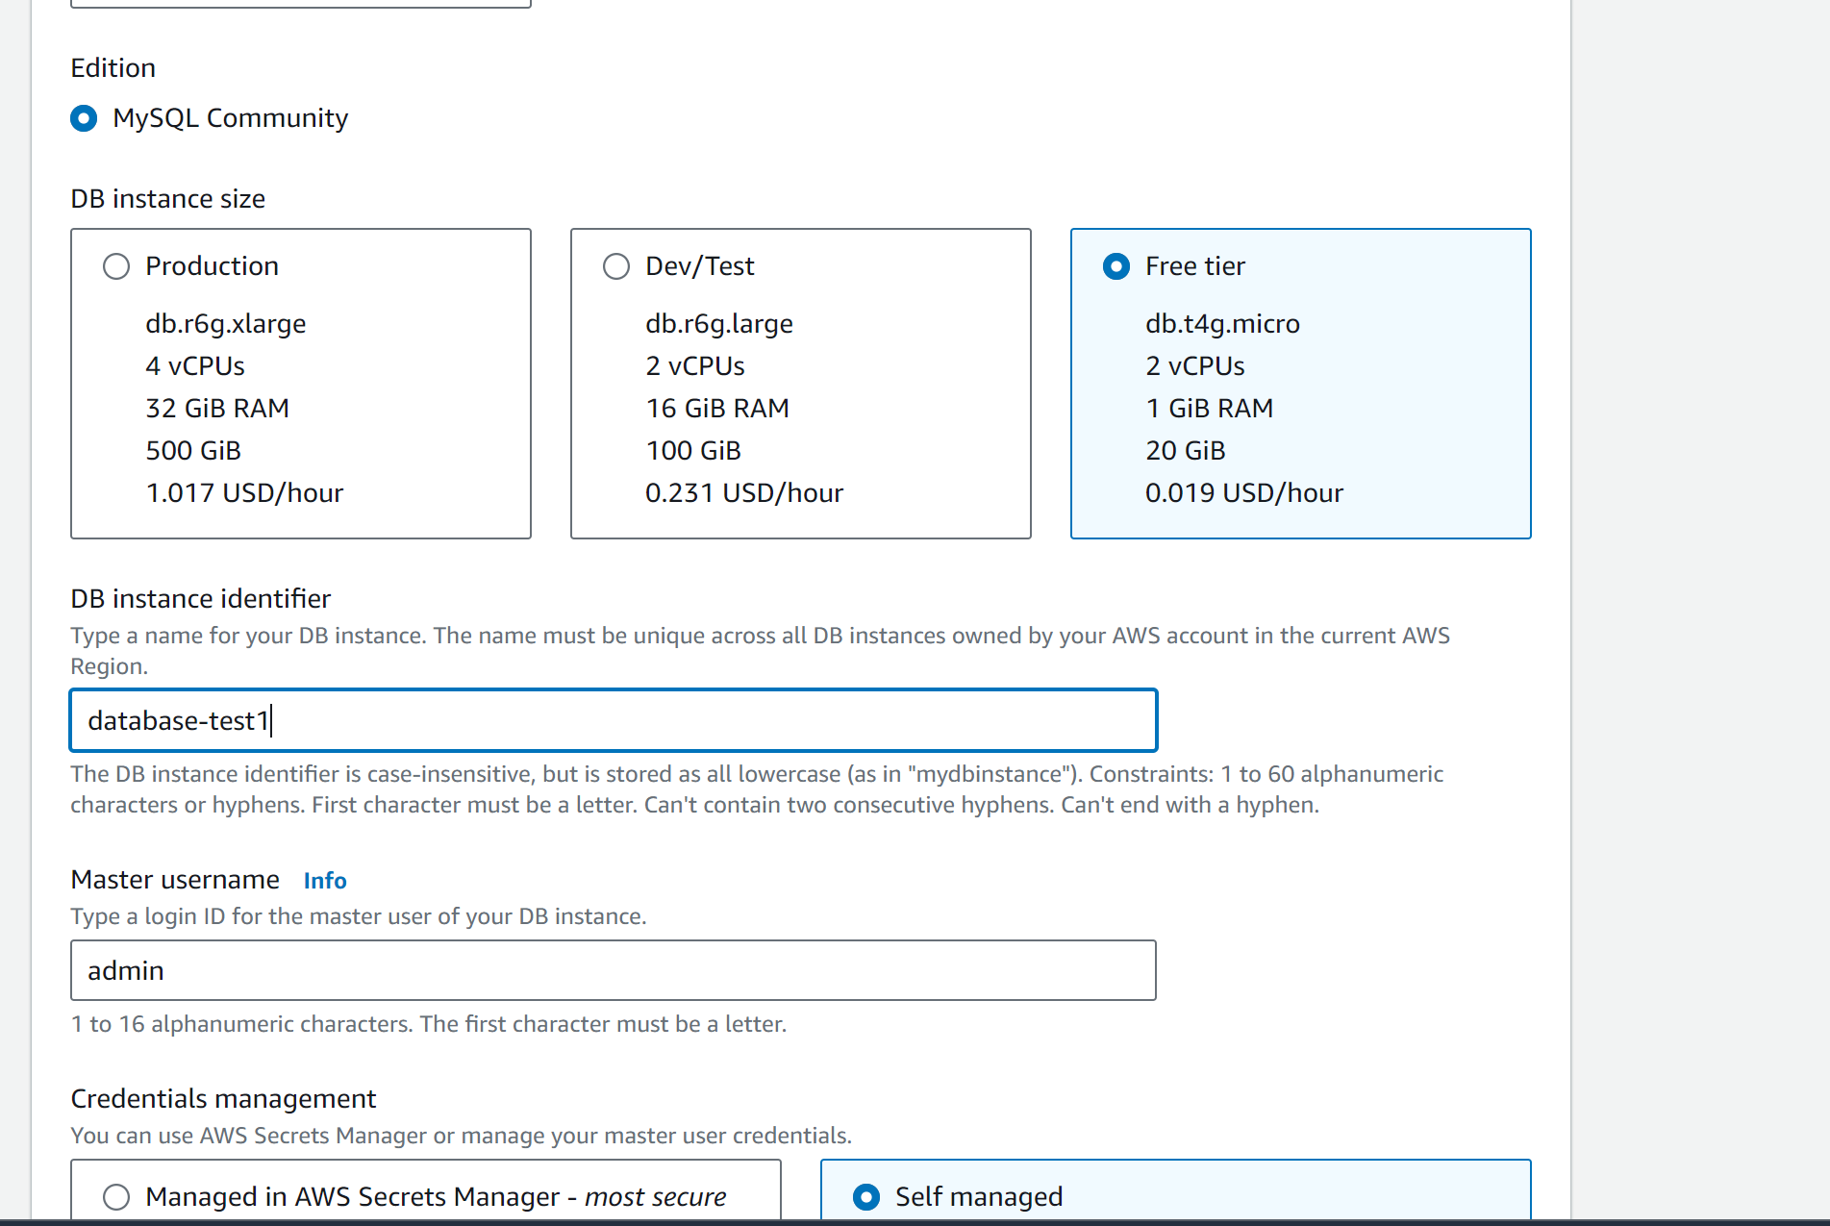
9. To use an automatically generated master password for the DB instance, select **Auto generate a password**.

To enter your master password, make sure **Auto generate a password** is cleared, and then enter the same password in **Master password** and **Confirm password**.

1. To set up a connection with the EC2 instance you created previously, open **Set up EC2 connection - *optional***.

Select **Connect to an EC2 compute resource**. Choose the EC2 instance you created previously.

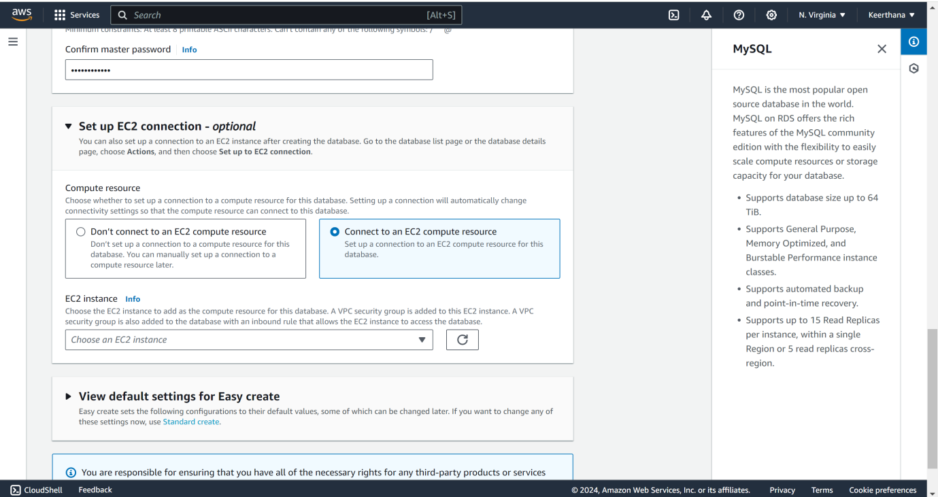

1. Choose **Create database**.To view the master username and password for the DB instance, choose **View credential details**.
2. In the **Databases** list, choose the name of the new MySQL DB instance to show its details.The DB instance has a status of **Creating** until it is ready to use.

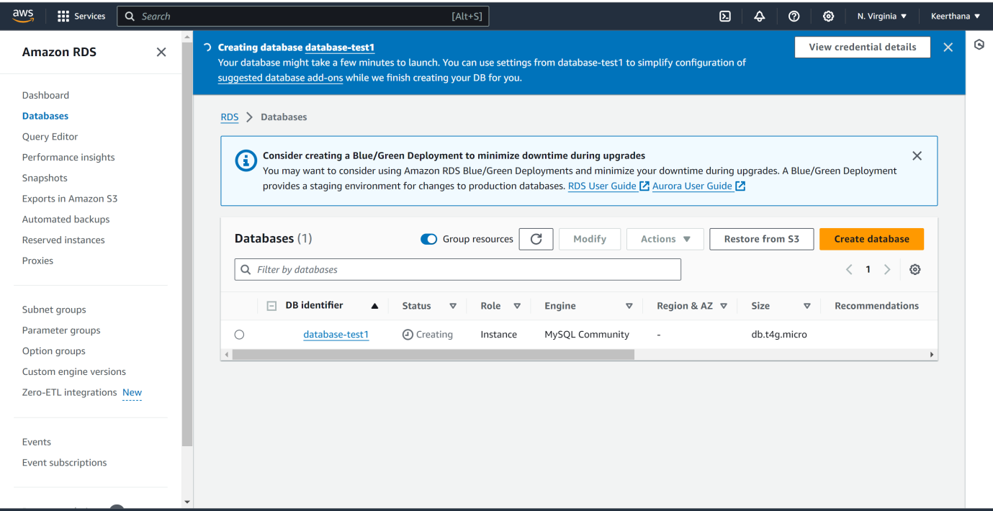

**Step 3: Connect to a MySQL DB instance**

**To connect to a MySQL DB instance**

1. Find the endpoint (DNS name) and port number for your DB instance.
   1. Sign in to the AWS Management Console and open the Amazon RDS console at <https://console.aws.amazon.com/rds/>.
   2. In the upper-right corner of the Amazon RDS console, choose the AWS Region for the DB instance.
   3. In the navigation pane, choose **Databases**.
   4. Choose the MySQL DB instance name to display its details.
   5. On the **Connectivity & security** tab, copy the endpoint. Also, note the port number. You need both the endpoint and the port number to connect to

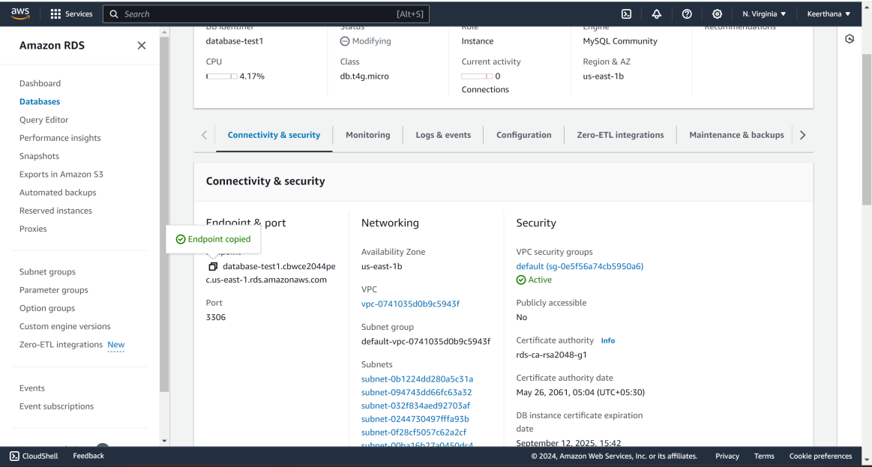

1. Connect to the EC2 instance that you created earlier by following the steps in [Connect to your Linux instance](https://docs.aws.amazon.com/AWSEC2/latest/UserGuide/AccessingInstances.html) in the *Amazon EC2 User Guide*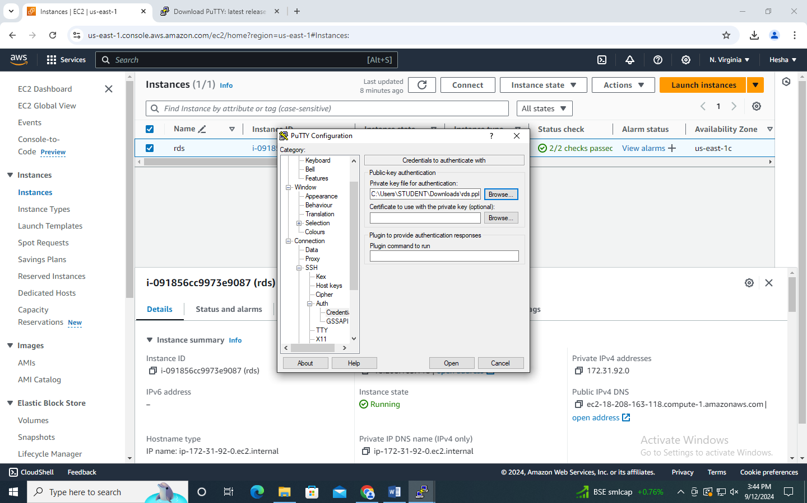
2. Using putty mysql -h <endpoint> -P <port> -u <master_username> -p  
   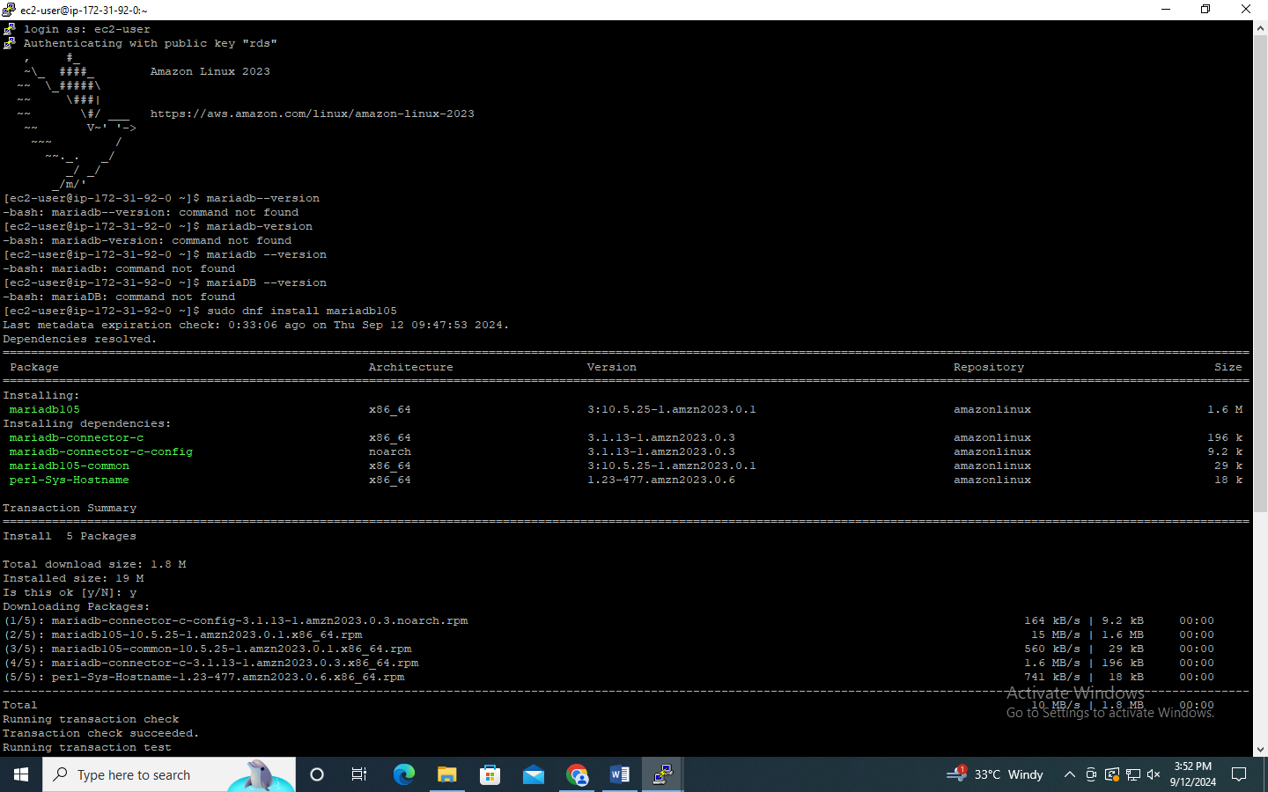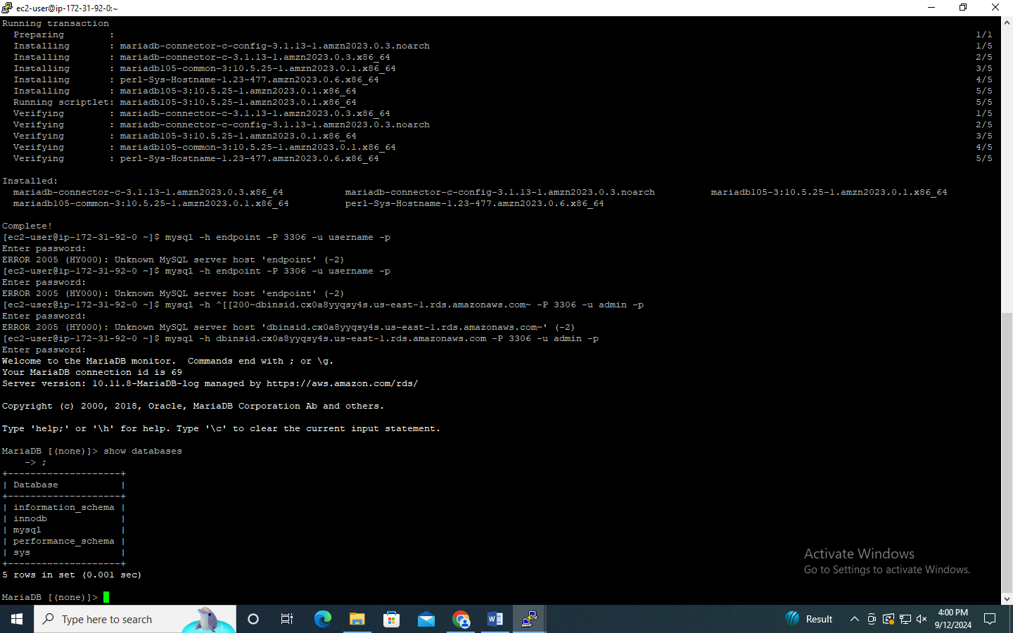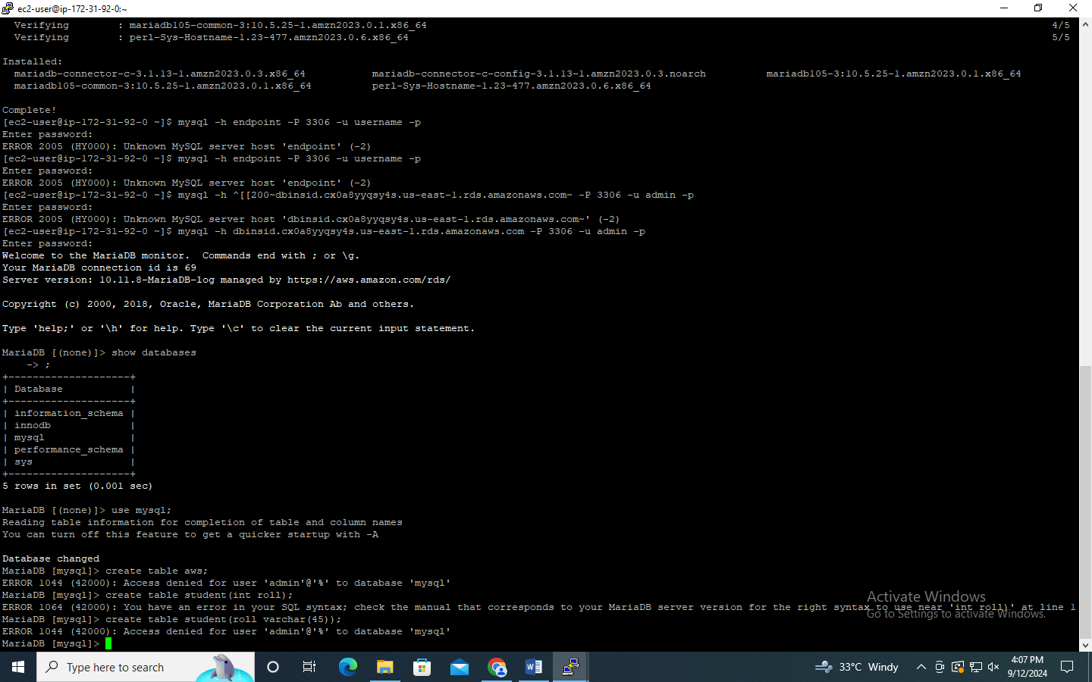**Result:**

Thus the procedure for creating an MYSQL Database has been executed successfully

# 8. Create and carryout Read and Write operations on DynamoDB

# Aim:

To create and carryout Read and Write operations on DynamoDB.

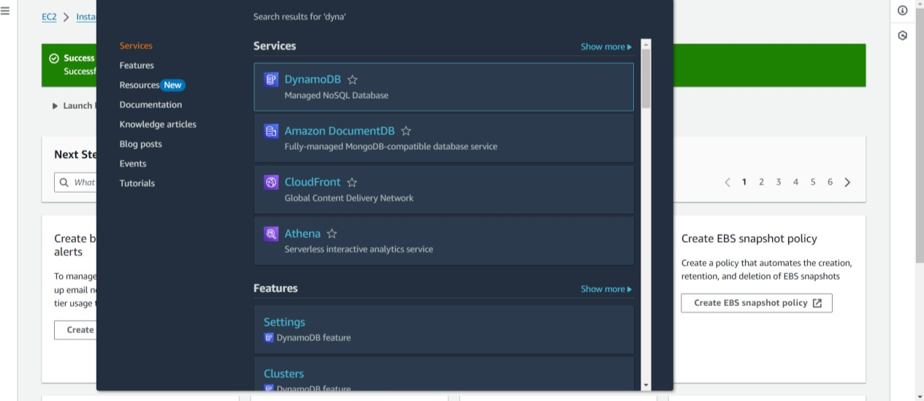

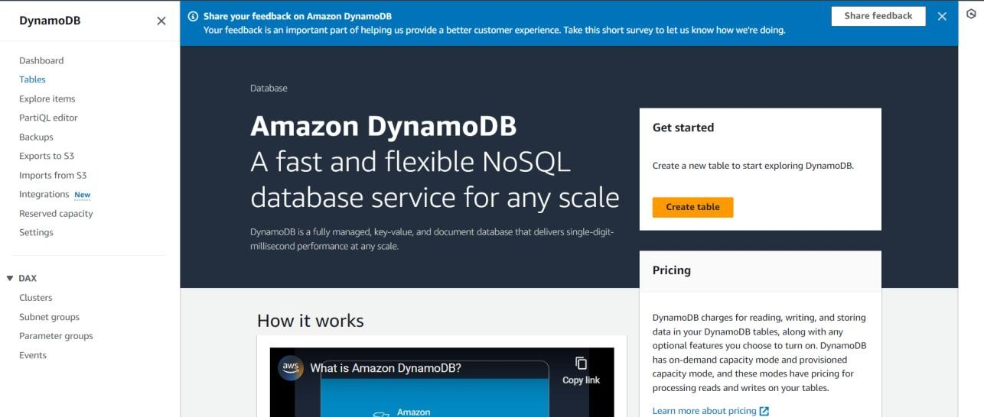

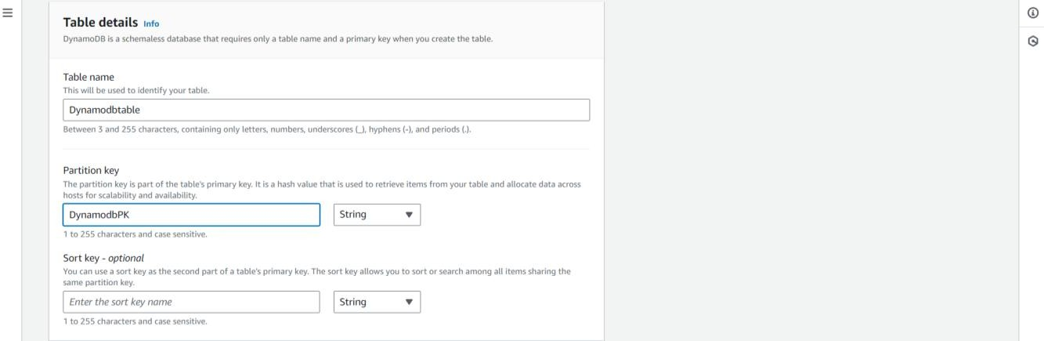.

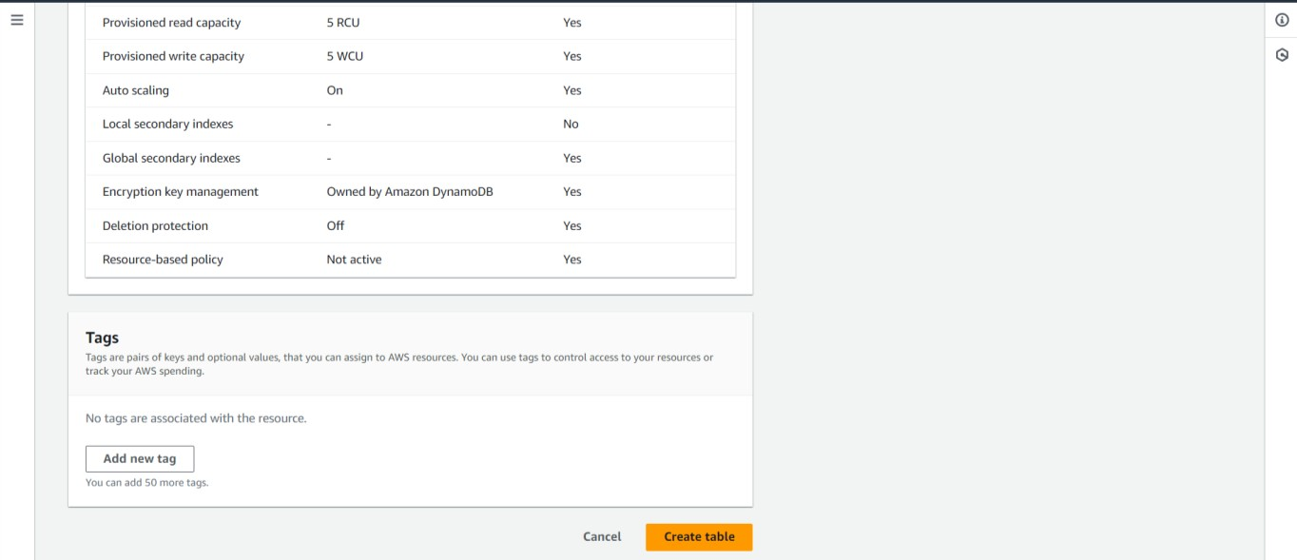



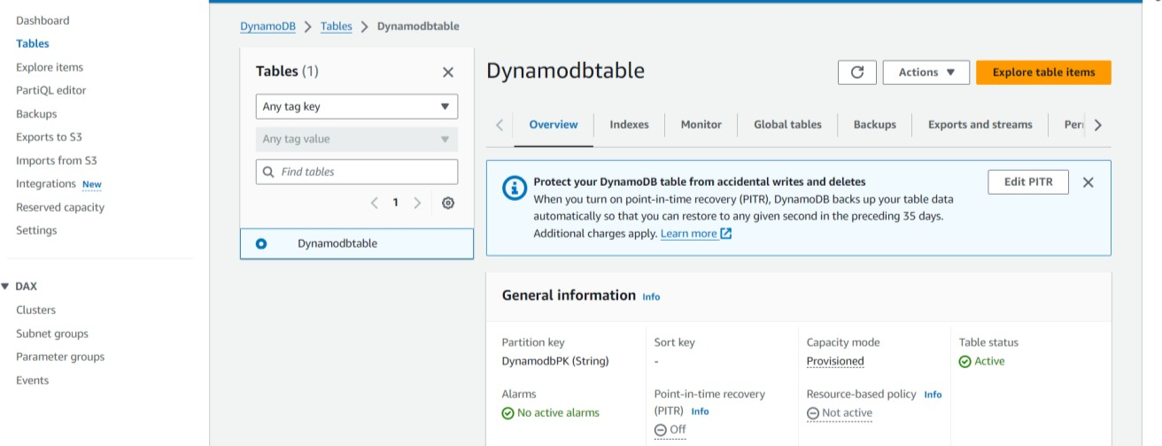

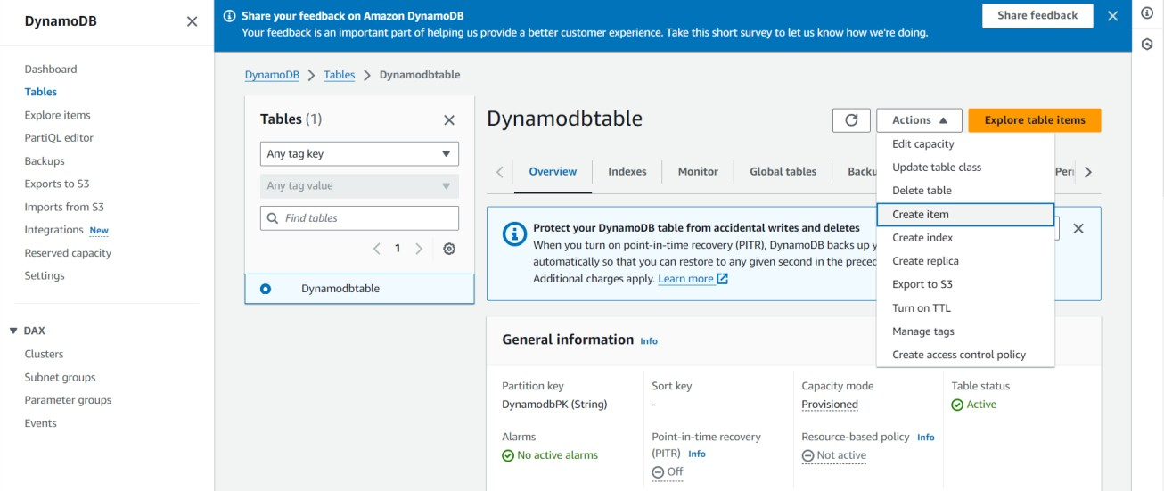

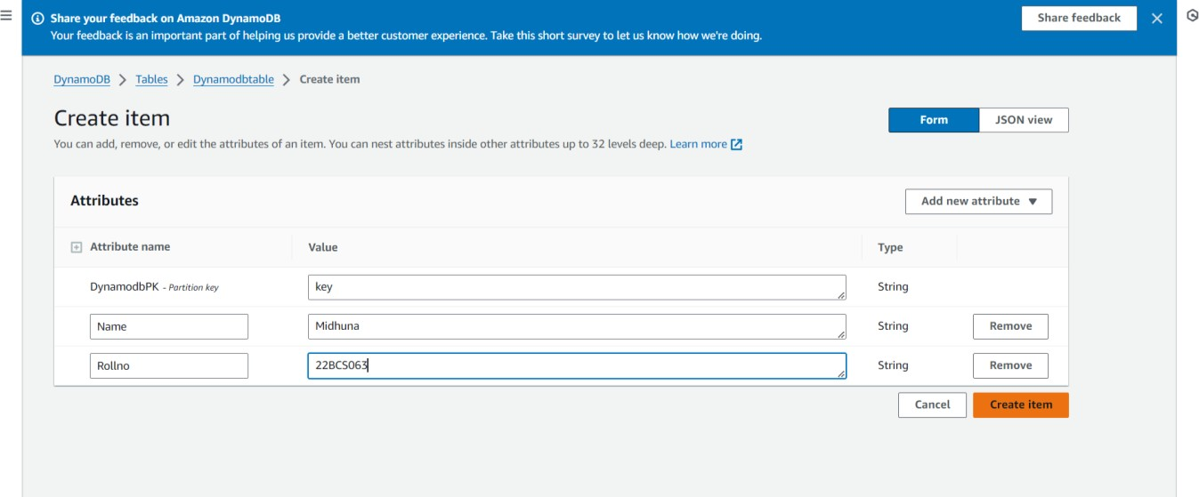

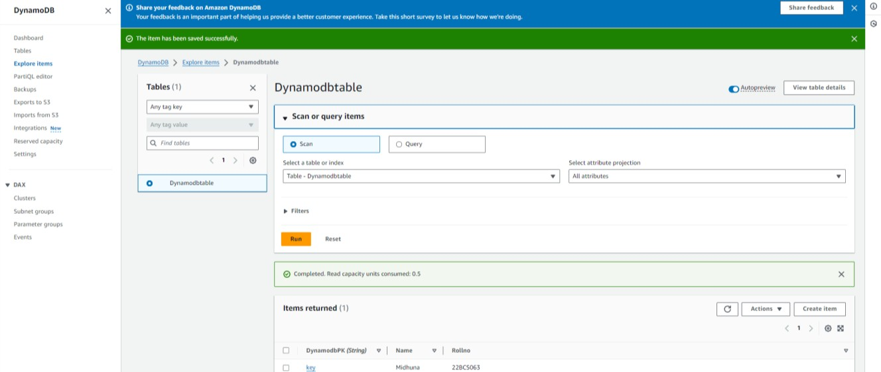

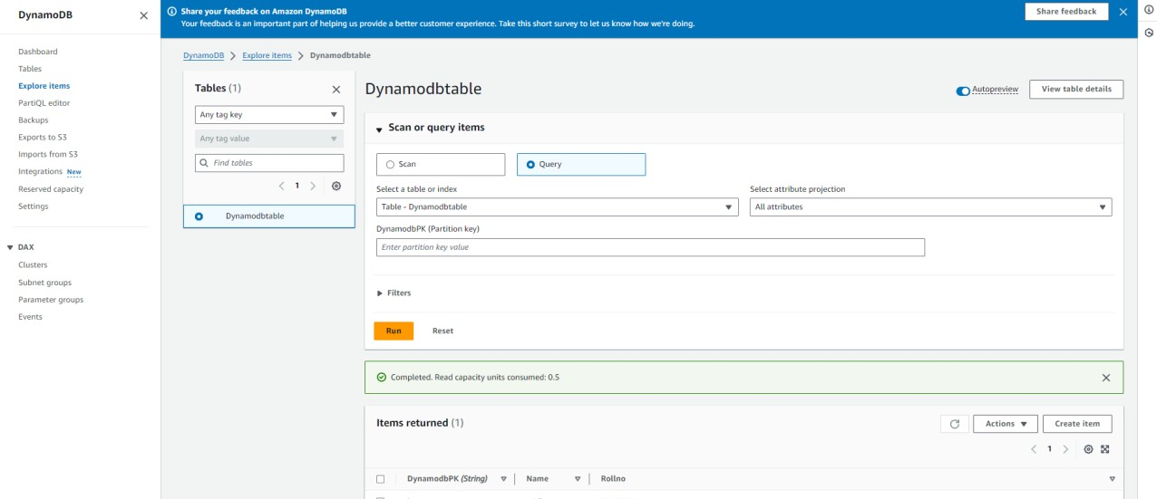

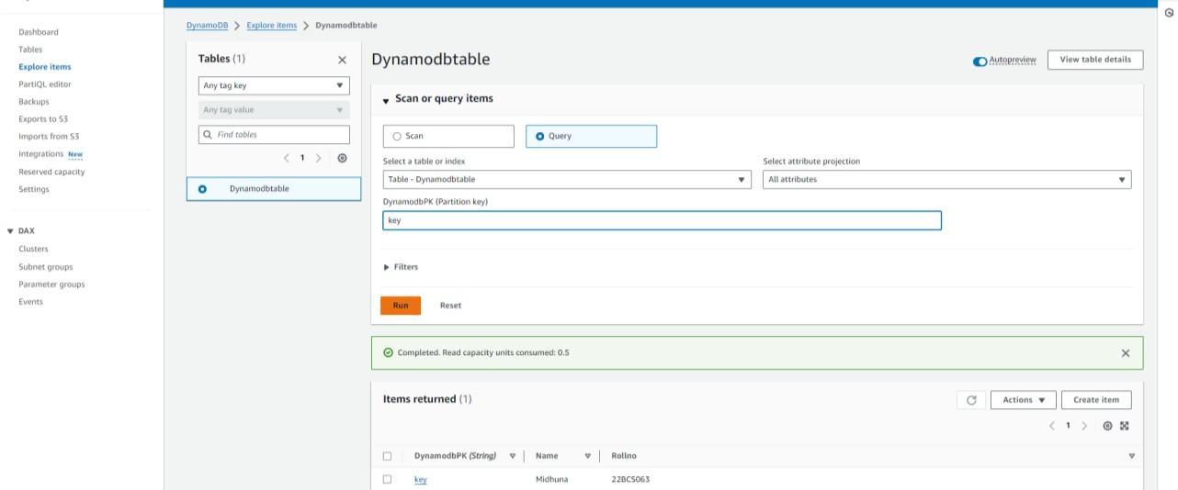

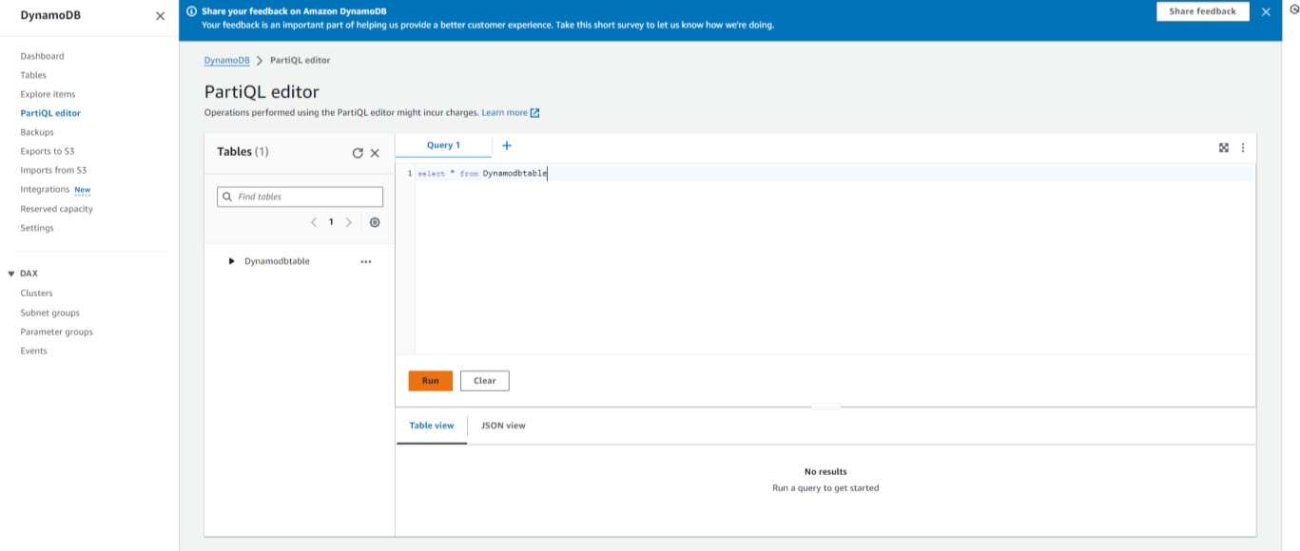

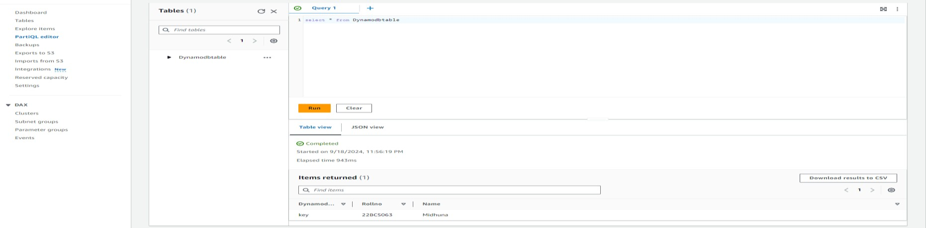

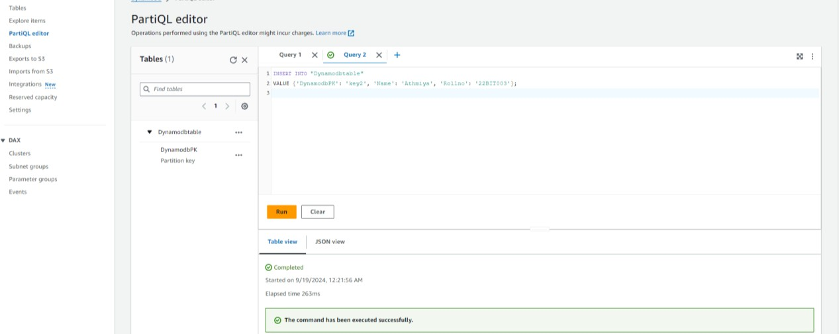

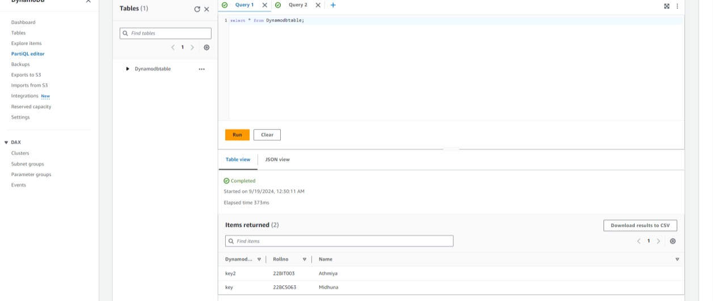

# RESULT:

Thus, table was created and read and write operations were performed successfully on DynamoDB.